Assignment Submission Report
Name: Robert Vinson
Course / Cohort: 114 CH 63
Assignment: 2
GitHub Repository Link: https://github.com/bbkkssv/FSDI-114.git

Evidence of Functionality

Frontend/UI
Attach 3 screenshots only:
- Main screen
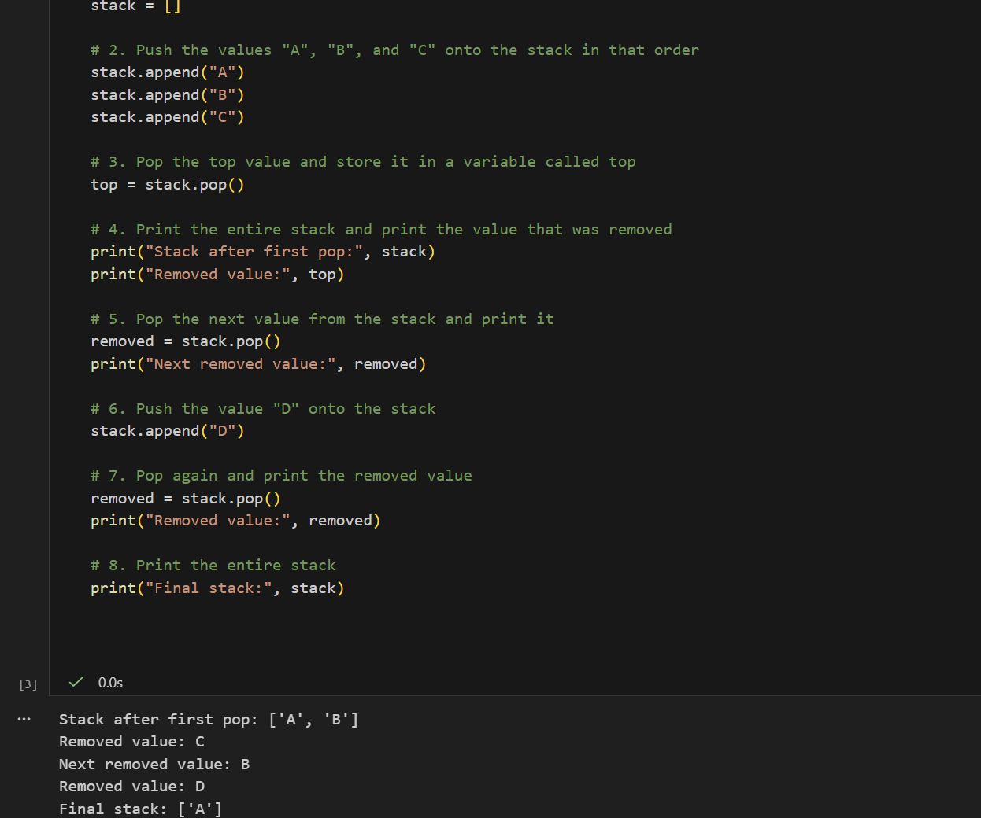
- One interaction working
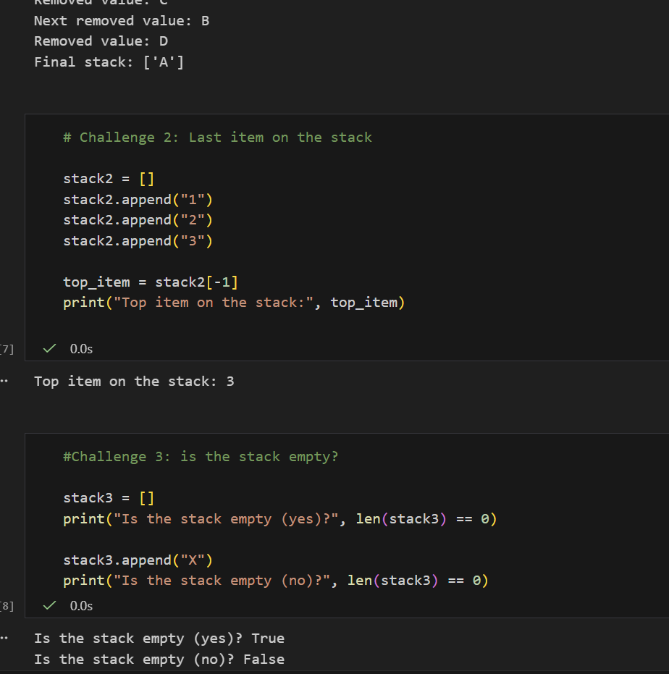
- One validation / error state
This really isn’t applicable to this assignment. There are no functions to call/break. And no validations for operations

Backend/Logic
- Screenshot of one key component/element (route / controller / service)
Not applicable

AI Disclosure (Required) – Highlight the one that applies
- I did not use AI
- I used AI for help
- AI generated parts of my code

