**Software Design**

|  |
| --- |
| An American Video Game Company |
| CRM Software Outline |
|  |

|  |
| --- |
| Brandon Blackburn  3-31-2021  [Version 0.1] |

Contents

A. Introduction 3

A.1. Purpose Statement 3

A.2. Overview of the Problem 3

A.3. Goals and Objectives 3

A.4. Prerequisites 3

A.5. Scope 4

A.6. Environment 4

B. Requirements 5

B.1. Business Requirements 5

B.2. User Requirements 5

B.3. Functional Requirements 5

B.4. NonFunctional Requirements 5

C. Software Development Methodology 6

C.1. Advantages of the Waterfall Method 6

C.2. Disadvantages of the Waterfall Method 6

C.3. Advantages of Agile Method 6

C.4. Disadvantages of Agile Method 7

C.5. Best Suited 7

D. Design 8

D.1. Contact Management Permission Denied Flowchart 8

D.2. GUI 10

E. Testing 11

E.1. Functional Tests 11

E.1.1. information and privileges test 11

E.1.2. User Customization Test 12

E.1.3. User history test 13

F. Sources 14

# Introduction

An American Video Game Company has need for a new CRM Software system. We propose a new system that will integrate with the current system, uses a cloud-based database, and will be available via web browser. This will allow for users to access the software on any device that can run the most recent version of popular web browsers.

# A.1. PUrpose Statement

In this proposal, we will explore the problems, goals, requirements, and scope of the project. Provided will be examples of what the GUI will look like, what tests will be used to ensure functionality, a list of prerequisites, and what the phases of production will be like. The waterfall method of project management has been determined by the American Video Game Company, which sets the scope of the project in the beginning phase and cannot be changed once agreed upon. It is important that this methodology is understood; so we have provided the pros and cons of the waterfall method and the agile method. After review, both the developer and the client will have a clear understanding of the project and what is expected.

# A.2. Overview of THE PROBLEM

As sales increase and An American Video Game Company grows, a new CRM system is needed to replace the current over-grown system. This new CRM system will need to consolidate contacts and business info, be accessible through third parties, and be securely accessed remotely based on given privileges. Orders, quotes, and user activity need tracking that records are available for any user and audits can quickly be exercised. The GUI will need to be user-friendly, while still careful enough so that information is not accidentally deleted.

# A.3. Goals and Objectives

The goals of this project are to integrate the information of the current system into a new database while having a software built around management of the data. The software will compensate for the increasing sales and users over the next decades. Our objective is to create an environment that is user friendly and efficient enough so if the American Video Game Company were to expand exponentially, the only additional need would be to purchase a larger database to store the information. Our software will continue to be supported and updated, but the only bottleneck for growth should be the amount of space that the client decides to purchase from their vendor of choice.

# A.4. Prerequisites

The following is an outline for the project.

|  |  |  |  |
| --- | --- | --- | --- |
| Number | Prerequisite | Description | Completion Date |
| 1 |  | Basic design and features of software, budget is estimated. Design is the first step and requires no prerequisite. | 05/03/21 |
| 2 | 1 | Approval of budget and agreed upon requirements. | 05/14/21 |
| 3 | 2 | Purchase of cloud database provider contract is made | 05/17/21 |

# A.5. Scope

The software will meet all requirements located in AVG company’s CRM Requirements Outline, under the General Requirements section. This includes:

* User Friendliness
* Custom user views that will not affect database integrity.
* Integrating with the prior system
* Privileges based on user roles to protect data.
* Recording user activity for monitoring and auditing
* Quoting, Order Management, Contracting, and Contacts will all be stored.

These services will be available on current internet browsers and will access the host database. We can guarantee the compatibility of up-to-date browsers, but not on previous versions or browsers not listed in the Environment outline.

What will not be included:

* The database host to be hired by AVG.
* The sales forecasting feature – this can be added on by another company that specializes in sales forecasts and continues support for this feature. The integration of this feature will be made simple so that the hired company may add-on on a later date.

It is our priority to ensure quality in our software. The scope will be met and held to the highest standards. Anything that we are uncertain we could provide high quality software engineering is left out of the scope intentionally, and we hope that you will understand.

# A.6. Environment

A cloud database and server will be contracted, such as InterServer.net. This database service should also provide security to ensure integrity and confidentiality of information. A custom software will be built that will allow users to edit the database based on privilege. The custom software should also be able to conduct sales and keep records. Last, the custom software will be able to share information securely with other software and networks to allow for easy integration and/or transfer of new services.

The software will be web-browser based and will require a computer, smartphone, or tablet to use. Browser minimum version requirements are:

* Chrome 89.0.X
* Firefox 86.0
* Internet Explorer 9.0
* Safari 6.0

# Requirements

The requirements for the application will address both business and user, and functional and non-functional uses as well.

# Business Requirements

With the expanding size of the American Video Game Company, the number of employees will also increase. As it will be more difficult to track down who is responsible for what actions manually, the program will have a built-in activity tracker for each of the users. It will automatically record all sales, quotes, edits, log-in and log-out times as well. All this information will be available in a User Report on demand. This report is useful for the business to find which user is responsible for specific activities, and to see if a user is meeting certain productivity expectations.

This satisfies the requirement for user monitoring and auditing.

# User Requirements

As the lists of contacts, orders, quotes, and other records is ever-expanding, it will be necessary for the user to be able to filter what they see. User views will be made available so that customized tables of these lists will be more relevant to the user. Adding and removing from theses view will not affect the information stored in the database itself.

This satisfies the requirement for user friendliness and satisfies being able to delete information from a user view without deleting it from the database.

# Functional Requirements

Information will be stored on a cloud-based database, such as our suggestion of InterServer.net. All data confidentiality, integrity, and availability will be guaranteed by the selected vendor.

How the information is stored will be handled by network administrators. But only users will be able to handle what information is stored in the database. To ensure that only authorized users can edit data, each user will be given a level of permissions upon creation. Only system admins will be able to change permissions granted to a user.

This satisfies the requirement for role-based privileges for each user.

# NonFunctional Requirements

The American Video Game Company has seen great success and would like to expand upon its current database system. To allow use of the current system and database rather than a complete overhaul, the new software and database will integrate and work with the current system. This will allow for an easier transition to our software without the need to copy over contacts or other information.

This satisfies the requirement for integration with AVG’s current information system.

# SOFTWARE DEVELOPMENT METHODOLOGY

The project will use a waterfall methodology for the development of this software by the AVG company. Provided are the pros and cons of such methodology for this project, and the pros and cons of an agile methodology as well. More information can be found in R, Stephens’ book, *Beginning Software Engineering*, pg. 145 – 157.

# Advantages of the waterfall method

Waterfall development is well structured:

* The phases will be conducted in order – Analysis, design, development, testing, and maintenance.
* All expectations will be outlined in this CRM Software outline. The deadlines for these phases are already set and will give a great estimate on when the project will be completed.
* The scope of the project has clearly been stated, all requirements are outlined, and if the CRM Software Outline is agreed upon then there is a clear understanding of what can be expected.
* Progress can easily be measured. An estimate on time of completion is more accurate than agile.

# disAdvantages of the waterfall method

Due to the waterfall methodology’s inflexibility:

* Phases must be completed for this project once in place. If one phase has a delay, the following phases will be delayed as well. The complexity of the software does not bare too many risks of delays, but if one does arise the following phases will be affected.
* Phases must be completed in order. Even if our development team has ideas of how to create the software, they must wait until our analysis and design phases are complete. If the QA team is ready to start testing, they cannot until the development per
* Once this CRM Software Outline has been agreed upon, there can be no added requirements or addition to the scope. If the American Video Game Company wishes to add to the scope, a whole new outline will need to be made and the project must restart.

# Advantages of Agile

Agile development’s incremental approach:

* Changes in scope and features may be added as the project progresses. If the American Video Game Company wishes to add a new requirement later (such as a customer view), there will be no need to restart the project.
* Phases can be combined, such that building the software and testing it may happen simultaneously. This allows for the QA and development team to fix problems as they arise rather than in phased order. This may also benefit the development speed and allow for the project to finish sooner.
* AVG company may be more involved, as the development team may ask for input and decide what the end-user would like to see.

# disAdvantages of agile

Agile development’s lack of structure:

* May allow for a delay in deadlines due to scope creep or unforeseen circumstances. Since adding to the scope is much easier with the agile approach, it can quickly become a much bigger project than outlined here.
* Has a more difficult estimation of when project will be complete due scope creep and mixed development speeds.
* Since the project may be added to at any time and the agile method focuses on one idea at a time, an expert will be needed to lead the project onward and to give time estimates to the best of his abilities.

# best SUITED

While Agile has potential to have a quicker development time in larger projects, this is not the case for the AVG CRM Software. The proposed software mostly involves adding and storing information into a database. If there were features that involved more complex development (such as sales forecasting which is not in the current scope,) then it could be more beneficial to develop the software and test it at the same time. There is also little involvement that working directly with AVG would be beneficially to the company – all functions and features are simple and straight-forward, the only thing that could vary is the cosmetic design of the software.

Given the small size of the project and the low complexity, choosing the Waterfall methodology is ideal. AVG will be given deadlines and has low risk for delays. Since all requirements and expectations are outlined in detail already by AVG, they can expect a quick development and keep expenses down. The scope is complete, and the company will know what they will receive (there will be no need to see how the database is implemented or what each menu will look like.) Evaluation of what phase the project is and how complete it is will allow AVG to prepare for the integration and user training as soon as they can.

# Design

Provided is a mock-up of a permissions flowchart and a storyboard of how the software could work. This is only to provide a visual of functions and how to progress through the program, the result may look and function differently. These will simply show how the CRM software will flow and meet the specific requirements outlined earlier.

# contact management permission denied flowchart

As required, a user will be able to customize their own views without permanently deleting the information. The user editing screen (figure 1) shows the users “current customers” view selected, and allows for the user to add and remove customers from their customized views. To actually delete a customer from the database, the user needs to enter a different menu entirely.

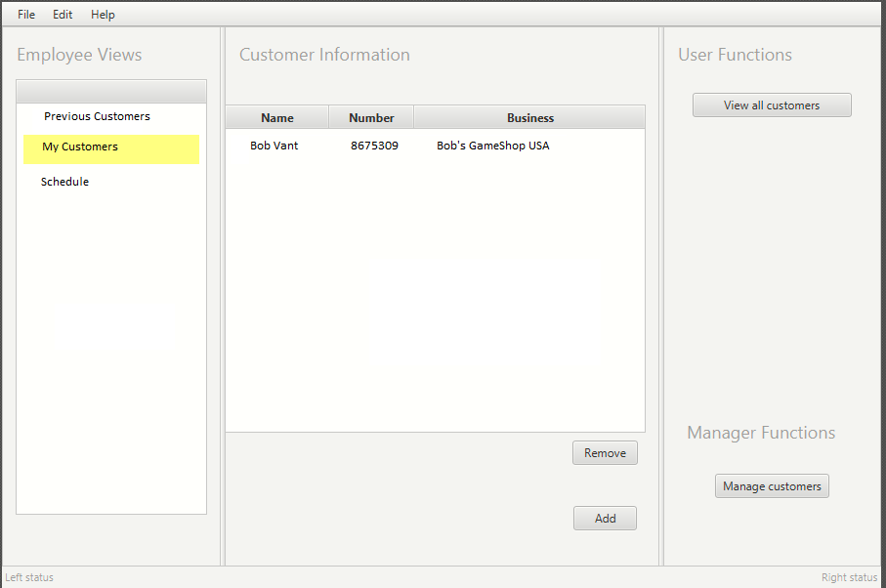

Figure : User’s customized views

If “Manage customers” is clicked, a new menu is opened (figure 2.) The user may add a new customer or edit information, but this specific user does not have the granted permissions necessary and thus a error screen is brought up (figure 3.)

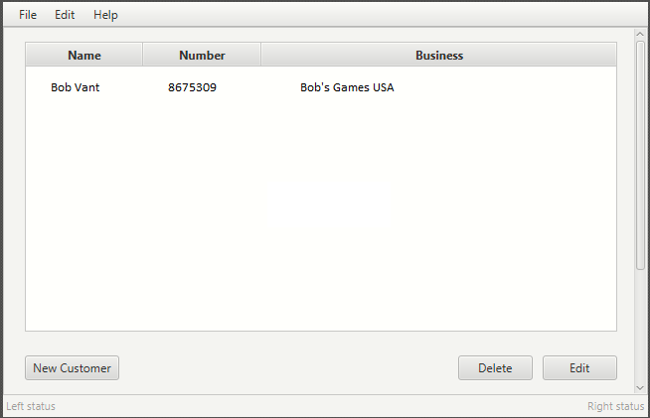

Figure 2: Manage customers menu

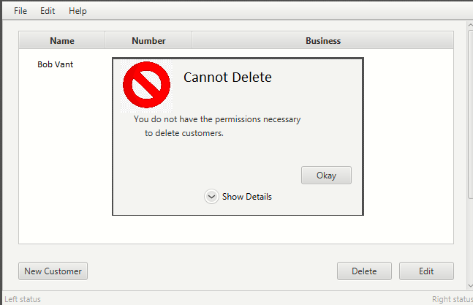

Figure 3: Permission denied

# Gui

The following is a user’s view once logging in and beginning to work on tickets. In the middle will be a list of scheduled meeting or important events that the user or admin may add to. Table 1 explains the functions of each arrow, and also from which database it would use.

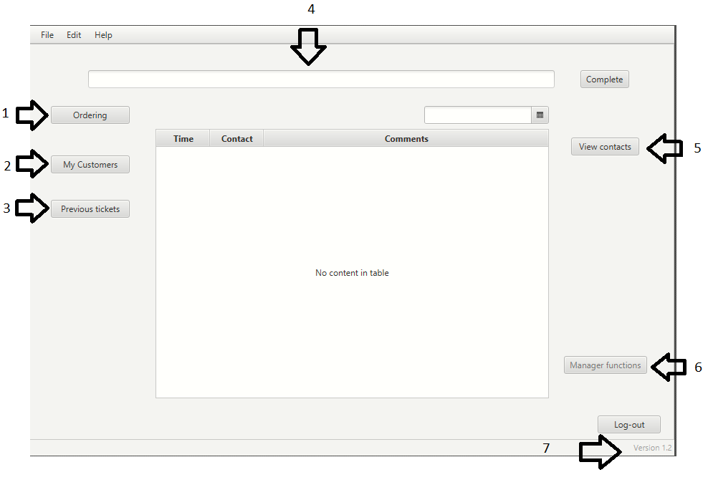

Figure 4: GUI Mock-up

|  |  |  |  |
| --- | --- | --- | --- |
| GUI Control Mapping | | | |
| Num | Control | Function | Database Used |
| 1 | Ordering | Make new orders, view old orders, or make a new quote. | Inventory, Pricing, Quotes, and Order |
| 2 | My Customers | List user’s assigned customers. | Customer |
| 3 | Previous tickets | View current user’s previous tickets. | User, Ticket |
| 4 | Ticket Number | User’s current ticket being worked on, followed by a complete button that will bring up another window for final input on ticket. | Ticket |
| 5 | View Contacts | View lists of customers, businesses, clients, or etc. | Contacts |
| 6 | Manager Functions | If privilege allowed (faded because this user does not have manager privileges,) allows user to view other user’s activity, reopen tickets, or other data management activities | User, Order, Customer, (any database used for auditing or to be edited) |
| 7 | Version | Current version. Version control will be available in the “Help” menu item. | N/A |

# Testing

The testing phase will take place to ensure that all requirements are met. Below describes a process of tests, what requirement they are testing for, and what is needed to pass testing.

# Functional Tests

These are some tests that will be used to guarantee that the functions are working and satisfy of said requirements.

# information and privileges test

|  |
| --- |
| Requirements for storing information and checking for appropriate privileges will be tested. |
| Preconditions: A under-privileged user must be logged in. |
| Steps:   1. User will create a new customer. 2. User then will view all customer records, and search for the new customer record. 3. The user will then attempt to delete this new customer. |
| Expected results: The database should be updated with the new customer information, and the software will receive a permission denied statement from the server. |
| Pass: The new customer record is still stored in the database even after attempting to delete the record. The user should be able to view the new customer record, and receive an error message explaining that they have insufficient privileges.  Fail: The database does not save the new customer record, the new customer does not appear in view of all customers, or the customer is successfully deleted. |

# user customization test

|  |
| --- |
| The requirement of deleting user views without deleting data from the database will be tested. |
| Preconditions: The database must be set up and connected to, and the user must be logged in. |
| Steps:   1. From the user’s customized customer list screen, add a new customer to the view. 2. The customer should still be visible from this view after logging out and then logging back in. 3. The user will delete the customer from the view. 4. From the view all customers window, search for the customer removed. |
| Expected results: The customer should be removed from the user view, but still visible in the customer database. No information should be different. |
| Pass: The customer is added to the view, removed from the view, and the customer should still reside in the database.  Fail: The view does not function, adding the customer edits the record in any way, removing the customer does not remove it from the view, or the customer record is deleted. |

# User history test

|  |
| --- |
| The user auditing requirement will be tested. |
| Preconditions: A user logs in, has added and edited both customers and orders, and then logs out. |
| Steps: The steps the tester must execute to test the feature.   1. From an admin account, log in and navigate to the User Report window. 2. Search for the user from the precondition. 3. Print a report for the user starting at least since the user logged in. |
| Expected results: There should be a generated report made about the user’s login activity, the customer and order records made and edited, and any other activity that is specified from the user history report. |
| Pass: The report successfully and accurately shows when the user logged in, logged out, and when customers and orders were created.  Fail: The report fails to print or has in inaccurate time of – Customer record activity, order record activity, log-ins, log-outs, or does not give the right user’s report. |

# Sources

Stephens, R. (2015). *Beginning software engineering*. Indianapolis: Wrox,   
ISBN-13: 978-1118969144