# The Web and Web Development

## Slide 1: Introduction

### Welcome to the World of Web Development!

* **Definition**: The Web is a system of internet servers that support specially formatted documents.
* **Web Development**: The process of creating websites and applications for the web. 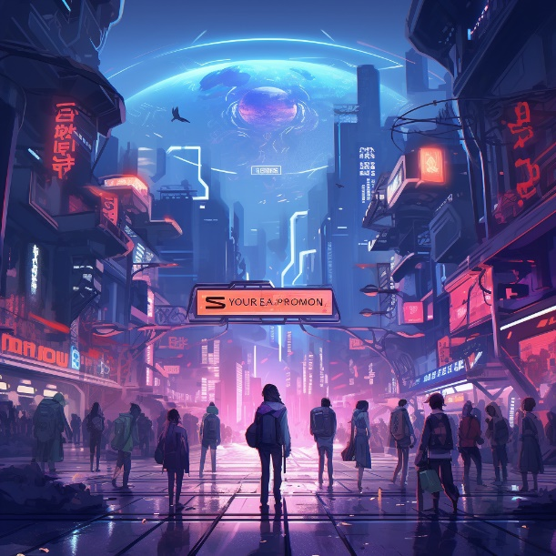 *Image Reference: Various images representing web development elements from Pixabay.*

## Slide 2: What is the Web?

### Exploring the Vast Digital Universe

* **Websites**: Collections of web pages that are accessed through the internet.
* **Web Browsers**: Tools (like Chrome, Firefox) to navigate the web.
* **URL**: The address used to access web pages. 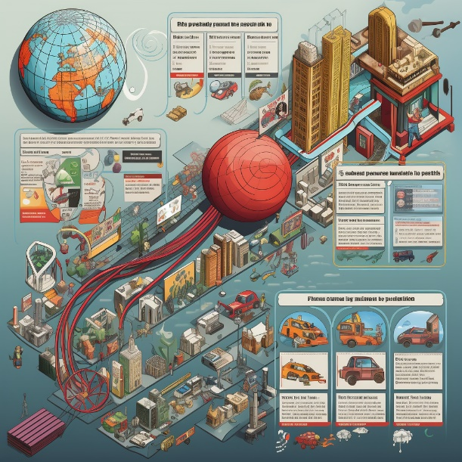 *Image Reference: Various images representing websites and web browsing from Pixabay.*

## Slide 3: How Does the Web Work?

### A Simplified View of Web Interactions

* **Servers**: Computers that store website files.
* **Browsers**: Request and display websites from servers.
* **HTTP/HTTPS**: Protocols that define how messages are formatted and transmitted on the web.  *Image Reference: Images illustrating web interactions, servers, and browsers from Pixabay.*

## Slide 4: Introduction to Web Development

### Crafting the Digital World

* **Front-end**: Deals with the visual aspects of the website.
* **Back-end**: Manages data and ensures everything runs smoothly.
* **Full Stack**: Combines both front-end and back-end development. *Image Reference: Various images illustrating web design and development from Pixabay.*

## Slide 5: Front-end Development

### Creating the Visual Web

* **HTML**: Structures the content.
* **CSS**: Styles the content.
* **JavaScript**: Adds interactivity. *Image Reference: Images representing HTML, CSS, and JavaScript from Pixabay.*

## Slide 6: Back-end Development

### Powering the Website Behind the Scenes

* **Server**: Manages data and user requests.
* **Database**: Stores and retrieves data.
* **Server-side Scripting**: Uses languages like PHP, Python, and Node.js. *Image Reference: Images illustrating servers and back-end development from Pixabay.*

## Slide 7: Web Development Tools

### Instruments that Aid Creation

* **Text Editor**: Where you write code (e.g., VSCode, Sublime Text).
* **Browser Developer Tools**: Helps in testing and debugging.
* **Version Control/Git**: Manages changes and collaboration in projects. *Image Reference: Various images representing web development tools from Pixabay.*

## Slide 8: Careers in Web Development

### Various Paths in the Web World

* **Web Developer**: Builds and maintains websites.
* **UI/UX Designer**: Ensures user-friendly design and experience.
* **SEO Specialist**: Optimizes websites for search engines. *Image Reference: Images representing various career paths in web development from Pixabay.*

## Slide 9: Getting Started with Web Development

### Embarking on the Web Journey

* **Learn the Basics**: HTML, CSS, and JavaScript.
* **Build Projects**: Apply your knowledge.
* **Join Communities**: Engage with other web developers. *Image Reference: Images representing learning coding and starting with web development from Pixabay.*

## Slide 10: Conclusion

### Wrapping Up Our Web Adventure

* **Recap**: Quick review of key points.
* **Encouragement**: Every expert was once a beginner.
* **Q&A**: Open floor to questions. *Image Reference: Various images representing website development from Pixabay.*

## Slide 11: Thank You!

### Gratitude and Acknowledgment

* **Appreciation**: Thank you for your attention and participation!
* **Contact**: [Your Email or Contact Information for Further Queries]
* **Next Steps**: Encourage exploration and learning in web development. *Image Reference: Images representing thank you notes from Pixabay.*