# The Web and Web Development

## Slide 1: Introduction

### Welcome to the World of Web Development!

* **Definition**: The Web is a system of internet servers that support specially formatted documents.
* **Web Development**: The process of creating websites and applications for the web. 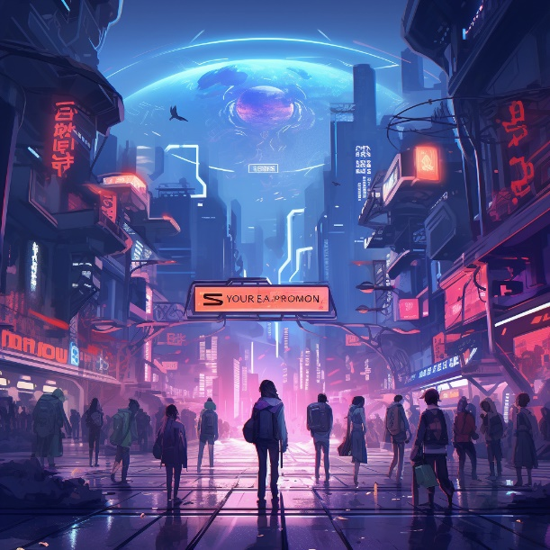 *Image Reference: Various images representing web development elements from Pixabay.*

## Slide 2: What is the Web?

### Exploring the Vast Digital Universe

* **Websites**: Collections of web pages that are accessed through the internet.
* **Web Browsers**: Tools (like Chrome, Firefox) to navigate the web.
* **URL**: The address used to access web pages. 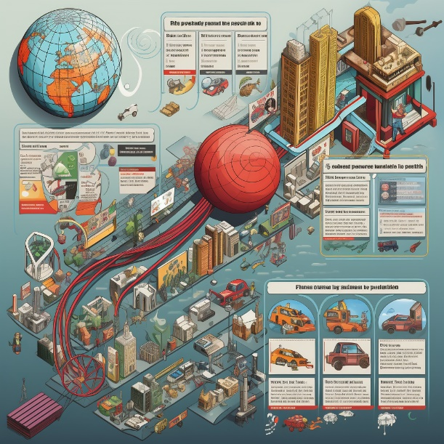 *Image Reference: Various images representing websites and web browsing from Pixabay.*

## Slide 3: How Does the Web Work?

### A Simplified View of Web Interactions

* **Servers**: Computers that store website files.
* **Browsers**: Request and display websites from servers.
* **HTTP/HTTPS**: Protocols that define how messages are formatted and transmitted on the web. 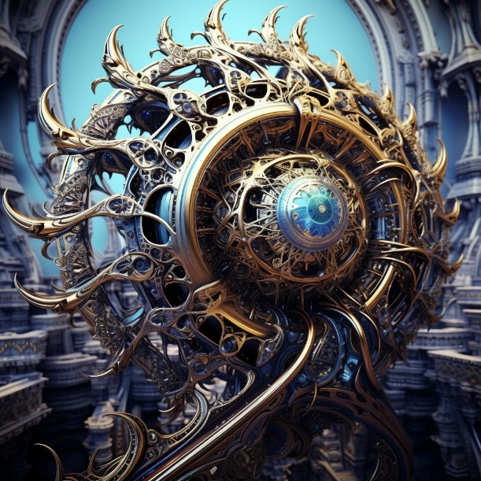 *Image Reference: Images illustrating web interactions, servers, and browsers from Pixabay.*