**Study of Low Temperature Conductivity**

Li Zhejun (lab partner: Mellor Robert L.)

January 31st to March 7th, 2023

This experiment investigates the behaviour of superconductors and semiconductors at low temperature. Liquid nitrogen is used to cool temperature down to lowest 80K, measure voltage and current at different temperature levels and make comparison with literature behaviour. The superconductor used is Bi-2223 and semiconductor is silicon in mode DT-670-SD. The results show a great fit to literature values.

1. **Introduction**

Past discoveries found that for some materials, their resistivity would reduce with the reduce of temperature, and at a certain point, the resistance would suddenly drop to zero, leaving no resistivity and magnetism inside. These materials are called superconductors. The currently most acceptable theory is called Bardeen-Cooper-Schrieffer theory (BCS theory). It explained superconductivity with the form of Cooper pairs by two electrons and many pairs form strong-connected electron beams. These beams can overcome the attraction of positive charges in the lattice, avoid the energy transfer to those positive charges in forms of particle vibration. Therefore, current would not be consumed, no voltage is required to support the circuit, and resistance becomes zero. High-Temperature superconductors (HTS) are those with a critical temperature above 77 K. HTSs are highly industrially promising because they can be cooled by liquid nitrogen, which is a cheap cooling agent. In 2008, HTS is first involved in the Long Island Power Authority’s grid network with working voltage at 138 kV at maximum current of 2400 A.

The relation between the resistivity and temperature highly depends on its components. The resistivity is calculated by:

where A is the crossing area, L is the length of the sample, R is the resistance and for materials with changing resistivity, R is derived by:

where V is the potential difference across the sample, and I is the current passing through.

Generally speaking, the resistance is ideally zero below the critical temperature. Within 5 K above the critical temperature, resistivity would experience a significantly increase and then turn to a smoother growth like common conductors. The growth mainly follows this equation:

Where is the resistivity, T is absolute temperature. However, in this experiment, the temperature range is not enough to show an exponential relation, so a linear expectation is accepted.

Apart from that, some materials tend to show up an increase in resistivity against temperature decrease, which are called semiconductors.

The relation between voltage V and temperature T for semiconductors are:

where is the charge of electron, is Boltzmann constant, is the band gap energy and is a function of current. To determine the relation of, the current is controlled so becomes a constant. Therefore, the relation can be rewrite as:

Where and . Hence

During the experiment, Hall effect might appear to be obvious when the resistivity minimize. The relation of hall effect is:

where is the Hall coefficient, and n is the charge carrier density. The Hall voltage is:

Where = the hall voltage, is current in x direction, is the magnetic field in z direction. The calculation of Hall voltage would not be used for result calculation but only for analysis of the data.

1. **Method**

The experiment requires a low temperature environment that is also stable and controllable. The apparatus used in this experiment is shown in Picture 1.

Optistat-DN2 is used as container to reach airless environment and low temperature. Mercuryitc is used to reach temperature balance. It is an instrument that combine a heater and a monitor. It can be remotely controlled by computer to automatically adjusting temperature and varying the power of the heater. The liquid nitrogen will flow in with a constant rate and the heater outputs suitable power to reach a balance. To achieve a smoother and more precise change, the power output is computed using the PID approach.

During the experiment, the temperature would drop to 80K, so it is important to keep dry around the sample. A centrifugal pump is used to extract air and fill the inside space with pure helium, in order to prevent the freeze of any water vapour which might damage the sample. Note the room for sample is separated from room for liquid nitrogen.

The superconductor used is Bi-2223 with molecular structure Bi2Sr2Ca2Cu3O(10+x), discovered in 1988. It appears superconductivity at T 108K. The diode sensor was made of silicon, mode DT-670-SD with a flat pure indium preform to enhance thermal contact.

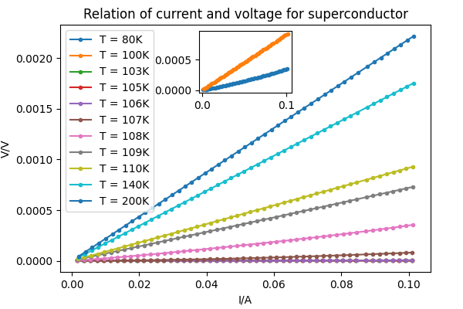

Figure 1: distribution of current and voltage at different temperature levels with T = 200 K at top.

The key factor that influences the experiment result would be the error on resistance, which would be strongly impacted by the error on measurements to voltage and current. A four terminal network is used in measurement. Two terminals are set on two ends of the sample to measure the current go through, and the other two terminals measure the potential drop across them. This method can eliminate contact resistance and other contact effects to an acceptable level and improve the reliability of data collected.

As temperature increase, traditional influence factor would take over, so hall effect becomes less dominative. As temperature decrease below critical temperature, the sample becomes superconductor and gain superdiamagnetism, and Hall effect would not generate voltage, leading to no energy cost by heat effect so no effective resistance measured.

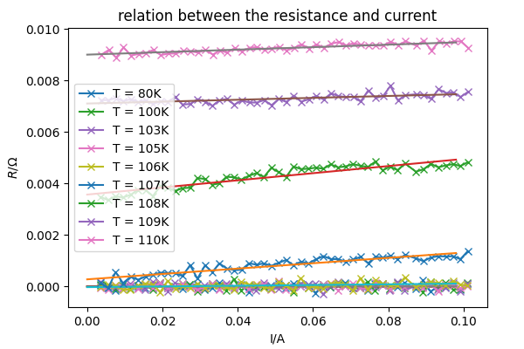

Figure2: resistance change against current increase with T = 109 K at top.

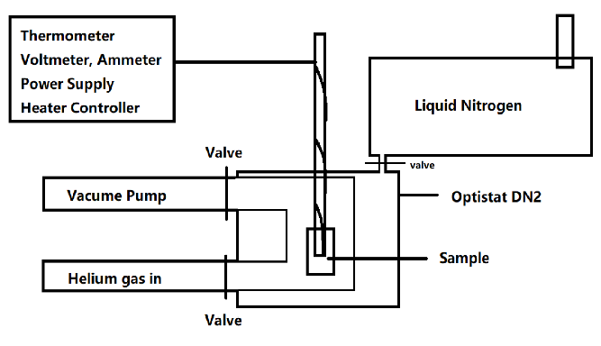

Picture 1: Experiment device diagram. Note all entries and valves are at the top of the device.

The pre-experiment is done to test the sensitivity by setting input voltage or current constant separately, varying the other tern to get sets of different voltage drop and current passing through at certain temperature. For superconductors, setting voltage constant and varying current gave better appearance on data precision. The other way was strongly influenced by an unexpected vibration on voltage. The current range set was 0-0.1 A with intervals of 0.002 A with a constant 5 V voltage input, which is the minimum current intervals of the power supplier. For semiconductors, changing voltage in range 0-5 V and maximizing current input to 0.1 A, gives a clear result.

1. **Results for Superconductor**

Figure 1 shows the distribution of voltage and current for superconductor at different temperature levels. A selected temperature choice is used to give a better appearance. Lines for temperature under 107 K are folded because their differences are too small to be shown in this scale. It behaves like a proportional relation, but according to the inserted plot, some of the relations tend to increase faster.

Figure 2 shows the relation between resistance and current when setting input voltage to 5.0V, increase current at different temperature level. This graph explains well for Figure 1 because the resistance on y-axis is just the gradient of V-I plot. The relation at all temperature levels appears to be straight line so we can use a least square fit line to represent this linear relation. The relation of the gradient against temperature is shown in Figure 3. There is an obvious peak at around critical temperature even the peaks have different intensities. The experiment 2 and 3 are highly accordance in region , showing that their resistances do not vary with increase of the current, while the resistance of the superconductor in experiment 1 still remains current sensitivity. This might be due to a failure in temperature control during the experiment because experiment 1is the first to be held and during the period, the temperature might still fluctuate in a small region, causing inaccuracy in the measurement of voltage and current. The behaviours below critical area is ideal because for superconductors, the resistance measured should stay at , resulting no fluctuation on slope.

After looking for plenty of resources, it is still unclear the cause of this effect. Some suggest that this might be the Hall effect which is the orthogonal potential generated when current passing through magnetic field. It explains the phenomenon that with the increase of current, the resistance increases as well. Hall effect would curve the electron beams by giving an orthogonal force. The beams will also generate opposite field to overcome this effect, which would lead to the lost in energy and the increase in effective resistance. As temperature increase, superconductors behave like common conductors more that other influential factors dominate. Below the critical temperature, the resistance is absolutely zero so that hall voltage produces no resistance.

Figure 4: static resistance changes along temperature for superconductor.

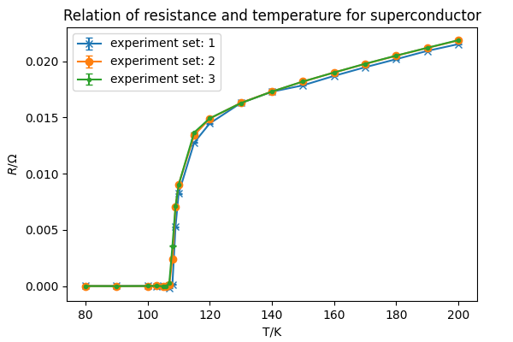

Figure 3: against temperature variation

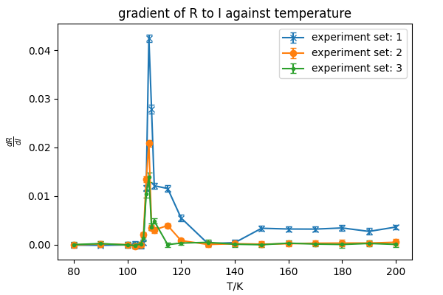

However, currently we have no methods to determine whether it is actually Hall effect or not. One reason is that Hall effect is strongly related to magnetic field. The magnitude of hall coefficient depends on the

To get rid of the influence of this effect, we need to find the static resistance at current = . we draw the least square fit line and determine the y-intercept at zero current. The result is shown in Figure 3. The resistance decreases with temperature in a linear relation and then drop significantly at around above critical temperature. The critical temperature can be derived by calculate the x-interception of Figure 3 and the result is . It is compared with literature value and sample message from manufacturer, and it accords with those data. The experiment finished at 200 K, and it already appears to be a linear relation. We calculate the gradient and the interception for part and calculate the expected resistance at . The gradient is and the resistance calculated it which fit literature value calculated at room temperature.

1. **Result for semiconductor**

Figure 5 shows the experiment data of potential difference and current measured for semiconductors. For all temperature, the current measured is zero initially and an increase in witness as voltage increase. An insert plot on the right-button side in figure 4 shows an exponential increase in a small region. The continuous growth appears to be linear but still contains parts as exponential which make least square fit not adaptable in this plot. With more analysis, we found that most data that appears in not-conducting area have current in magnitude of , so taking the point when current reach level to be the breakdown voltage. Relation of temperature and critical voltage is plotted at left-up corner, which express as great linear decrease. In reality, it supposed to be an exponential relation. The reason for this linear relation might be caused by the shortage of experiment devices which limit the maximum input power, in order to protect sample from destroyed. Therefore, the range of testing area is not wide enough to express an exponential relation. To determine the band gap energy of silicon, we choose current as the sampling points. In regards of the limit in minimum scale of power supply and uncertainty on temperature control, we select as acceptable range. For all the data in selected range, calculate least square fit line and the result is shown in Figure 6. The gradient is and the y-interception is . Taking these two results back to formular X and the energy gap calculated is . This value is higher than the literature value with so it is reasonable to consider another influential factor in the formular.

Figure 5: Current and voltage relation for semiconductor at different temperature level. Thanks for help from lab demonstrator, the gap of missing data at is due to an uncontrollable error in the power supply. Later analysis would ignore or try to avoid calculation across this area.

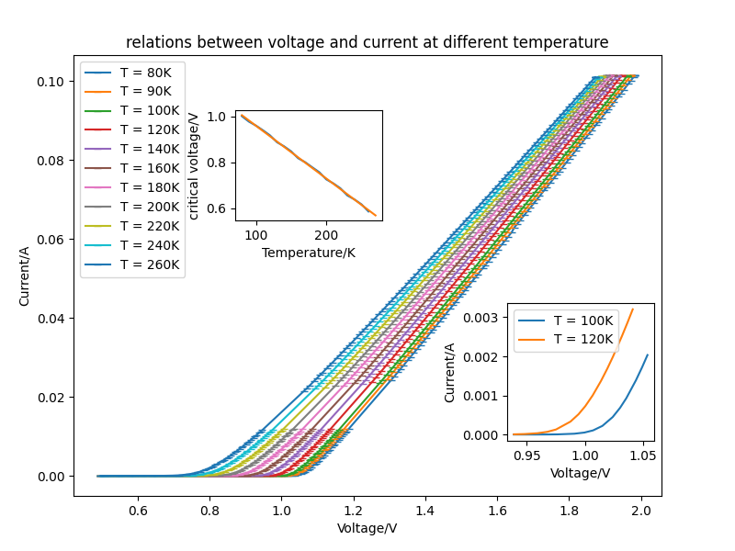

Figure 7: band gap energy variation with current.

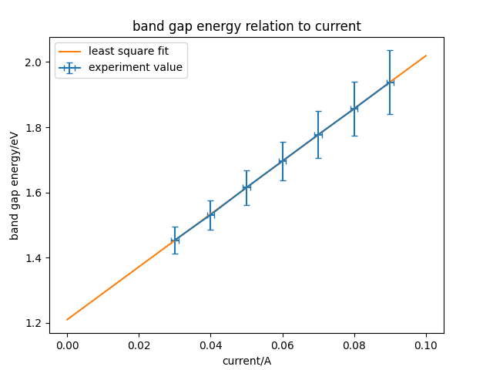

Figure 6: Relation between temperature and voltage at

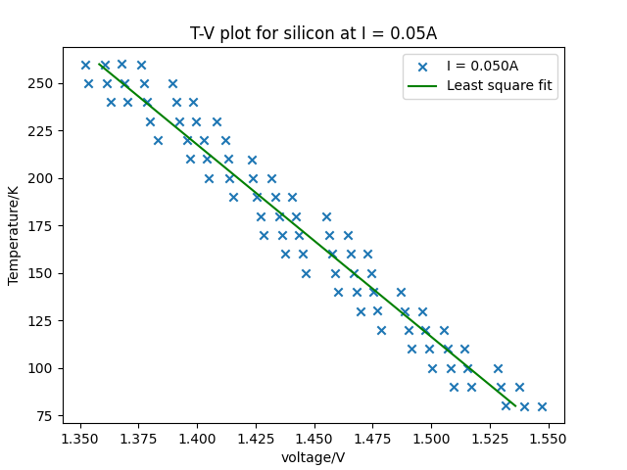

During the experiment, we found that the result of band gap calculated varies with the current passing through. This can provide evidence for a non-linear relation for T-V relation. We again investigate the relation between the band gap and the current and the result is shown in Figure 7. The result expresses a linear relation so we can find the gradient and interception to be (8.06±0.02) and (1.205±0.001). This result is in great agreement with literature results, and the temperature response curve fits with graph given by manufacturer in experiment temperature range.

1. **Conclusion**

The experiment gives expected results for both superconductor Bi-2223 and the silicon diode DT-670. Bi-2223 was found a critical temperature at around . Below the critical temperature, the resistance appears to be great zero. Above the critical temperature, the resistance increases significantly in a short period, then slow to a linear increase. The calculated room-temperature resistance fits the literature value list by manufacturer.

The semiconductor shows a suitable relation for voltage and current distribution. The energy gap is also calculated, even though the results depend on current used. All results and behaviours fit the data from manufacturer.

**Acknowledgement:**

The author wishes to acknowledge Professor Aidan Hindmarch for the generous help on code and data analysis suggestion.

**Reference:**

[1]Hofmann, P. (2022) *Solid state physics: An introduction.* Weinheim, Germany: Wiley-VCH.

[2] Department of Physics of Warwick, *Temperature Dependence*. Available at: https://warwick.ac.uk/fac/sci/physics/current/postgraduate/regs/mpagswarwick/ex5/techniques/electronic/hall-effect/temperature/ (Accessed: March 20, 2023).

[3] Neamen, D.A. (2012) *Semiconductor physics and devices: Basic principles*. New York, N.Y: McGraw-Hill.

[4] Ju¨rgen W. Precker, Warcı´lio A. da Silva, (2002) *Experimental estimation of the band gap in silicon and germanium from the temperature–voltage curve of diode thermometers*

**Error Appendix:**

The experiment data was collected using computer automatically to minimize human error. Data is analysed using python built-in functions and NumPy, Matplotlib, SciPy as supporting tools.

The experiment is repeated for 3 times at each temperature levels, and each single set is provided with the same environment. During the superconductivity experiment, the temperature appeared to fluctuate around a range of 0.1K, which cause a fractional error for about 0.1% at 80K. The minimum readings for ampere meter and voltage meter are in levels of 10^-24 which is much smaller than temperature error. Therefore, the experiment results take the error of temperature for best precision.

Though the experiments are controlled with same condition, the evolution during the experiment would be different which we could not simply average the results with same voltage levels. Each set should be taken as isolated experiment set and analysed separately.

The critical temperature for Bi-2223 is calculated by doing least-squaring fit to points at 107, 108 and 109K, where the gradient of the resistance against temperature can be seen as linear relation. The error for critical temperature is given by:

where represent their corresponding error and temperature at temperature n. This error has limited reliability because the actual relation for temperature and resistance is exponential.

The error of resistance of the superconductor at room temperature is calculated by:

where , are resistance calculated using data in each experiment set and are there corresponding error. Each set of are calculated by:

where are values calculated using least-squaring fit line and , are their errors, is absolute room temperature.

For semiconductor, the method used to choose current is not that prefect. The standard of choosing sample lack of strong evidence, and simply average the data could be improve to weight average:

where is the current measurement in the selected range, is the difference between and expected current.

The calculation for energy gap actually gives a large range for error, but all midpoints line up in a great agreement. It is reasonable to expect the final results would have better accuracy and reliability.

**Summary for a general audience**

Some materials have a changing resistance according to the change of temperature. The phenomenon of conductors getting zero resistivity at certain temperature is called superconductivity. This experiment is about the properties for superconductor Bi-2223 and semiconductor silicon diode under different temperature and power input. Research found that the Bi-2223 material has a critical temperature for 107.2±0.2K and the silicon diode have an increase of resistance with the decrease of temperature. These results have a great agreement with literature values. The discovery would be beneficial for industry and research, especially in energy transportation and computer chips design areas.