HISTORY OF THE UNIVERSITY OF WISCONSIN EXTENSION

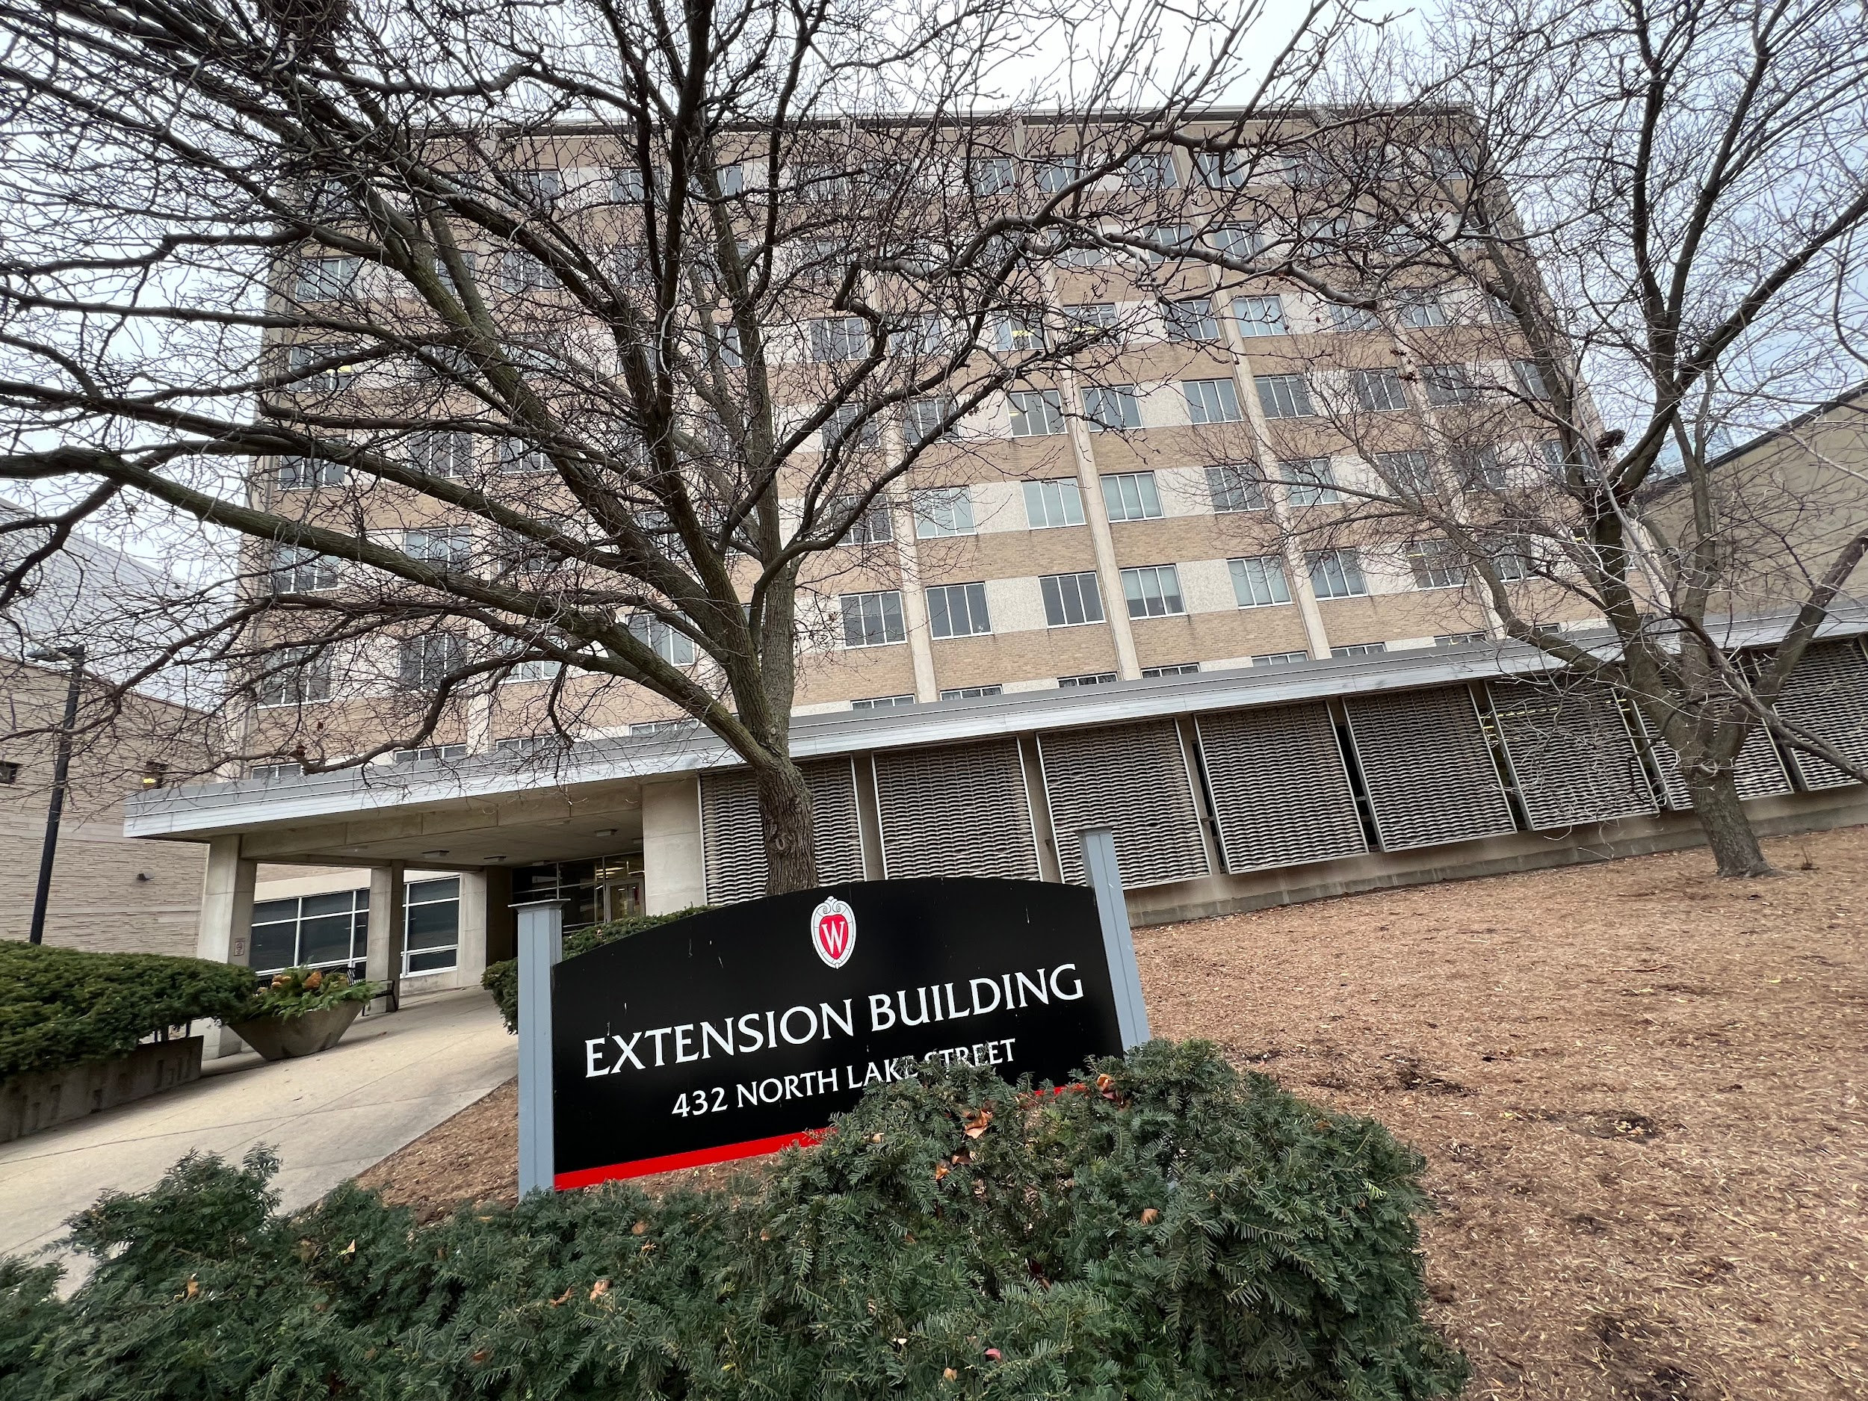

In 1981, fourteen years prior to Charles Van Hise founding the Wisconsin Idea, the University of Wisconsin – Madison began its pursuit to effectuate real change in the lives of Wisconsinites by creating the University Extension program. Wisconsin, a primarily agricultural state, utilized the extension to teach farmers in rural areas across the state “about farm management, crops, and livestock.” The 1914 Smith-Lever Act of the United States Congress would grow the Extension by increased funds for programs that partnered between counties, colleges, and the U.S. Department of Agriculture. Innovation in farming technology would be taught within the Extension, and in 1954, the first “Farm Progress Day” (now known as Farm Technology Days) was held in Waupaca County. The variety of subjects covered by the extension would grow, with course offerings in the mid-twentieth century increasing to include topics like food and nutrition, as well as gardening courses.[5] While the work of the UW-Extension still primarily focuses on farming communities, it is an exemplar of the Wisconsin Idea by spreading the wealth of knowledge within the University to all corners of the state.

[5] University of Wisconsin – Madison, Division of Extension. 2023. *Extension’s Impactful History.* https://extension.wisc.edu/about-us/history/#:~:text=1891%3A%20UW%2DMadison%20begins%20University,a%20division%20of%20UW%2DMadison.