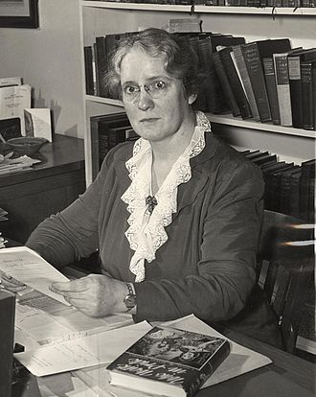

Helen Constance White was born in New Haven Connecticut in 1896. She became a PhD student and instructor at UW Madison in 1919. On Saturday mornings during this period, she would tutor anyone who decided to visit her office. She was the first woman to advance to the rank of professor in the college of letters and science and later the first woman to chair the English department. While being a well liked colleague and professor, she also managed to be a distinguished author, her academic scholarship is considered classic and her novel *A Watch for the Night* was named runner up for Pulitzer prize in 1934, though is unfortunately no longer in print. White spent her entire life a devout catholic (I tried to find out if she had specifically renounced eugenics, but I couldn't find any evidence that she ever really spoke on the subject), her almost entirely purple wardrobe, however, was not an expression of this (several sources say that it made it easier for her to pack for travel, but I really have no idea why that might be the case), but did lead her to be dubbed "the purple goddess" by some of her graduate students.

I could not find anything directly connecting White to the Wisconsin Idea, but she seems to be a perfect example of someone who has taken to heart its values. We don't have much knowledge about her actual teaching, but I her devotion as a graduate student to spreading education to anyone willing to seek her out as well as her standing among the students that she taught is probably an indication of this. Mark Ingraham also characterized her as someone with a "breadth of knowledge," a speaker "with a superb voice, which she used with skill," and someone who "Doubtless knew how distinguished she was. This did not cause resentment, for she treated her colleagues as if they were equally so–a compliment much more pleasing than humility would have been.” Though she herself said the correspondence desk in her apartment (she had three other desks for varying purposes) is "hopelessly littered and I can never find anything in it," she answered all of her mail. She was known as someone who would always help with personal and professional problems if she was able. Her deep caring and for education and the people around her is clear in all of the work that she did and the recollections of those who knew her. Though she may not have been thinking of herself that way, I think that her service to those people and knowledge makes her a good representation of the Wisconsin Idea.

Sources:

<https://www.library.wisc.edu/college/about-college/about-helen-c-white/#footnote>

<https://www.uwalumni.com/news/helen-c-white/>

[Links to an external site.](https://www.uwalumni.com/news/helen-c-white/)

<https://womeninwisconsin.org/profile/helen-c-white/>

[Links to an external site.](https://womeninwisconsin.org/profile/helen-c-white/)