Robert “Fighting Bob” La Follette

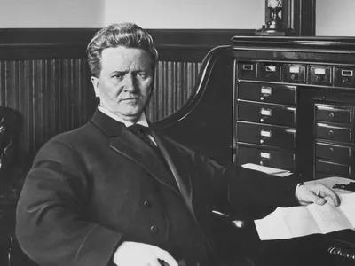

Born June 14, 1885 in Primrose, Wisconsin, Robert La Follette would grow up on a small farm and later become one of Wisconsin’s most important figures as a lawyer and politician. Attending school from a young age, La Folette would later attend the University of Wisconsin where he was greatly influenced by the ideas of John Bascom. Soon after graduating, he would be elected to district attorney in Dane county in 1880. By 1884, La Follette would be elected to the Wisconsin House of Representatives as a Republican. After losing office in 1890 and working as a lawyer, he organized a group of progressive Republicans to help him later become Governor of Wisconsin in 1900. Winning two more re-elections, La Follette was nominated to the US senate in 1906 by the Wisconsin legislature. Serving nearly two decades in the US senate, La Follette became a figure for progressive policies, often compromising with both parties and pushing for proper regulations and reform. In 1924, he would run for president as a progressive having one of the most successful third-party canidacies in US history, receiving over 15% of the popular vote. La Follette would pass nearly a year after on June 18th, 1925.

La Follette left behind a great legacy and is one of the greatest proponents of the Wisconsin Idea. He began as a direct product of the Wisconsin idea, being influenced by John Bascom during his attendance at the University of Wisconsin. He would dedicate his political career to calling out deceptive politicians and advocating for the benefit of the common man. He advocated for civil rights continuously and for the regulation of monopolies. Today, people call upon the spirit of “Fighting Bob” for politicians who truly advocated for the betterment of politics, education, workers rights, and American greatness.

<https://www.youtube.com/watch?v=GJcefWWlzH8> related speech