The office of Professional Learning and Community Education (PLACE) works to ensure that the knowledge fostered within the School of Education at the University of Wisconsin-Madison has a global impact. By cultivating meaningful relationships with individuals and communities who are committed to education, professional development, and lifelong learning, “PLACE represents the Wisconsin Idea in action.”

Mission: “*To further UW–Madison School of Education research and resources by creating communities of practice and facilitating innovative and engaging learning experiences that foster equity, creativity, and well-being”* [1]

PLACE offers a wide range of programs and services in the fields of education, art, and health. These offerings provide transformative learning experiences for diverse audiences, generating tangible impact not only within the Madison community but throughout and beyond the state. The team comprises professionals from various disciplines within the UW’s School of Education (SoE), including faculty from the departments of Art, Curriculum and Instruction, Dance, and Educational Leadership and Policy Analysis.

The office of PLACE was formerly branded Education Outreach and Partnerships (EOP), focusing almost exclusively on professional development programming for K-12 teachers. In 2018, Senior Associate Dean Julie Mead was tasked with conducting a strategic review to better align the office’s programming with SoE’s interdisciplinary nature. As the School encompasses departments beyond those directly centering education, Mead believed it essential to expand its scope into these broader disciplines. EOP did not fully capture the office's vision and capabilities, bringing about its reimagination as the Office of Professional Learning and Community Education.

PLACE's target audience encompasses education, arts, and health practitioners both within and beyond the state of Wisconsin. The office strongly embraces the voices and perspectives of future practitioners as well, including students at UW. Recognizing that learning is a lifelong journey, programming is designed for learners of all ages.

PLACE focuses programming under two broader umbrellas: Professional and Lifelong Learning[2] and the UW Community Arts Collaboratory.[3] Professional and Lifelong Learning provides professional development opportunities for K-12 teachers, administrators, and school leaders. Past programming has highlighted topics including college readiness, navigating politics in the classroom, student-centered coaching, and promoting equity in math and science education. The UW Community Arts Collaboratory is committed to youth empowerment and advocacy toward social change. The Collaboratory’s vision is to inspire Wisconsin youth to view themselves as both learners and vehicles for change through art-making. Additionally, PLACE extends program design and event planning services to community members and partner organizations.

Lisa Barker, the current Executive Director of PLACE, views the connection between the office and the Wisconsin Idea as “dismantling the ivory tower” with the ultimate goal of creating meaningful learning experiences. To uphold these aims, the office steers away from recruiting individuals with specialized content expertise (e.g. math education specialists), but instead, favors candidates who are adaptable, interdisciplinary, and eager to learn along the way.

PLACE adopts a collaborative and asset based approach in translating UW faculty’s research into accessible forms of learning and engagement. For instance, Barker points to Educational Policy Studies professor Simone Schweber's initiative to develop a program for K-12 educators on teaching about the Holocaust. In developing this program, PLACE took the lead on instructional design and event planning to effectively deliver her research and ideas to educators. She also highlights the work of Curriculum and Instruction professor Erica Halverson whose research explores student identity development through the arts. PLACE houses her theatre and creative writing program, Whoopensocker, which serves student populations across the Madison Metropolitan School District that face greater barriers to artistic access (including students of color, English language learners, and those belonging to lower-income families).

Ultimately, universities are structured to maintain students’ pre-college communities. The housing options, academic programs, clubs, jobs, and other aspects of the higher education experience work to immerse students within the same networks they occupied prior to entering their institution. However, student participation in outreach programs and learning through outlets such as PLACE––venturing off-campus and engaging with communities that were once “invisible”––effectively disrupts this cycle.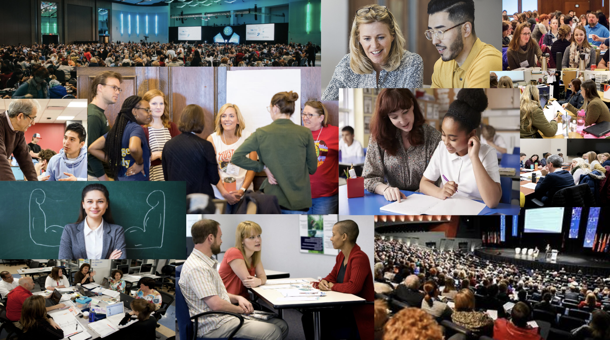

1. “Our Mission,” https://place.education.wisc.edu/about/
2. https://place.education.wisc.edu/k12-programs/
3. https://place.education.wisc.edu/youthprograms/uw-community-arts-collaboratory/