Peter Andrews

Professor Brighouse

PS259

Warfarin and The Wisconsin Idea

Wisconsin Farmers encountered a serious problem: When their dairy cows ate spoiled sweet clover, they would die. They brought this problem to University of Wisconsin Professor Karl Paul Link (Photographed on the right). Professor Link studied the chemical makeup of the spoiled sweet clover, and from that was able to isolate and synthesize the compound Dicumerol. This important discovery resulted in a powerful blood thinner that makes blood resist coagulation. Warfarin's mechanism of action lies in its ability to interfere with the synthesis of vitamin K-dependent clotting factors in the liver. By inhibiting the activation of these clotting factors, Warfarin reduces the risk of blood clot formation, making it an invaluable tool in preventing conditions such as deep vein thrombosis, pulmonary embolism, and stroke. There are currently over one hundred variants of Dicumerol in use today. One of which is the drug Warfarin. “Warfarin was named for the Wisconsin Alumni Research Foundation. Link gave the patent to the foundation, which has made tens of millions of dollars from it and used the money to fund more research.” (what is the Wisconsin idea? Professor Basam Z. Shakhashiri, director of the Wisconsin initiative for science literacy,Scifun.org). As a result of the Wisconsin Idea, millions of people are alive today. In recent years, newer anticoagulants, such as direct oral anticoagulants (DOACs), have been developed to address some of the limitations associated with Warfarin. Despite these advancements, Warfarin remains a widely prescribed and cost-effective option, particularly for patients with specific medical conditions and those requiring long-term anticoagulation. In addition, this guiding principle along with the subsequent drug discoveries, have enabled the Wisconsin Dairy industry to be a worldwide leader in animal health and food production. 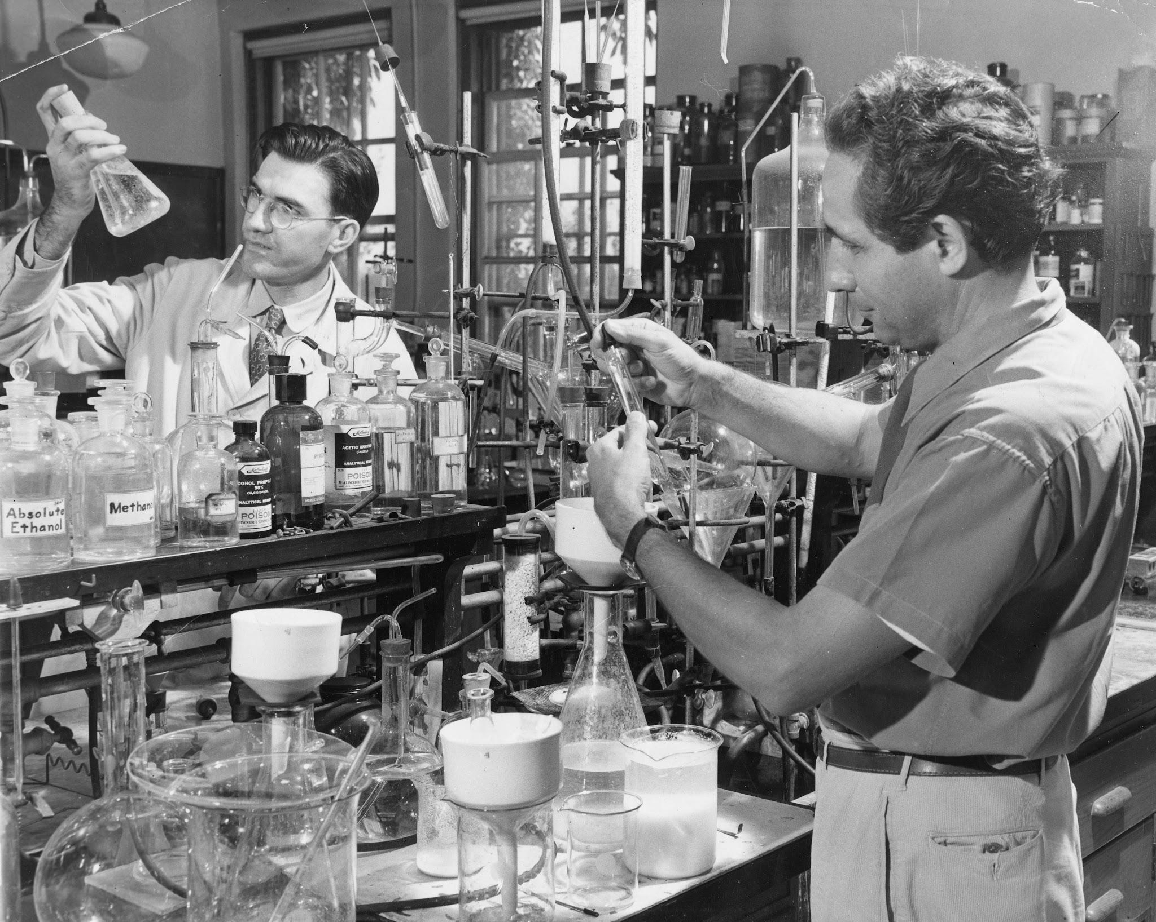

From this noble philosophy that the college should serve the State as well as its students, endless benefits and opportunities continue to this day. In the example above, both the animal and human population continue to benefit. Jobs continue to be created, lives saved, farmers continue to thrive and the school is enriched in ways never anticipated. The exponential number of opportunities continue to grow to this day. The Wisconsin idea serves as the basis for public/private partnerships that evolve from academia applied to enrich the surrounding community. Once again, the University of Wisconsin leads in the evolution of the mantra that doing good for the community yields endless benefits.

A further iteration of the Wisconsin Idea exists in the tech transfer area. In order to understand the evolution of public/private collaborations, it’s important to trace the genealogy of the Wisconsin Alumni Research Foundation (WARF). In 1925, Wisconsin Biochemistry professor Harry Steenbock, who embodied the Wisconsin Idea, developed a process to add vitamin D to milk using ultraviolet radiation. “He didn’t do this for personal gain. Instead, Steenbock (Photographed on the right) rejected offers to commercialize his invention and looked for a way to protect the discoveries made by himself and his UW colleagues. He wanted to ensure they were used for the public good. (Grow.cals.wisc.edu: tech transfer then,now,and tomorrow).” This prompted the board of regents to approve the WARF to encourage research to benefit society. Fast forward to today, where competition to retain academic talent is fierce. A professor is often faced with the dilemma of inventing a technology outside of academia, so that they may enjoy the financial rewards of their talents. Tech transfer evolved from the first steps of WARF in order to encourage academic research in a joint manner with the inventor, so that they didn’t need to leave the university in order to have ownership in the intellectual property.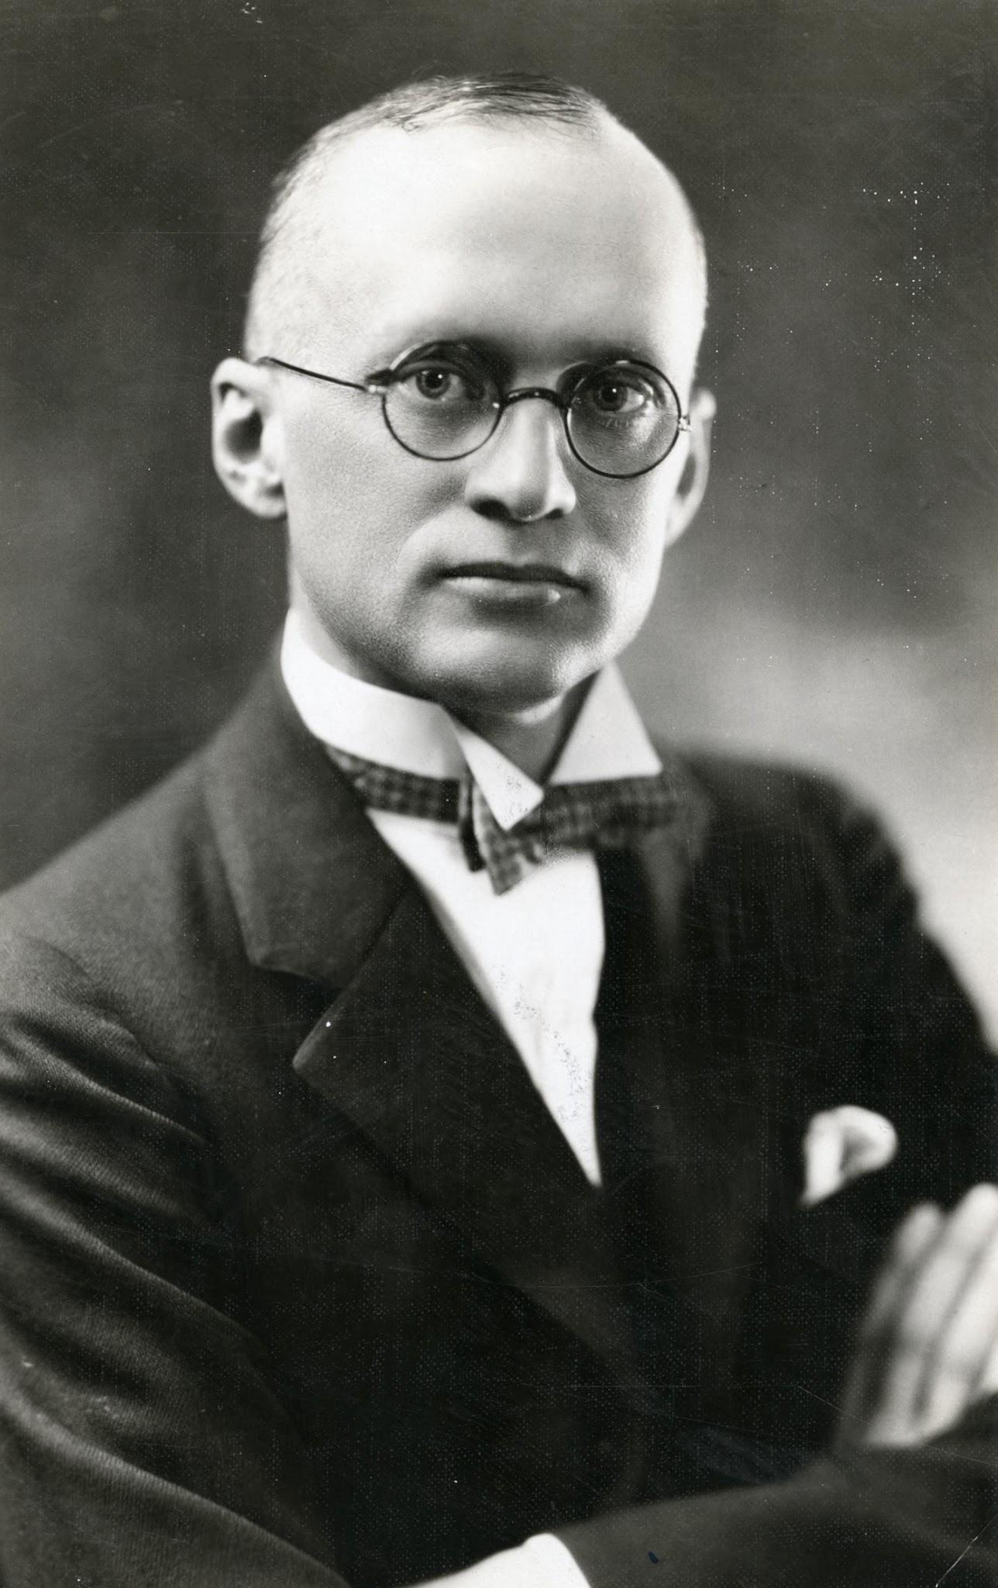

The initial intentions of John Bascom that The Wisconsin Idea to serve only the State of Wisconsin didn’t survive, fortunately. The depth and significance of the breakthroughs were used worldwide, far outside of the original intent. In the example above regarding the development of Warfarin, it is unthinkable to limit the access of this life saving drug to those in the state of Wisconsin. The invention of Warfarin represents a pivotal moment in medical history, marking a transition from observing nature's effects on animals to harnessing those effects for human health. When considering the numerous advancements that were made possible by the philosophy of the Wisconsin Idea, the world would have been at a disadvantage having excluded those in need from help. It simply runs counter to the intent and spirit of the Idea: To share life saving breakthroughs with those outside of the confines of academia. Given the enormity of lives saved, farming advances and the easing of suffering, I think that Van Hise and Bascom would be proud to see that the advancements benefitted the entire world and not just the state of Wisconsin.