Notes on modeling Synergy

# Drugs and Effects: Terminology

When a drug is administered in a biological system, we expect a measured output or effect which depends on the drug’s dosage[1]. Usually, when we test drugs on cell lines, the measured output is the viability (response) of the cells, i.e. the percentage of the cells that survived. Generally, the following definitions can be used interchangeably:

1. %Affected $f_{a}$, drug effect $E$, %death or %inhibition. Note that this definition closely relates to *the drug effectiveness itself* – how much effective was the drug?
2. %Unaffected $f_{u}$, viability, cell growth, survival, global output $gl$ (used in the DrugLogics pipeline). Note that this definition relates to the *output on the system that the drug is used*: e.g. how much were the cells affected by the drug?

Note that the two definitions are complementary: $f_{a}+f_{u}=1⇒E+gl=1$.

# Dose-response curves (single drug)

Drugs are administered in specific doses, so the drug’s effect is measured per each dosage. After the experiments are done, you end up with measurements for each drug in the form: $\left(x,y\right)$, where $x$ is the dosage and $y=E∈\left[E_{min},E_{max}\right]$ the measured effect/viability/response (depending on which definition you use). I can plot these points to get the *dose-response or dose-effect* curve. Usually we assume that these curves are *monotonous* (always increasing or decreasing) though that may not always be true. There exist mathematical formulas that describe them, the most prominent of which is the *4-parameter log-logistic (4PL) model* (Yadav et al. 2015):

|  |  |  |
| --- | --- | --- |
|  | $$E=\frac{E_{min}+E_{max}{\left(\frac{x}{m}\right)}^{λ}}{1+{\left(\frac{x}{m}\right)}^{λ}}$$ | (1) |

Note that $λ$ is the sigmoidicity of the curve and $m$ is the dosage of the drug that produces half the maximum effect (also seen as: ${EC}_{50},{IC}_{50}$). For $E_{min}=0$, this equation is called *Hill’s equation.* The most general form of this equation was proposed by (Chou and Talalay 1984) and it’s called the *median effect equation[2]*:

|  |  |  |
| --- | --- | --- |
|  |  | (2) |

Where $f_{a}+f_{u}=1$. The goal when plotting this function is to find a way to measure the $m,λ$ parameters. (Chou and Talalay 1984) proposed to re-write it as (generating the *medial effect plot*):

|  |  |  |
| --- | --- | --- |
|  | $$log\left(\frac{f_{a}}{1-f_{a}}\right)=λlogx-λlogm$$ | (3) |

Where we can easily compute the $m,λ$ parameters (one is the slope, the other can be found where the plot cuts the $x$-axis: $y=log\left(\frac{f_{a}}{1-f_{a}}\right)=0$). Using (1), and having: $E_{max}=1,E_{min}=0$ and as $x$ the $x/m$, we can see how the sigmoidicity $λ$ affects the shape of the plot:



Figure 1: Hill’s equation for different values of the slope parameter λ

Note that for $λ=1$ the shape is a hyperbole.

Also, using equation (2), we can compute any dose $x$ as:

|  |  |  |
| --- | --- | --- |
|  | $$x=m{\left(\frac{f_{a}}{f_{u}}\right)}^{1/λ}=m{\left(\frac{y-E_{min}}{E_{max}-y}\right)}^{1/λ}$$ | (4) |

# Drug Combinations and Dose-Response Matrices

When doing experiments (usually high-throughput screens) with drug combinations[3], specific dosages for each drug are tested and the combined effect is measured. The results are usually represented in a matrix form, where the $a_{i,j}$ element is the combined response, while the labeling/name of the $i$-row is the concentration of the first drug and the labeling of the $j$-column is the concentration of the second drug. From such a representation you can generate the surface response model and perform analyses using that 3D plot, which search for dose combinations that have larger combined effects (Chou and Talalay 1984). Another method plots the combination response vs the combined dosages of the two drugs (could be the sum of the doses for example), such that the description of the drug combination as synergistic or antagonistic is based on *visual comparison* between the single drug-response curves and the combined one, as is done in the CImbinator tool (Flobak et al. 2017).

Most methodologies use a (mathematical) model that describes a response/effect threshold, which distinguishes synergy from non-synergy (see “Null reference (non-interaction) models”). Thus, comparing each observed response with that threshold, we get a different synergy score value for each element of the dose-response matrix and then we can average these values (or use another method) to get a single value for the whole dose-response matrix – a *summary interaction score* that tells us if the combination was synergistic or not in the end. Examples of such methods are the ExcessHSA, beta (β), gamma (γ), summary delta score $\left(Δ\right)$, etc. (Mathews Griner et al. 2014), (Yadav et al. 2015). The models that describe how to define those thresholds (for each combination data point in the dose-response matrix for example) are discussed below.

# Null reference (non-interaction) models

Drugs produce effects. When used together (referred to as a drug combination) they can have greater or lesser effects (synergy or antagonism) than when used alone. To distinguish and categorize the combination effect we compare it to the effect that the drugs would have if they were used and *no interaction was seen between them* (also called the *additive* *effect*). The model that describes the non-interaction between two drugs is called the *null reference model* (Lederer, Dijkstra, and Heskes 2018). This is exactly like defining an effect *threshold*, for which if we observe a greater combination effect we would call the interaction a synergy (an antagonism otherwise). There are two kinds of null reference models: the ones that are *effect-based* and the ones that are *dose-effect* based. The distinction is on what is used to define the specific thresholds that characterize a synergy effect: just the effects of the combined drugs or also information on their dosages (dose-response curves)? The most common in each category are:

* Effect based
  + HSA (Highest Single Agent)[4]
  + Bliss Independence (Bliss)
  + Response additivity
* Dose-effect based
  + Loewe Additivity (Loewe)
  + ZIP Model
  + Explicit Mean Equation Model

## Effect-based Models

The HSA model describes a combination effect as synergistic if it is larger than the maximum effect of the two drugs. The response additivity model describes a combination effect as synergistic if it is larger than the sum of the effects of the two drugs. The Bliss model assumes that each drug acts via mechanisms independently of the other, contributing to a common measured output. Based on that logic, after the drug $A$ is used, the drug $B$ is acting on the residual unaffected part of drug $A$ and the combined expected effect is: $E_{Bliss}=E_{A}+E_{B}\left(1-E_{A}\right)$. The Bliss model fails to correctly characterize a sham zero-interaction combination where a drug is combined with itself (see Sham combination principle) and ignores the shape of the dose-effect curve.

In the next figure (Foucquier and Guedj 2015), 4 effect-based models are illustrated as well as the defined thresholds (dotted lines), above which synergy is assumed:

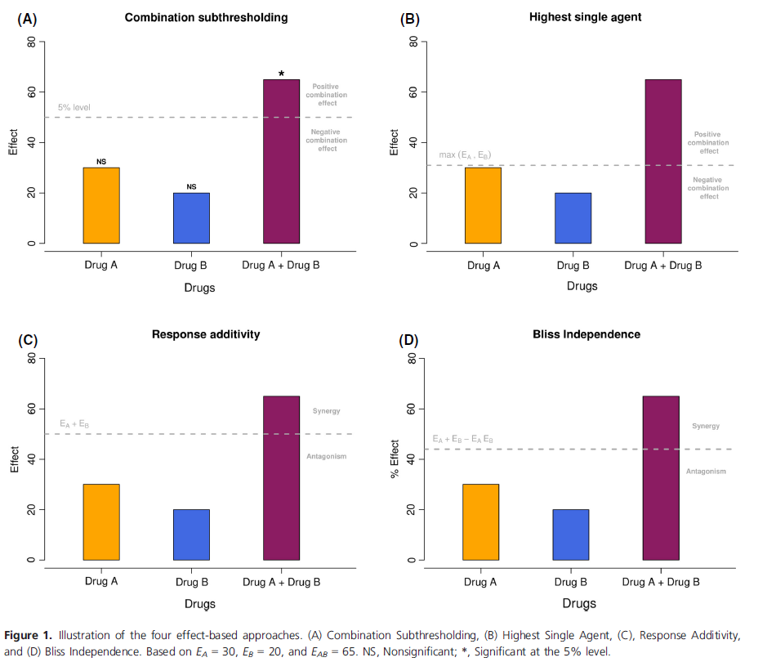

Figure 2: The 4 effect-based models

Note that $E_{A},E_{B}$ and $E_{A+B}$ define the observed effects of drugs $A,B$ and the observed effect of their respective combination. The thresholds for non-interaction in each model of interest are summarized below:

|  |  |  |
| --- | --- | --- |
|  | $$E_{T}=\left\{\begin{matrix}max\left(E_{A},E_{B}\right) & \text{HSA} \\ E_{A}+E_{B} & \text{Response Additivity} \\ E_{A}+E_{B}-E_{A}E_{B} & \text{Bliss Independence}\end{matrix}\right.$$ | (5) |

So, the golden rule is that if $E_{A+B}>E_{T}$, which means that we observe a greater combination effect than the threshold effect (as defined in the model we choose), we have a synergy. This relates to the definition of drug combination effect as the affected affect $f_{a}$. If we use the other complementary definition (viability/unaffected/global output) then synergy is defined as:

|  |  |  |
| --- | --- | --- |
|  | $$E_{A+B}>E_{T}⇒1-{gl}_{A+B}>E_{T}⇒{gl}_{A+B}<1-E_{T}$$ | (6) |

When the viability/global output definition is used, it is usually defined in the $\left[0,1\right]$ range: Zero is cell death, 1 is cell survival. So, considering that ${gl}_{T}=1-E_{T},$ we have a synergy when:

|  |  |  |
| --- | --- | --- |
|  | $${gl}_{A+B}<{gl}_{T}$$ | (7) |

Here, ${gl}_{A+B}$ is the observed global output/response from the drug combination. Note that the global output definition is used in the DrugLogics pipeline and so, the thresholds for each model used should be based on that definition. Using the relations: ${gl}_{A}=1-E_{A},$ ${gl}_{B}=1-E_{B}$, ${gl}_{T}=1-E_{T}$ and equation (5), we have that:

|  |  |  |
| --- | --- | --- |
|  | $${gl}_{T}=\left\{\begin{matrix}min\left({gl}_{A},{gl}_{B}\right) & \text{HSA} \\ {gl}_{A}+{gl}_{B}-1 & \text{Response Additivity} \\ {gl}_{A}{gl}_{B} & \text{Bliss Independence}\end{matrix}\right.$$ | (8) |

That’s why in the DrugLogics pipeline, using the HSA model, synergy is characterized when: ${gl}_{A+B}<min\left({gl}_{A},{gl}_{B}\right)$.

### Combination Index (CI)

This index (Chou and Talalay 1984) is used as a standard measure to identify a combination as a synergy, an antagonism or an additive effect (non-interaction):

|  |  |  |
| --- | --- | --- |
|  | $$CI=\left\{\begin{matrix}<1 & \text{synergy} \\ 1 & \text{additivism} \\ >1 & \text{antagonism}\end{matrix}\right.$$ | (9) |

For the effect-based models the $CI$ is defined as:

|  |  |  |
| --- | --- | --- |
|  | $$CI=\frac{E_{T}}{E_{A+B}}$$ | (10) |

The denominator is the observed combined effect, while the numerator is the effect threshold defined differently for each model in equation (5).

## Dose-Effect based Models

### Loewe Additivity

In the Loewe model, the *threshold effect* that is used to characterize the combination as synergistic, additive or antagonistic is now *implicitly* defined through the use of the dosages of the two drugs in the combination tested. The idea is to use the dosage of each drug *alone* that can produce the same effect as the combination. Generally, for a combination of drugs $\left(x_{1},x_{2}\right)$, where $x_{i}$ is the concentration of drug $i$, and which together produce a combined effect $E_{1+2}=e$, there should exist dosages for each drug alone that elicit that same effect $e$: we will call them $x_{e,1}$ and $x_{e,2}$ respectively (else Loewe analysis can’t be used – see Figure 3B). Loewe additivity states that the following formula should apply (the general isobole equation):

|  |  |  |
| --- | --- | --- |
|  | $$\frac{x_{1}}{x_{e,1}}+\frac{x_{2}}{x_{e,2}}=1$$ | (11) |

The effect threshold $e$ is now implicitly defined through the two dosages $x_{e,1}$ and $x_{e,2}$. If we use a Cartesian coordinate system where each axis represents the concentration of each drug, the equation (11) defines a straight line which connects the points $\left(0,x_{e,2}\right)$ and $\left(x_{e,1},0\right)$. This line is called the *isobole of additivity or linear isobole* – see figure A below from (Yadav et al. 2015)):

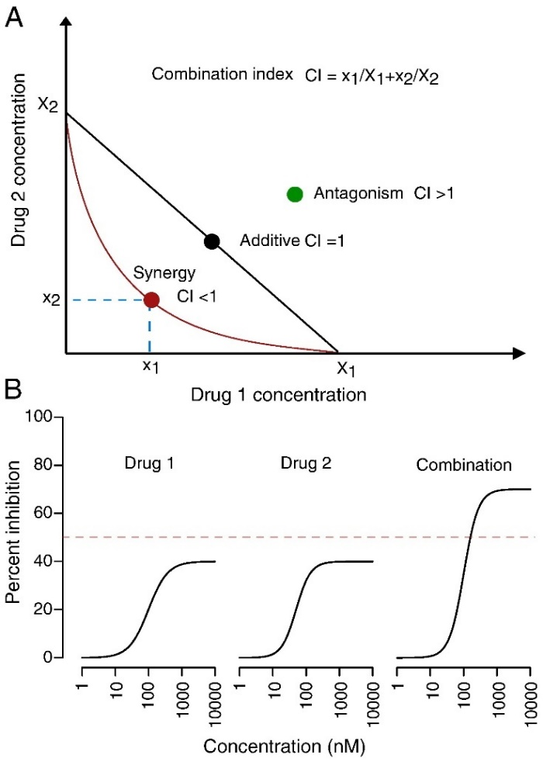

Figure 3: A) The Additive Isobologram B) The problem when there is no single drug dose which matches a combined effect

The mathematical way (Yadav et al. 2015) to define a synergy in this case (as was done in the effect-based models), would be to have a greater effect in the observed combination than what is defined as a threshold in your model: $E_{1+2}>E_{Loewe}$, where $E_{Loewe}$ is implicitly defined through $x_{Loewe,1}$ and $x_{Loewe,2}$ in equation (12), taken from equation (11) where the effect $e=Loewe$:

|  |  |  |
| --- | --- | --- |
|  | $$\frac{x_{1}}{x_{Loewe,1}}+\frac{x_{2}}{x_{Loewe,2}}=1$$ | (12) |

Considering that the dose-response curves are monotonous (always increasing since we define the effect here as the % affected $f_{a}$) and $x_{Loewe,1}$ corresponds to $E_{Loewe}$, then a larger single-drug dose ${x_{E_{1+2},1}>x}_{Loewe,1}$ is needed to produce the larger effect value $E_{1+2}>E_{Loewe}$. Same goes for the second drug: ${x_{E_{1+2},2}>x}_{Loewe,2}$. But this means that for the point $\left(x_{E_{1+2},1},x_{E_{1+2},2}\right)$ the following equation holds:

|  |  |  |
| --- | --- | --- |
|  | $$\frac{x_{1}}{x_{E_{1+2},1}}+\frac{x_{2}}{x_{E_{1+2},2}}<1$$ | (13) |

So, all the points $\left(x_{1},x_{2}\right)$ that satisfy equation (13), should be below the additive line defined for the observed combination effect $E_{1+2}$ (the same equation with an equality operator instead). The left part of the equation (13) is the Combination Index for the Loewe additivity model (defined below for any given effect $e$) which is in accordance with the categorization of synergy as defined in equation (9):

|  |  |  |
| --- | --- | --- |
|  | $$CI=\frac{x_{1}}{x_{e,1}}+\frac{x_{2}}{x_{e,2}}$$ | (14) |

Notes:

1. Loewe correctly characterizes a sham zero-interaction combination (where a drug is combined with itself) as additive (see Sham combination principle).
2. The Loewe model assumes a *constant potency ratio $R=\frac{x_{e,1}}{x_{e,2}},∀e$* effect. In practice, dose–effect curves with constant potency ratio have a constant ratio of doses at every level of effect and hence *are parallel on a log-dose scale*, while they also have equal individual drug maximum effects (Foucquier and Guedj 2015) – see Figure 4. This is mathematically proven in (Lederer, Dijkstra, and Heskes 2018) in their supplementary material S3, in which they showed that for the *dose equivalence* principle of Loewe additivity (see below) to hold, while the two drug’s dose-response curves follow the full 4-PM model (see equation (1)), the $E_{min},E_{max},λ$ should be the same for the two drugs’ curves (they have to be in the same effect/response range, have the same slope and only different half-maximum effects $m_{i}$). In that case, they showed that: $R=\frac{x_{m,1}}{x_{m,2}}$.

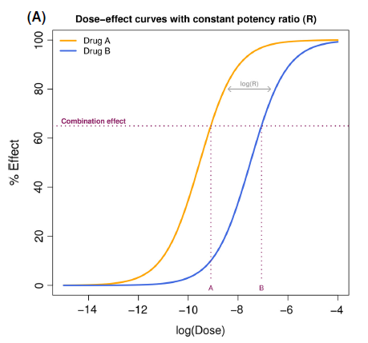

Figure 4: Dose-effect curves with constant potency ratio

In case that the maximum effects of the two drugs are unequal and/or the dose-effect curves are non-parallel (so the potency ratio is not constant across all effect levels which is caused by the fact that the shape parameters are different), then the resulted additive isobole is *curvilinear* (Grabovsky and Tallarida 2004). The calculation of the $CI$ and the subsequent isobologram analyses are more technical in these cases but feasible (as seen in the Tallarida paper).

1. The Loewe Additivity model is based on the notion of *dose equivalence*: consider the case of an effect $e$ that is produced by the combination doses $\left(x_{1},x_{2}\right)$. The Loewe model says that there exists a $x_{e,1}$ dosage of the drug 1 alone that can produce the same effect $e$. Surely, this is larger than the dose of drug 1 used in the combination (since there is also $x_{2}$ to consider): $x_{e,1}>x_{1}$. So, there is a concentration of drug 1 which if added to $x_{1}$ it should reach the concentration $x_{e,1}$: $x_{1}+x=x_{e,1}$. The equivalence principle says that this $x$ can *be substituted by an equivalent dose* of drug 2. In the case that the two drugs’ single dose-response curves follow the 4PM model (equation (1)) and given that we follow the dose equivalence principle, then we have that: $x=x_{2}\frac{x_{e,1}}{x_{e,2}}=x_{2}R$ (this is proven for more general dose-response functions in (Lederer, Dijkstra, and Heskes 2018)). Visually you can think of this principle as “moving” on the additive isobole, from point to point and exchanging equivalent doses between $x_{1}$ and $x_{2}$, while having the same effect. Thus, we get equation (15) which is equal to equation (11) that describes the general isobole equation:

|  |  |  |
| --- | --- | --- |
|  | $$x_{1}+x_{2}\frac{x_{e,1}}{x_{e,2}}=x_{e,1}$$ | (15) |

1. The Loewe model relies on *accurately estimated dose–effect curves* to support the calculation of the effective doses $x_{e,1}$ and $x_{e,2}$ for a given effect $e$ and thus the construction of the additive isobole (Foucquier and Guedj 2015).
2. Using the median effect equation forms (2) and (4) proposed by (Chou and Talalay 1984), we can substitute the doses $x_{e,1}$ and $x_{e,2}$ from equation (14) and get the Combination Index as (an extension to the Loewe additivity model):

|  |  |  |
| --- | --- | --- |
|  | $$CI=\frac{x_{1}}{m_{1}{\left(\frac{f_{a}}{f_{u}}\right)}^{1/{λ_{1}}}}+\frac{x_{2}}{m_{2}{\left(\frac{f_{a}}{f_{u}}\right)}^{1/{λ_{2}}}}$$ | (16) |

Where $m_{1},m_{2},λ_{1},λ_{2}$ are the half-maximum effect doses and slope parameters of the dose-effect curves of drugs 1 and 2 respectively and $f_{a}=e,f_{u}=1-e$.

This model has been further extended to the interaction index *α* (alpha)model (Greco, Bravo, and Parsons 1995):

|  |  |  |
| --- | --- | --- |
|  | $$1=\frac{x_{1}}{m_{1}{\left(\frac{f_{a}}{f_{u}}\right)}^{1/{λ_{1}}}}+\frac{x_{2}}{m_{2}{\left(\frac{f_{a}}{f_{u}}\right)}^{1/{λ_{2}}}}+α\frac{x_{1}x_{2}}{m_{1}m_{2}{\left(\frac{f_{a}}{f_{u}}\right)}^{\left(1/{2λ_{1}}+1/{{2λ}_{2}}\right)}}$$ | (17) |

In this case, for $α=0⇒CI=1$, thus corresponding to Loewe additivity. For $α>0$, the combination effect is defined as synergistic in this model.

1. Loewe is generally referred to as a phenomenological approach to define synergy rather than a mechanistic one (Lederer, Dijkstra, and Heskes 2018),(Fitzgerald et al. 2006).

#### Sham combination principle

When you test two drugs that are actually the same, then you never want to quantify the combination effect of a drug with itself as a synergy (or antagonism), but just as an additive (no-interaction) effect. This is a problem with some of the null reference methods like the Bliss model.

An external file that holds a picture, illustration, etc.
Object name is prp20003-e00149-f2.jpg

Figure 5: Example illustrating the failure of some null-reference models to account for the sham combination principle

In the figure above (Foucquier and Guedj 2015), if you use dose = 4 of drug $A$ you have an expected effect $y$ of 25%. Then, using the Bliss model, you get that any effect above the $y+y-y*y=43\%$ threshold effect is classified as a synergy. If you use twice the drug A (so a dose of 8) this will have an effect of 91%, which will be classified as a synergy (but as we said, we don’t want a drug that interacts with itself to be classified as synergistic). Note that the Loewe additivity model correctly classifies this as a non-interaction (additivism):

$$\frac{a}{A}+\frac{b}{B}=1, \text{where} a=b=4, A=B=2*4=8$$

### Zero-Interaction Potency (ZIP) Model

This new approach (Yadav et al. 2015) derives an interaction score for a specific measurement $\left(x_{1},x_{2}\right)$ by considering not only the effects of each drug (like HSA and Bliss models do) or the single drug dose-response curves (like Loewe does), but also the dose-response curves of their combinations. To clarify this, see the figure below taken from (Yadav et al. 2015):

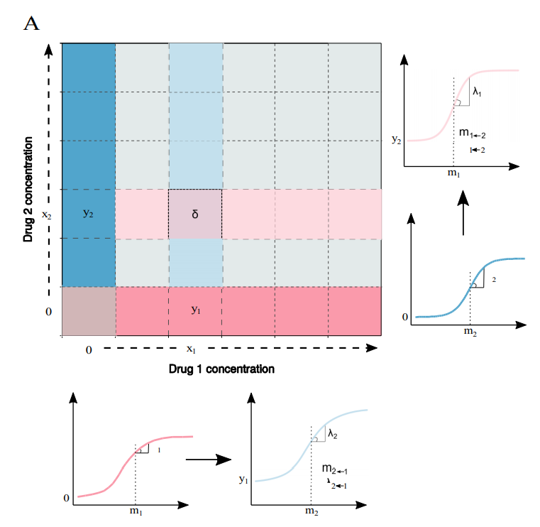

Figure 6: A dose response matrix, two single-drug dose-effect curves and two combined dose-effect curves describing the data on the row and column crossing at the δ-box according to the ZIP model.

The Figure 6 shows a dose-effect matrix where each element in the matrix has a measured/observed combined effect $e$ measured at the dosages $\left(x_{1},x_{2}\right)$. At concentration $x_{1}$ in the matrix above, the Drug 1 has effect $y_{1}$, while at concentration $x_{2}$, the Drug 2 has effect $y_{2}$. Note that the first column and last row represent the effects of each drug alone at all different doses tested (the other drug has zero concentration in each case). So, the first column corresponds to the dose-effect curve of Drug 2 alone (the one with the $\left(m_{2},λ_{2}\right)$ parameters) while the last row corresponds to the dose-effect curve of Drug 1 alone (the one with the $\left(m_{1},λ_{1}\right)$ parameters). The purpose here is to define an interaction score/metric for the specific $\left(x_{1},x_{2}\right)$ block (the one that has the $δ$ inside). Let’s say that the value (measured combined effect) in that specific little δ-box is $e$.

The HSA and Bliss models would just define an effect threshold based only on the values $y_{1}$ and $y_{2}$ ( $max\left(y_{1},y_{2}\right)$ and $y_{1}+y_{2}-y_{1}y_{2}$ respectively). If the combined effect $e$ is larger than the defined threshold, then you would have a synergy for that specific concentration (it’s another matter entirely how to derive a summary score for the whole matrix based on the individual boxes values). For the Loewe model, you would use the two single-drug dose-effect curves to calculate the half-maximum effect doses and slope parameters $m_{1},m_{2},λ_{1},λ_{2}$ (typically this is done by using a least-squares method to fit the data) and then either equation (16) to calculate the combination index $CI$ and decide if the concentration $\left(x_{1},x_{2}\right)$ was synergistic or not (Chou and Talalay’s Method) or compute the Loewe implicit effect threshold by using equation (11) with $x_{e,i}$ substituted from equation (4). This method is based on the assumption that the single-response curves are represented by Hill’s curves.

The ZIP model goes a little further by not only considering the two single-drug dose-effect curves (as Loewe method does) but *utilizing also the row and column values that pass through the $δ$-box*, in order to compute the parameters $m_{1→2},m_{2→1},λ_{1→2},λ_{2→1}$ ( $1→2$ means adding drug 1 after drug 2) from the other 2 curves shown in Figure 6 (again by using the least-squares method to fit the data). In this model, the row that passes through the $δ$*-box* for example, is assumed to describe a dose-effect relationship that is a lot similar to the curve of drug 1 (last row) while drug 2 at dose $x_{2}$ (with effect $y_{2}$) is added: the new curve has been raised by a value equal to $y_{2}$ while the curve parameters $m_{2→1},λ_{2→1}$ have slightly deviated from the $m_{1},λ_{1}$ ones.

So, if you attain all these parameters $θ=\left\{{{m_{1},m_{2},λ_{1},λ_{2},m}_{1→2},m}_{2→1},λ_{1→2},λ_{2→1}\right\}$, you can compute a $δ$ (delta) score to capture the “deviation” from the non-interaction (ZIP) model as:

|  |  |  |
| --- | --- | --- |
|  | $$δ\left(θ\right)=\frac{y_{c}^{1→2}-y_{ZIP}^{1→2}}{2}+\frac{y_{c}^{2→1}-y_{ZIP}^{2→1}}{2}$$ | (18) |

This tell us all we need to know for computational purposes (since formula (18) depends only on the $θ$ parameters – see the full equation (19) on (Yadav et al. 2015)), but how are the $y_{c}^{1→2},y_{ZIP}^{1→2},y_{c}^{2→1},y_{ZIP}^{2→1}$ defined and what’s the logic behind the ZIP model? $y_{ZIP}$ is the zero-interaction potency effect (the threshold for defining synergy – the *null reference model* as discussed previously) while the $y_{c}$ is the assumed observed combination effect as described in Yadav’s model and corresponds to the two combination curves in Figure 6. Thus, the $δ$-score is nothing more than a measure to quantify the deviation from the zero-interaction potency effect.

Consider for example that the drug 1 dose-effect curve is described by $y$ as in equation (19) and then we add drug 2 at dose $x_{2}$: the zero-interaction potency effect $y_{ZIP}$ should be such that the *potency* of the individual dose-effect curve of drug 1 will not change: that means that the parameters $m_{1},λ_{1}$ will not change and that the curve will just “raise” by $y_{2}$. So, if drug 1 follows the dose-effect formula as in equation (1) with $E_{max}=1,E_{min}=0$ (used here for simplification, the method can be applied to the more general equation):

|  |  |  |
| --- | --- | --- |
|  | $$y=\frac{{\left(\frac{x}{m_{1}}\right)}^{λ_{1}}}{1+{\left(\frac{x}{m_{1}}\right)}^{λ_{1}}}$$ | (19) |

By adding drug 2, we get:

|  |  |  |
| --- | --- | --- |
|  | $$y_{ZIP}^{2→1}=\frac{y_{2}+{\left(\frac{x}{m_{1}}\right)}^{λ_{1}}}{1+{\left(\frac{x}{m_{1}}\right)}^{λ_{1}}}$$ | (20) |

The authors (Yadav et al. 2015) showed that:

|  |  |  |
| --- | --- | --- |
|  | $$y_{ZIP}^{1→2}=\frac{y_{1}+{\left(\frac{x}{m_{2}}\right)}^{λ_{2}}}{1+{\left(\frac{x}{m_{2}}\right)}^{λ_{2}}}=y_{ZIP}^{2→1}$$ | (21) |

, which is expected since the combination effect with no interaction between the drugs should be independent of the order that they are administered. Next, the observed combination effect (adding drug 1 after drug 2 is used, the other case is similar) is defined as:

|  |  |  |
| --- | --- | --- |
|  | $$y_{c}^{1→2}=\frac{y_{1}+{\left(\frac{x}{m_{1→2}}\right)}^{λ_{1→2}}}{1+{\left(\frac{x}{m_{1→2}}\right)}^{λ_{1→2}}}$$ | (22) |

This is exactly what is shown as expected dose-effect curves in the 2 combination graphs of Figure 6 and discussed before equation (18) was introduced: in this case the combination effect is raised by the $y_{1}$ value and the slope parameters have deviated from the original single-drug dose-effect curve. This deviation between equations (21) and (22) is what the $δ$-score tries to capture – the shift of interaction potency for a non-interactive drug combination as described by $y_{ZIP}$.

Notes:

1. The ZIP model assumes that the dose-effect curves of the single drugs and their combinations - so all 4 curves in Figure 6, follow the 4-parameter log-logistic (4PL) model – see equation (1). Also, all analysis and formulas are based on the notion of drug effect as the % affected ($f_{a}$).
2. The ZIP model can only be used with a full dose-effect matrix (you need at least a 3x3 matrix – the larger the matrix the more reliable the delta estimates), because you need the data of the combination effects for all the doses to compute the $m_{1→2},m_{2→1},λ_{1→2},λ_{2→1}$ parameters (if you only have the diagonal data for example you cannot compute the $δ$-score). This means of course that the single-drug dose-effect data are essential.
3. The ZIP model correctly characterizes a sham zero-interaction combination (where a drug is combined with itself) as additive (see Sham combination principle).
4. A $δ$-score of $0,>0, \text{or}<0$ corresponds to the zero interaction, synergy and antagonism, respectively.
5. The ZIP model is like a combination of the Bliss and Loewe models, since the authors actually showed that ${y_{ZIP}=y}_{1}+y_{2}-y_{1}y_{2}$ (probabilistic independence) and you also use the data on the single dose-effect curves as Loewe model does.
6. It was shown in Yadav’s paper that the summary Delta $Δ$-score for the whole response matrix (calculated as the mean value of all the individual $δ$-scores), produced the best classification results (ROC analysis) among all the other methods used (based on HAS, Bliss and Loewe) when applied to a High-Throughput drug combination dataset (Mathews Griner et al. 2014). R code is also provided for the $Δ$-score calculations in their paper.

### Explicit Mean Equation Model

In the paper (Lederer, Dijkstra, and Heskes 2018), the authors mathematically formulate the general foundation of the Loewe additivity principle (the first to do so actually) and derive a new (explicit) null reference model based on that principle. Some useful notes:

* The authors distinguish between the *principles for additivity and the methods derived from them*. We have seen two “strong” principles – that of Bliss Independence (different mechanisms of action) and Loewe additivity (one compound can be substituted for the other – they act as if they are the same compound) – which give birth to two known null reference models, the Bliss Independence model and the general isobole equation (11).
* The null reference models are built upon the single dose-response relationships of the individual compounds. So, if $f\left(x_{1},x_{2}\right)$ is the response of the combination, then the *conditional* *responses* are defined as: $f_{1}\left(x_{1}\right)= f\left(x_{1},0\right)$ and $f_{2}\left(x_{2}\right)= f\left(0,x_{2}\right)$ (the condition here is that the other drug’s concentration is zero). In their analysis, the authors use Hill’s curves (the 4PM model – see equation (1)) but any other single dose-response model will do – the only condition being that it is monotonically decreasing or increasing and twice differentiable.
* They refer to the dose-response matrices as *records*.
* The *null reference model* is defined as one that gives the expected additive (non-interaction) response (or effect) $y=f\left(x_{1},x_{2}\right)$ for the combination of dosages $x_{1}$ and $x_{2}$. In the case of the Loewe model (also called the General Isobole Equation Model) the expected response $y=f_{GI}\left(x_{1},x_{2}\right)$ is calculated as the solution to the equation:

|  |  |  |
| --- | --- | --- |
|  | $$\frac{x_{1}}{f_{1}^{-1}\left(y\right)}+\frac{x_{2}}{f_{2}^{-1}\left(y\right)}=1$$ | (23) |

As previously said, the expected response in equation (23) is *implicitly* defined through the conditional responses $f_{1}\left(x_{1}\right)$ and $f_{2}\left(x_{2}\right)$: $f_{1}^{-1}\left(y\right)$ is the dose of drug 1 alone that produces the combined response $y$ and $f_{2}^{-1}\left(y\right)$ is the same for drug 2. So, the conditional responses are a prerequisite in this model.

#### LACC (Loewe Additivity Consistency Condition)

The authors mathematically formulate the Loewe additivity principle, which in simple words says that I can exchange doses between the two compounds, when they yield the same effect. So, if I have dose $x_{2}$ of the compound 2 which gives a (conditional) response $f_{2}\left(x_{2}\right)$, what is the equivalent dose of the drug 1 that yields the same response and how to define it? The authors use this symbolism:

|  |  |  |
| --- | --- | --- |
|  | $$x_{1}^{equiv}\left(x_{2}\right)=f_{1}^{-1}\left(f_{2}\left(x_{2}\right)\right)$$ | (24) |

But, the whole point here is that I can ask the same thing for the drug 2: which is the equivalent dose of drug 2 that gives the same response as dose $x_{1}$ of drug 1? Its:

|  |  |  |
| --- | --- | --- |
|  | $$x_{2}^{equiv}\left(x_{1}\right)=f_{2}^{-1}\left(f_{1}\left(x_{1}\right)\right)$$ | (25) |

And now I can define not one, but *two null reference explicit models*, based on which equivalent dose I add/exchange in my additive model: if for example I add to drug 1’s dose the equivalent dose of drug 1 that yields the same response as dose $x_{2}$ of drug 2, I get (see argument before equation (15):

|  |  |  |
| --- | --- | --- |
|  | $$y=f\left(x_{1},x_{2}\right)=f_{2→1}\left(x_{1},x_{2}\right)=f_{1}\left(x_{1}+x_{1}^{equiv}\left(x_{2}\right)\right)=f_{1}\left(x_{1}+f_{1}^{-1}\left(f_{2}\left(x_{2}\right)\right)\right)$$ | (26) |

Or the other way around:

|  |  |  |
| --- | --- | --- |
|  | $$y=f\left(x_{1},x_{2}\right)=f_{1→2}\left(x_{1},x_{2}\right)=f_{2}\left(x_{2}+x_{2}^{equiv}\left(x_{1}\right)\right)=f_{2}\left(x_{2}+f_{2}^{-1}\left(f_{1}\left(x_{1}\right)\right)\right)$$ | (27) |

The previous two null reference models describe the expected response $y$ through the functions $f_{1},f_{2}$ and their inversions. So, they are *explicit* in the sense that if I know the individual dose-response functions and they are invertible, I can easily compute the expected response $y$. This is the case if I use the Hill’s curves in my analysis for example.

Based on the previous formulation, the authors define the *Loewe additivity consistency condition* (LACC), which says that it shouldn’t matter if we exchange the dose of compound 1 with the equivalent dose of compound 2 or vice versa (what we called Loewe additivity principle up until now), as the equation:

|  |  |  |
| --- | --- | --- |
|  | $$f_{2→1}\left(x_{1},x_{2}\right)=f_{1→2}\left(x_{1},x_{2}\right)$$ | (28) |

Equation (28) mathematically expresses the Loewe Additivity principle.

#### Conditions for the LACC to Hold

Next, the authors (Lederer, Dijkstra, and Heskes 2018) describe that if the LACC is true, this poses specific restrictions on the *relationship between the individual dose-response curves* (which is very important, because usually in practice these restrictions don’t apply, meaning that the LACC does not hold either!). Specifically, they showed that (Theorem 1) the LACC (equation 28) holds, if and only if a dose and its equivalent are ***proportional*** to each other:

|  |  |  |
| --- | --- | --- |
|  | $$x_{1}^{equiv}\left(x_{2}\right)=f_{1}^{-1}\left(f_{2}\left(x_{2}\right)\right)=cx_{2}$$ | (29) |
|  | $$x_{2}^{equiv}\left(x_{1}\right)=f_{2}^{-1}\left(f_{1}\left(x_{1}\right)\right)=\frac{1}{c}x_{1}$$ | (30) |

, for a constant $c>0$. Rewriting equation (29), we have that:

|  |  |  |
| --- | --- | --- |
|  | $$\log\left(x_{1}^{equiv}\left(x_{2}\right)\right)=\log{c}+\log{x_{2}}$$ | (31) |

, which means that the LACC holds if and only if the individual dose-response curves are *shifted* *copies* of each other on the logarithmic dose axis. In the case of the Hill’s curves (equation (1)), this means that both drug’s dose-response curves should have the same $E_{min},E_{max}\text{ and }λ$ (same effect ranges and same slope parameter). The half-maximum effect doses can be different ( $m_{1}≠m_{2})$ and their division amounts to the constant $c=\frac{m_{1}}{m_{2}}$.

The authors also showed that *when the LACC holds*, the two explicit null reference models mentioned in the previous section and the implicit general isobole equation match (Corollary 1):

|  |  |  |
| --- | --- | --- |
|  | $$f_{2→1}\left(x_{1},x_{2}\right)=f_{1→2}\left(x_{1},x_{2}\right)=f_{GI}\left(x_{1},x_{2}\right)$$ | (32) |

This makes the computation of the expected response easier of course (through the explicit models).

So, the LACC requires a very specific interplay between the individual dose-response curves of the 2 compounds, which is often violated in practice (the curves are not exactly parallel in a logarithmic dose axis). To demonstrate this, the authors (Lederer, Dijkstra, and Heskes 2018) used the Mathews Griner dataset (Mathews Griner et al. 2014) and showed that it statistically contained a lot of single-dose response data represented by curves with different slopes and maximal effects (the null hypothesis was that the two conditional responses for every dose-response matrix in the dataset were equal).

#### The Mean Equation Model

The authors searched for an explicit null reference model $y=f_{mean}\left(x_{1},x_{2}\right)$ which will be based on the two explicit ones mentioned above – derived from the Loewe additivity principle, see equations (26) and (27). This model should be almost the same as the implicit general isobole equation model under mild violations of the LACC (the equivalent doses of the two compounds are *not proportional* to each other but also depend now on a small quadratic term – see Supplementary Material 4 of (Lederer, Dijkstra, and Heskes 2018)): $f_{mean}\left(x_{1},x_{2}\right)≈f_{GI}\left(x_{1},x_{2}\right)$. This means, that even if the LACC is slightly violated and subsequently the individual dose-response curves are not parallel, this model will give close to linear isoboles. So, they found out that a simple arithmetic mean does actually the best job to stay as close as possible to the GI under mild violations of the LACC:

|  |  |  |
| --- | --- | --- |
|  | $$y=f_{mean}\left(x_{1},x_{2}\right)=\frac{1}{2}\left(f_{1→2}\left(x_{1},x_{2}\right)+f_{2→1}\left(x_{1},x_{2}\right)\right)$$ | (33) |

Equation (33) is called the explicit mean equation and $f_{2→1}\left(x_{1},x_{2}\right),f_{1→2}\left(x_{1},x_{2}\right)$ are taken from equations (26) and (27) respectively.

#### Comparison between General Isobole and Mean Equation Model

Lastly, the authors (Lederer, Dijkstra, and Heskes 2018) wanted to test whether their explicit Mean Equation Model (33) was better than the General Isobole Equation Model (23) in the case where the dataset under question violated the LACC and was categorized as non-interactive (referring to the drug combinations in the dataset). Since they wanted to compare null reference results, they used the datasets from the (Mathews Griner et al. 2014) and (Cokol et al. 2011) papers and after some consultation with the authors of each paper, they got the dose-response matrices from each dataset that were classified as non-interactive and also removed the ones that had negative slopes or negative ${EC}_{50}$ values (2159 out of 463 for the Mathews Griner data and 79 out of 200 in the Cokol’s dataset). Then, they measured the *quality of fit* (how good the null reference models described the non-interaction data?) by computing the bias and mean square errors (mse) for every record in each dataset:

|  |  |  |
| --- | --- | --- |
|  | $$bias=\frac{1}{N}\sum_{i=1}^{N}{\left(y_{i}^{model}-y_{i}^{obs}\right)}$$ | (34) |
|  |  |  |
|  | $$mse=\frac{1}{N}\sum_{i=1}^{N}{{\left(y_{i}^{model}-y_{i}^{obs}\right)}^{2}}$$ | (35) |

, where $N$ is the number of elements in the record (64=8x8 for Cokol’s and 36=6x6 for the Griner’s dataset), $y_{i}^{model}$ is the expected additive (non-interaction) response $y$ as is predicted by the model in each case – using either equation (23) for the general isobole ($y_{i}^{model}=f_{GI}\left(x_{1},x_{2}\right)$) or equation (33) for the mean equation model ($y_{i}^{model}=f_{mean}\left(x_{1},x_{2}\right)$) – and $y_{i}^{obs}$ is the observed measured response in the record (a simple element of the dose-response matrix). The results can be seen in Figure 7 and Figure 8 where both the bias and mse were larger for the General Isobole Model (for both datasets), meaning that the Mean Equation Model made response estimates closer to the real (non-interaction) data and as such, it is a better null-reference model (also supported by statistical tests made by the authors, mainly Wilcoxon signed-rank test).

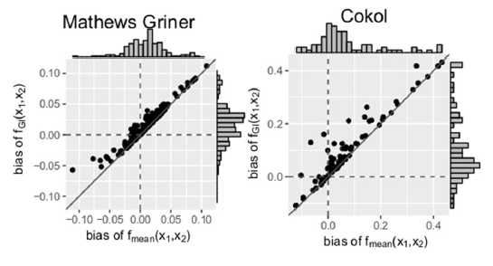

Figure 7: Bias mean difference between the responses given by the model and the measured responses. The distribution of the models’ bias values is given in histograms plotted on the axes.

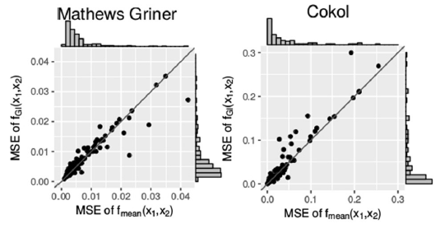

Figure 8: Mean squared error between the measured and the expected responses of the general isobole and mean equation model, each drawn in the according axes. The distribution of the models’ mean squared error values is given in histograms plotted on the axes.

The authors also conducted a small benchmark test in order to compare the computation times of the two compared models. They showed that the median time to compute the explicit formulation of Loewe Additivity (the mean equation model, equation (33)) is ~280 times faster than the implicit one (the general isobole model, equation (23)) – see Figure 9. This constitutes another reason why someone should use the mean equation model instead of the isobole equation: e.g. the authors comment that in a large high-throughput experiment with 10,000 records this would reduce computing time from 20 h to less than 5 min.

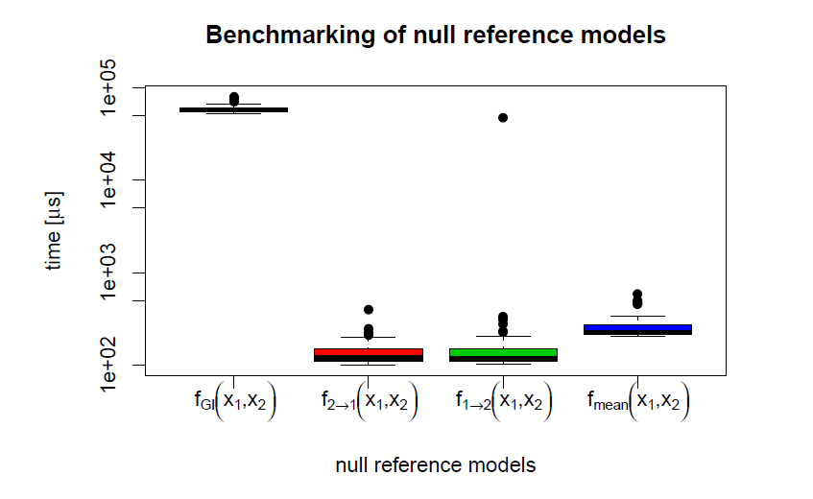

Figure 9: Execution time for each null reference model

# References

Chou, Ting-Chao. 2006. “Theoretical Basis, Experimental Design, and Computerized Simulation of Synergism and Antagonism in Drug Combination Studies.” *Pharmacological reviews* 58(3): 621–81. http://www.ncbi.nlm.nih.gov/pubmed/13465303 (June 25, 2018).

Chou, Ting-Chao, and Paul Talalay. 1984. “Quantitative Analysis of Dose-Effect Relationships: The Combined Effects of Multiple Drugs or Enzyme Inhibitors.” *Advances in Enzyme Regulation* 22: 27–55. http://linkinghub.elsevier.com/retrieve/pii/0065257184900074 (June 5, 2018).

Cokol, Murat et al. 2011. “Systematic Exploration of Synergistic Drug Pairs.” *Molecular systems biology* 7: 544. http://www.ncbi.nlm.nih.gov/pubmed/22068327 (June 22, 2018).

Fitzgerald, Jonathan B, Birgit Schoeberl, Ulrik B Nielsen, and Peter K Sorger. 2006. “Systems Biology and Combination Therapy in the Quest for Clinical Efficacy.” *Nature Chemical Biology* 2(9): 458–66. http://www.nature.com/articles/nchembio817 (June 20, 2019).

Flobak, Åsmund, Miguel Vazquez, Astrid Lægreid, and Alfonso Valencia. 2017. “CImbinator: A Web-Based Tool for Drug Synergy Analysis in Small- and Large-Scale Datasets” ed. Jonathan Wren. *Bioinformatics* 33(15): 2410–12. https://academic.oup.com/bioinformatics/article/33/15/2410/3740895 (August 7, 2018).

Foucquier, Julie, and Mickael Guedj. 2015. “Analysis of Drug Combinations: Current Methodological Landscape.” *Pharmacology research & perspectives* 3(3): e00149. http://www.ncbi.nlm.nih.gov/pubmed/26171228 (March 18, 2018).

Grabovsky, Yury, and Ronald J Tallarida. 2004. “Isobolographic Analysis for Combinations of a Full and Partial Agonist: Curved Isoboles.” *The Journal of pharmacology and experimental therapeutics* 310(3): 981–86. http://www.ncbi.nlm.nih.gov/pubmed/15175417 (June 5, 2018).

Greco, W R, G Bravo, and J C Parsons. 1995. “The Search for Synergy: A Critical Review from a Response Surface Perspective.” *Pharmacological reviews* 47(2): 331–85. http://www.ncbi.nlm.nih.gov/pubmed/7568331 (June 22, 2018).

Lederer, Simone, Tjeerd M H Dijkstra, and Tom Heskes. 2018. “Additive Dose Response Models: Explicit Formulation and the Loewe Additivity Consistency Condition.” *Frontiers in pharmacology* 9: 31. http://www.ncbi.nlm.nih.gov/pubmed/29467650 (June 5, 2018).

Mathews Griner, Lesley A et al. 2014. “High-Throughput Combinatorial Screening Identifies Drugs That Cooperate with Ibrutinib to Kill Activated B-Cell-like Diffuse Large B-Cell Lymphoma Cells.” *Proceedings of the National Academy of Sciences of the United States of America* 111(6): 2349–54. http://www.ncbi.nlm.nih.gov/pubmed/24469833 (June 22, 2018).

Yadav, Bhagwan, Krister Wennerberg, Tero Aittokallio, and Jing Tang. 2015. “Searching for Drug Synergy in Complex Dose–Response Landscapes Using an Interaction Potency Model.” *Computational and Structural Biotechnology Journal* 13: 504–13. https://www.sciencedirect.com/science/article/pii/S2001037015000422?via%3Dihub (June 5, 2018).

1. In this text, dosage and dose are equivalent terms and are used to describe the *quantity* of the administered drug used.
2. This equation fits to the expectation of the mass-action law principle that dictates many biological processes such as cell growth or ligand-binding interactions – it’s the unified theory for the Michaelis-Menten equation, Hill equation, Henderson-Hasselbalch equation and Scatchard equation (Chou 2006).
3. Referring to combinations, we will mean 2 drugs for the rest of the text
4. Also known as Gaddum’s non-interaction model