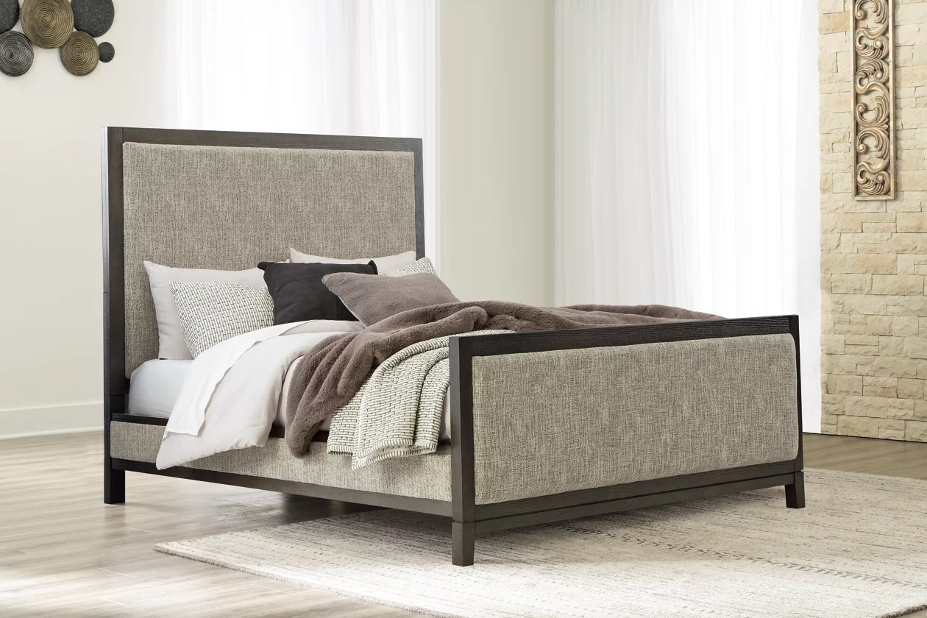

# Name product: **Burkhaus Queen Upholstered Panel Bed**

Elegance, Comfort, Durability

Size: 200*150*50

Material: Velvet

Price: 1000$

Description:

Dressed to thrill, the simply stunning Burkhaus queen upholstered bed offers a high-design look at a down-to-earth price. Ultra sleek lines are accentuated with a dark waxy brown oak-tone finish that’s so easy on the eyes. Cushioned panels emphasize the bed’s clean, modern lines, while luxurious cream and black upholstery completes the upscale aesthetic.

* Includes queen headboard, footboard and rails
* Made of wood
* Dark waxy brown oak finish
* High-low woven polyester upholstery
* Foundation/box spring required; sold separately
* Mattress available, sold separately
* Assembly required
* Bed is compatible with an adjustable base
* Estimated Assembly Time: 70 Minutes