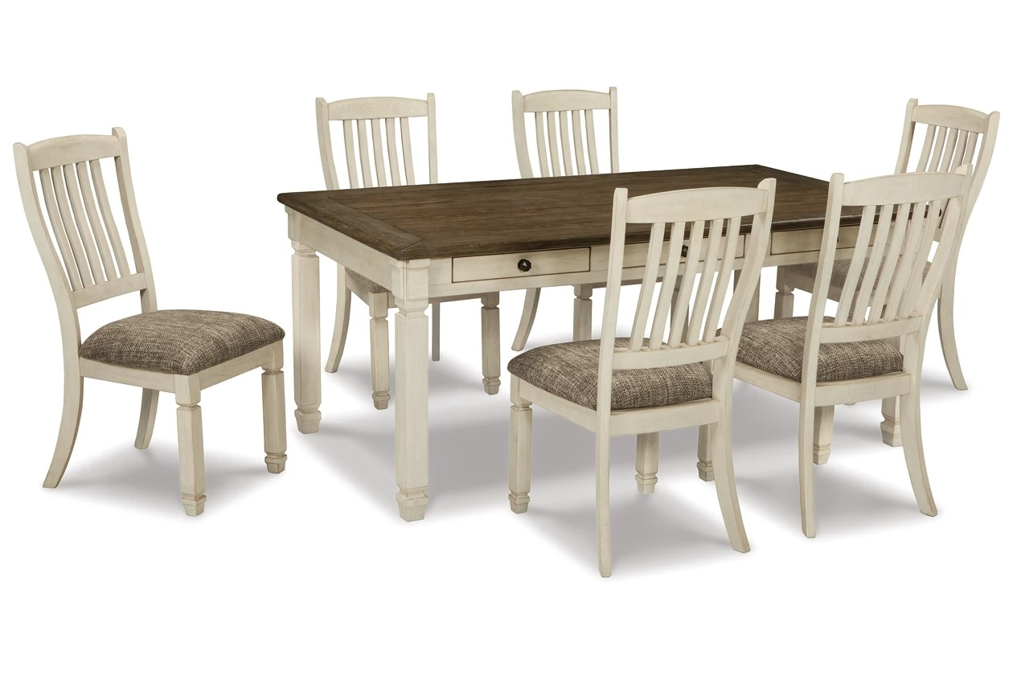

# Name product: **Bolanburg Dining Table, 6 Chairs, and Bench**

Size: 200*100*50  
Material: Leather

Price: 1700$

Description:

Enjoy beautiful cottage style with the classic Bolanburg dining table set. With a rustic planked top, this table serves up casual with a vintage twist. The gently distressed tabletop, paired with the rake-back design of the chairs in a textured antique white finish, is a perfect set for impromptu gatherings. With six built-in drawers, you can keep placemats, napkins and utensils on hand for maximum practicality in any living space. For a quaint ensemble you're bound to love, choose this Bolanburg set.

* Includes dining table and 6 dining chairs
* Table made of veneers, wood and engineered wood
* Chairs made of solid wood with heavily woven fabric upholstered seats
* 6 drawers on table (3 on each side)
* Seats up to 6
* Assembly required
* Estimated Assembly Time: 225 Minutes