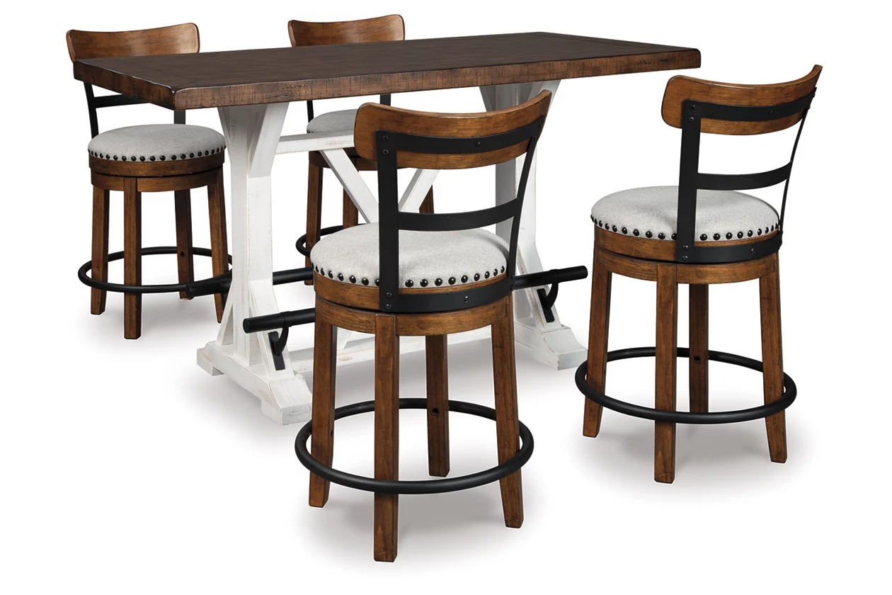

# Name product: **Bolanburg Dining Table, 6 Chairs, and Bench**

Size: 200*100*50  
Material: Leather

Price: 1300$

Description:

The Valebeck 5-piece dining set serves up the best in rustic farmhouse living. The counter height table's two-done distressed finish pairs a brown tabletop with a distressed vintage white base, while black metal footrests add a distinctive twist. The cushioned bar stool adds a visually intriguing touch of rustic-industrial style.

* Includes counter-height dining table and 4 upholstered barstools
* Table made of pine wood, veneers and engineered wood
* Table with two-tone finish and black metal footrest
* Barstools made of wood, engineered wood and metal
* Barstools with linen colored polyester upholstered cushioned seats
* Barstools with smooth 360-degree swivel
* Barstools with nailhead trim detail
* Seats up to 4
* Assembly required
* Estimated Assembly Time: 90 Minutes