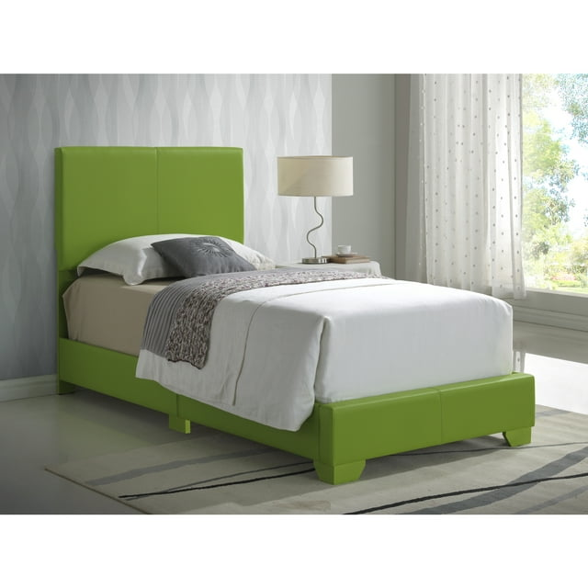

# Name product: **Glory Furniture Aaron G1807-TB-UP Twin Bed , APPLE GREEN**

Size: 200*100*50  
Material: Faux Leather, Upholstered, Manufactured Wood

Price: 750$

,Description:

Serenity now. This queen upholstered bed is sure to awaken a love for modern platform styling with a softer side. Plush to the touch and so easy on the eyes, a pale beige fabric hugs the bed—from the chic headboard with square button tufting, to the low footboard and side rails, emanating the calming mood you long for in the bedroom. Mattress and foundation/box spring sold separately.

* Includes headboard, footboard and rails
* Engineered wood frame
* Polyester upholstery on headboard, footboard and rails
* Square button tufting on headboard
* Foundation/box spring required
* Mattress available, sold separately
* All parts required for assembly of this bed are packed in the open space in the back of the headboard
* Bed is compatible with an adjustable base
* Estimated Assembly Time: 45 Minutes