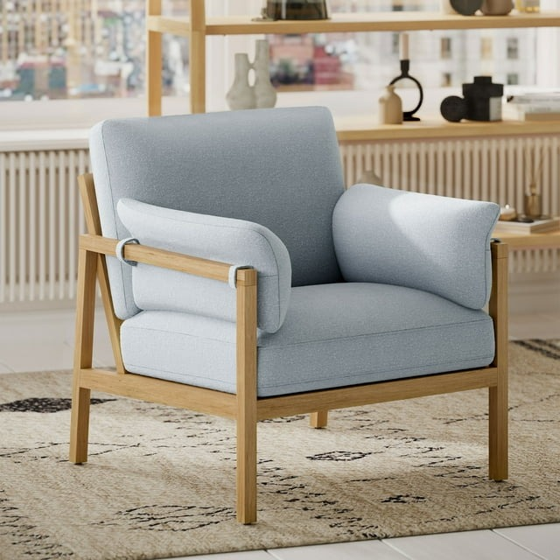

# Name product **Beautiful Wrap Me Up Accent Chair With Removable Cushions** **by Drew, Cornflower Blue**

# Size: 50*50*50 Material: Leather

Price: 500$

,Description:

### Description

Fresh and sophisticated. The Tartonelle accent chair with button tufting is a classy addition to your home. Inside-out design with linen weave fabric on the seating area and taupe faux leather on the back. Large nailhead trim ties the look together. Charles of London arms and turned bun feet make this a stylish heirloom piece.

* Attached back and loose seat cushions
* High-resiliency foam cushions wrapped in thick poly fiber
* Linen weave interior upholstery; faux leather exterior upholstery
* Polyester upholstery
* Exposed feet with faux wood finish
* Estimated Assembly Time: 15 Minutes

### Fabric Details

* Body: Polyester (100)%
* Body: Polyester (95)%,Polyurethane (5)%