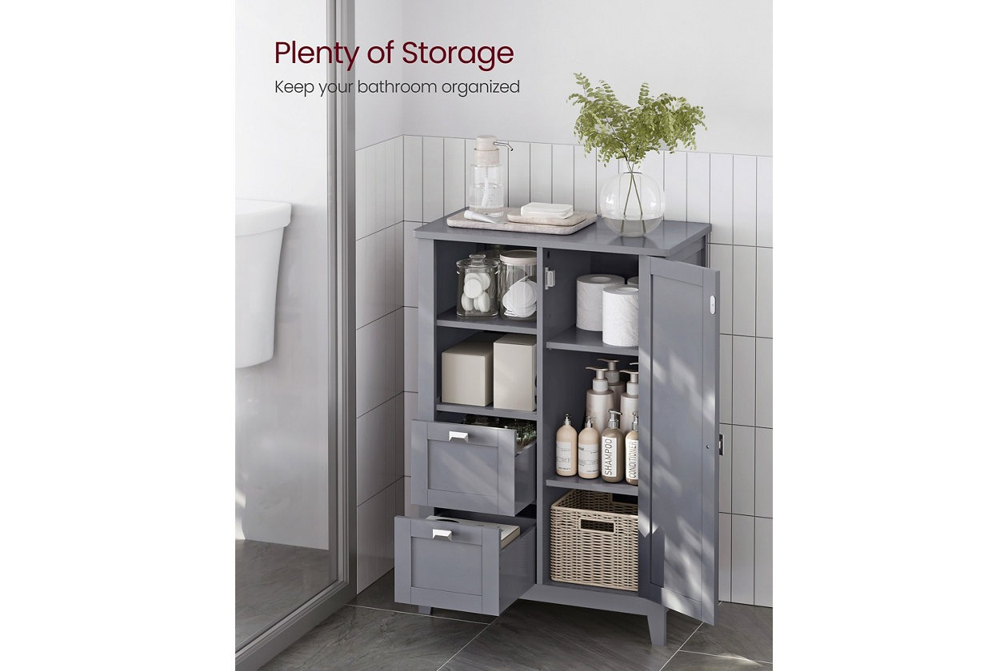

# Name product **Humphrey Bathroom Wall Cabinet**

# Size: 50*50*50 Material: Wood

Price: 200$

,Description:

Keep your hairdryer and bath supplies organized with this spacious bathroom cabinet. It boasts a storage cabinet, 2 drawers, and 2 open compartments, providing plenty of space to neatly store all of your bathroom essentials

* The floor cabinet is thoughtfully designed with rounded corners on its top surface, ensuring a safer living space for you and your loved ones by preventing accidental bumps [Stable and Stylish] The sturdy MDF and included anti-tip kit make this bathroom cabinet stable and safe. The elegant color and simple design effortlessly enhance your home decor, helping you create a stylish and inviting space
* Crafted from high-quality MDF
* [Easy to Assemble] This freestanding bathroom cabinet is a breeze to assemble, thanks to its easy-to-follow instructions and clearly marked parts
* [Adjustable Shelves and Flexible Drawers] With 1 adjustable shelf on the left and 2 in the cabinet, each offering 5 height options, this bathroom unit fits items of varying sizes. The drawers can be pulled out and switched around in the open compartments
* Imported