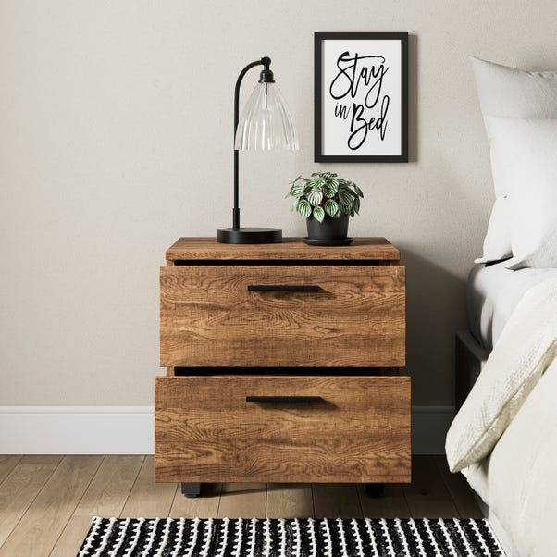

# Name product **Freddie 2 Drawer Bedside Table**

# Size: 50*50*50 Material: Wood

Price: 150$

,Description:

* Wooden bedside table
* 2 spacious drawers for storage
* Assembly required

With metal accents and a wood effect finish, this bedside table seamlessly combines style and functionality. It offers two spacious drawers for storing nighttime essentials and reading materials, all while exuding a modern and fashionable aesthetic. The dark metal handles add an industrial edge, and smooth metal runners ensure effortless drawer operation. To complete your look, explore other value-for-money pieces in our coordinating Freddie collection.