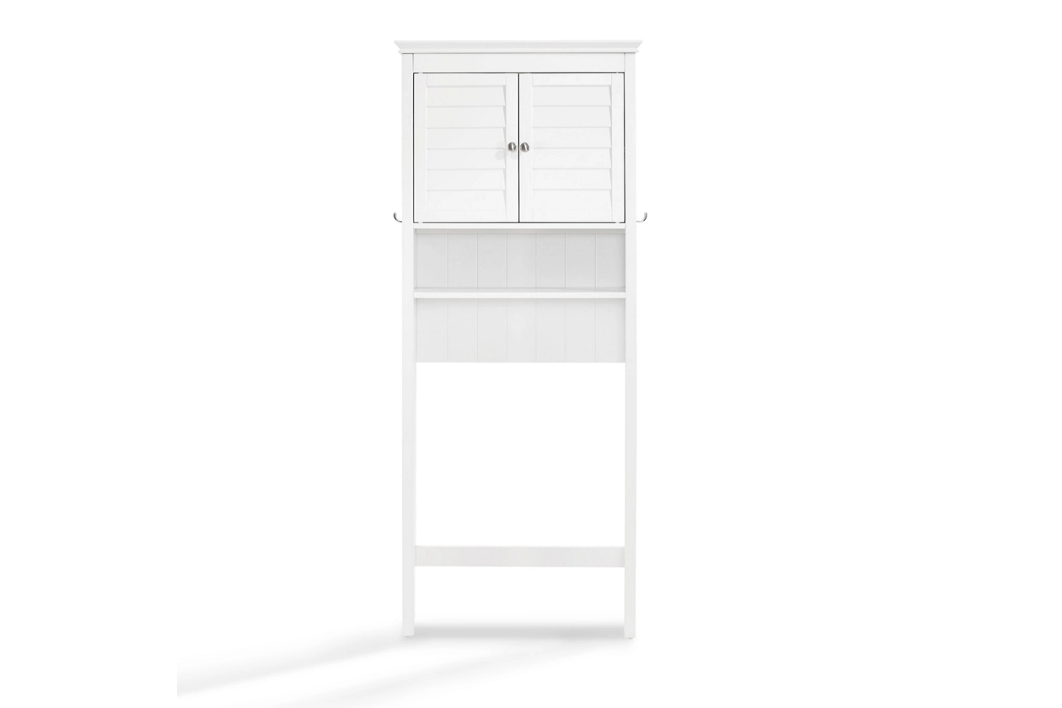

# Name product: **Crosley Lydia Over the Toilet Cabinet**

Elegance, Comfort, Durability

Size: 27*67*11

Material: Pine

Price: 160$

Description:

Bring a sense of order to your bathroom with this chic shelved tower. Designed to add much-needed bathroom storage, its roomy cabinet, open shelf and assortment of hooks provide an elegant use of space. At home in the tightest or most spacious bath, its compact footprint allows you to live large in small places.

* Pine frame with white finish
* Double door cabinet with adjustable shelf
* Open shelf
* Towel bar
* 2 hooks on either side
* Space-saver design fits over most standard toilets
* Assembly required
* Ships directly from third party vendor. See Warranty Information page for terms & conditions.