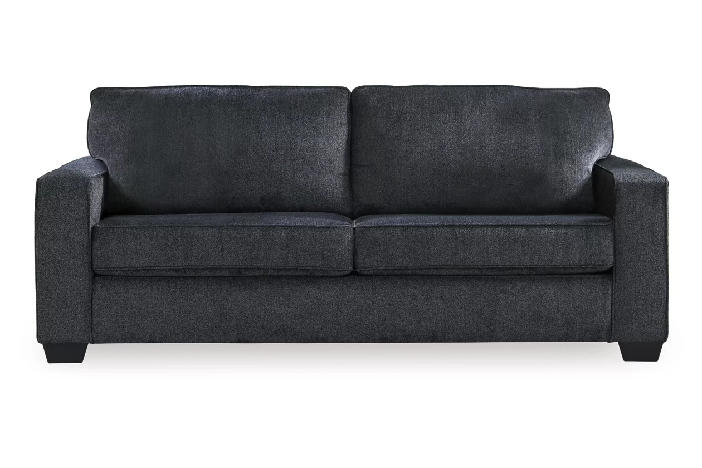

# Name product: **Altari Sofa**

Elegance, Comfort, Durability

Size: 85*37*38

Material: Polyester (100)%

Price: 400$

Description:

If style is the question, then the Altari rocker recliner is the answer. Clean-lined profile is beautifully contemporary. Plush chenille fabric and plump cushioning make it so easy to comfortably kick up your heels. Richly neutral hue complements a variety of decor.

* Gentle rocking motion
* Attached cushions
* High-resiliency foam cushions wrapped in thick poly fiber
* Corner-blocked frame with metal reinforced seat
* One-pull reclining motion
* Polyester upholstery

**Fabric Details**

* Body: Polyester (100)%