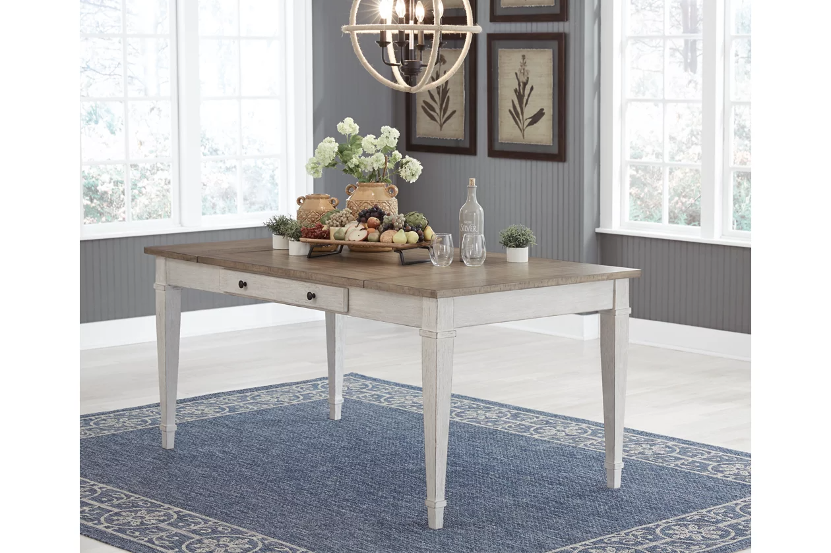

# Name product: **Skempton Storage Dining Table with 2 Side Drawers**

Elegance, Comfort, Durability

Size: 36*30*66

Material: wood, acacia veneer and engineered wood

Price: 350$

Description:

Set the scene for coastal chic or modern farmhouse living with the Skempton dining room table. Clean-lined, simply striking table doubles the charm with a brown tone top with plank effect, paired with a grayish white base with rub through effect for timeworn appeal. Multi-functional dining table features two convenient side drawers and a storage bin on each end for maximum use of space. Styled to comfortably seat six, this table makes room for one and all.

* Made of wood, acacia veneer and engineered wood
* Two-tone finish (brown tone top and distressed grayish white base)
* 2 smooth-gliding drawers and 2 lift-top storage bins
* Seats up to 6
* Assembly required
* Estimated Assembly Time: 30 Minutes