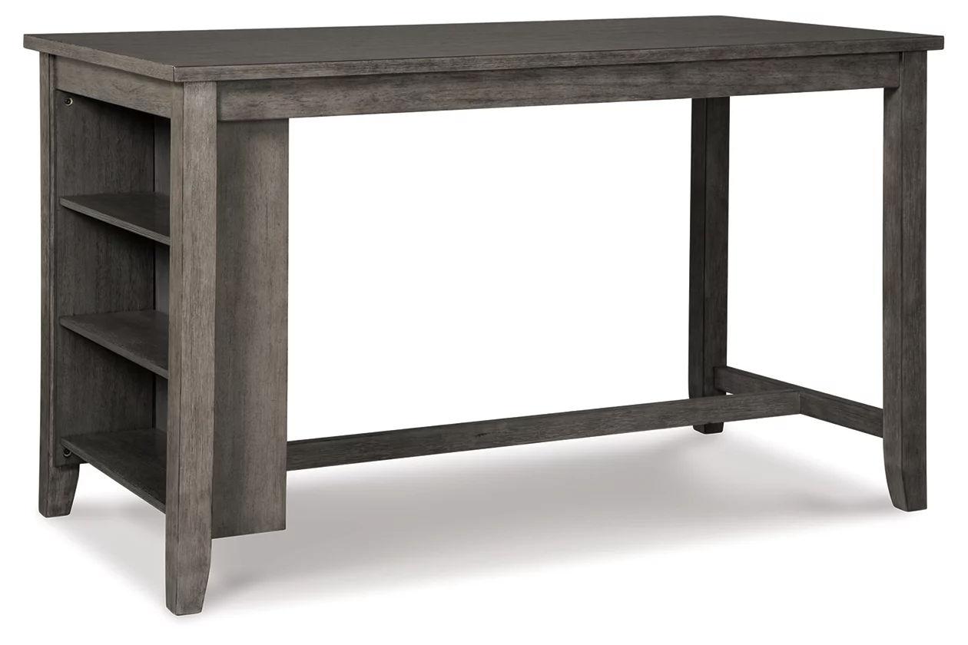

# Name product: **Caitbrook Counter Height Dining Table with Shelves**

Elegance, Comfort, Durability

Size: 60*26*30

Material: veneers, wood and engineered wood

Price: 300$

Perfect portion. Striking a simply chic pose, the Caitbrook dining room counter height table serves up high style on a smaller scale. Its antiqued gray wash finish gives the clean-lined design a casually cool sensibility. Side shelves cleverly balance form and function.

* Made of veneers, wood and engineered wood
* 2 fixed shelves
* Seats 4
* Assembly required
* Estimated Assembly Time: 45 Minutes