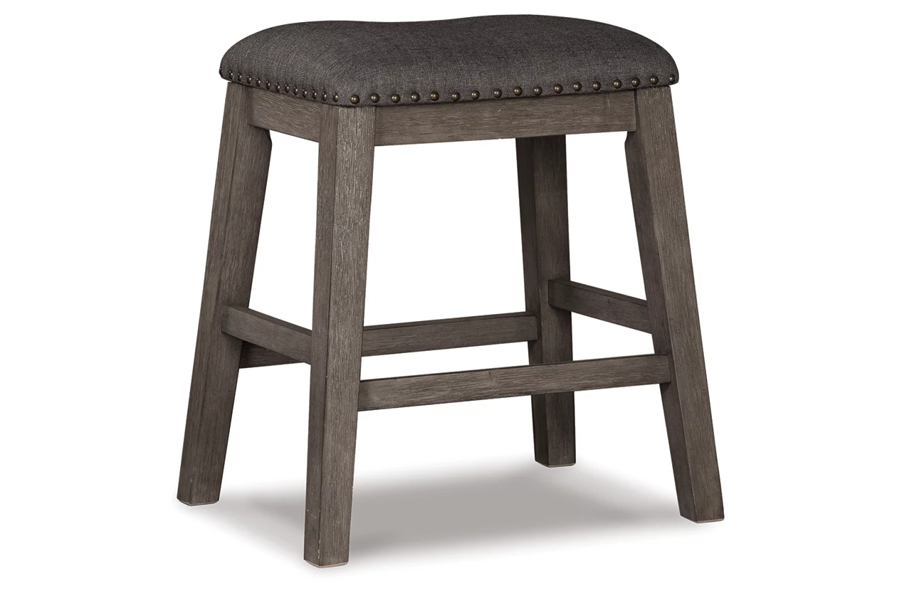

# Name product: **Caitbrook Counter Height Backless Bar Stool**

Elegance, Comfort, Durability

Size: 21*24*16

Material: solid acacia wood

Price: 120$

Description:

Bring a relaxed yet refined sense of good taste to a space with the Caitbrook upholstered stool. The clean-lined frame sports a gray-washed finish that’s so easy on the eyes. Covered in a complementary textured gray fabric, the stool’s cushioned upholstered seat goes easy on the body.

* Made with solid acacia wood
* Antiqued gray wash finish
* Polyester upholstery over foam cushioned seat
* Nailhead trim
* Assembly required
* Estimated Assembly Time: 30 Minutes