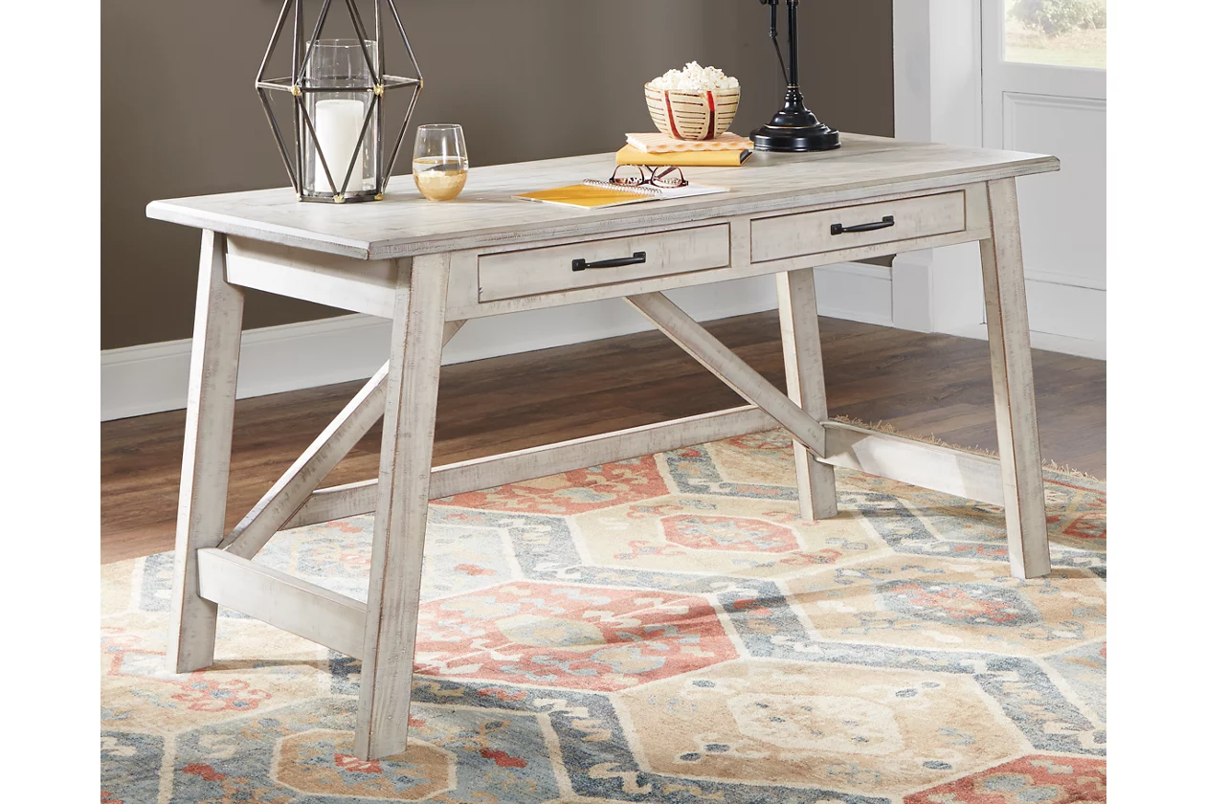

# Name product: **Carynhurst 60" Home Office Desk**

Elegance, Comfort, Durability

Size: 60*31*26

Material: pine veneers, pine wood and engineered wood

Price: 230$

Description:

Elevating the art of traditional cottage styling, the Realyn L-shaped desk is your heavenly home office realized. Two-tone finish combines chipped white with distressed wood tone tops for added charm. Framed drawer fronts, decorative corbels and elegantly turned and tapered legs add refinement, while dark bronze-tone knobs lend a classic touch. Spring lift top raises the surface to a comfortable standing position, for a healthy alternative. Built for looks and productivity, the built-in power supply and dual USB ports keep your devices close at hand and ready to go.

* Includes desk and desk return
* Made of wood, engineered wood and veneers, with cast resin components
* Antiqued two-tone finish
* Return with 2 smooth-gliding drawers with dovetail construction
* Desk with spring lift top and drop-front drawer
* Return with cutout for cord management
* Dark bronze-tone finished metal hardware
* 2 AC electrical plug-ins and 2 USB slots
* Power cord included; UL-listed
* Assembly required
* Estimated Assembly Time: 35 Minutes