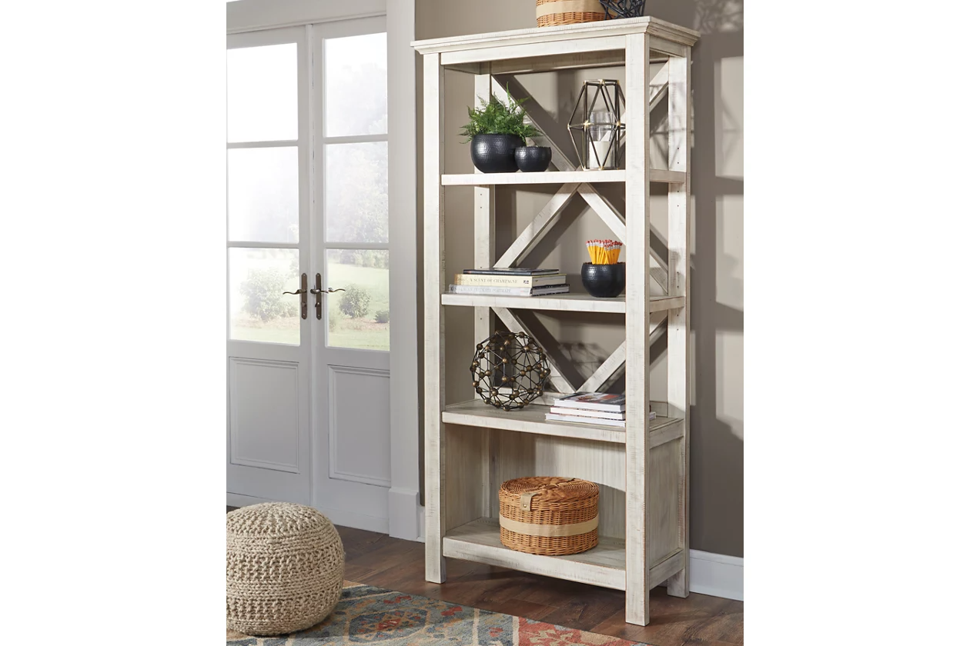

# Name product: **Carynhurst 75" Bookcase with 4 Shelves**

Elegance, Comfort, Durability

Size: 38*78*16

Material: pine veneers, pine wood and engineered wood

Price: 370$

Description:

Looking for a fresh approach to modern farmhouse living? The Carynhurst bookcase works on so many levels. Clean-lined profile with crossbuck back never goes out of fashion. Whitewash finish is a mastery in subtle sophistication.

* Made of pine veneers, pine wood and engineered wood
* Distressed whitewash finish
* 4 shelves; 2 of which are adjustable
* Assembly required
* Estimated Assembly Time: 45 Minutes