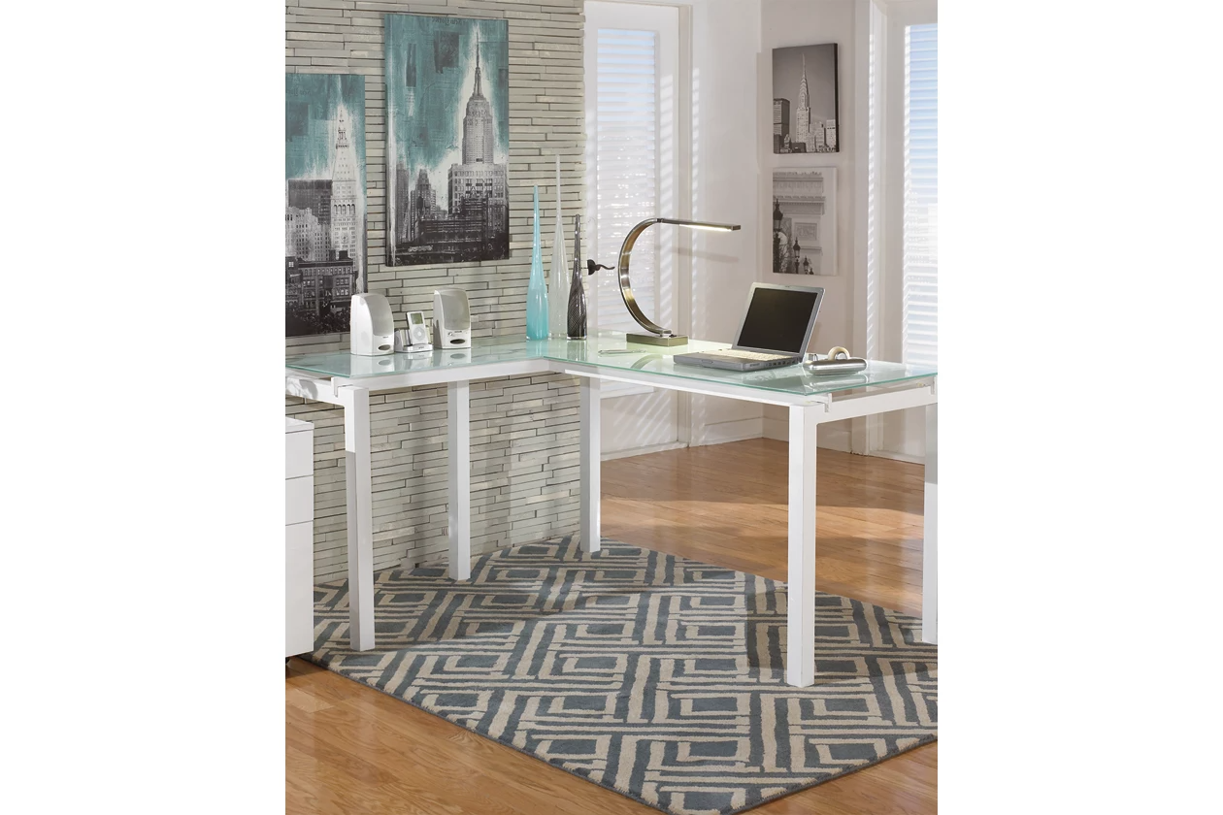

# Name product: **Baraga 61" Modular L-Shaped Home Office Desk**

Elegance, Comfort, Durability

Size: 61*30*51

Material: glass and metal

Price: 240$

Description:

The Baraga L-desk delivers the functionality you crave with the modern style that suits your taste. Frosted glass appears to float over the streamlined metal base. The desk's L-shape design sets up two different ways, enabling left-handed and right-handed users to maximize their workspace.

* Made of glass and metal
* Assembly required
* Tempered glass tabletop
* Modular design
* Powder coated finish