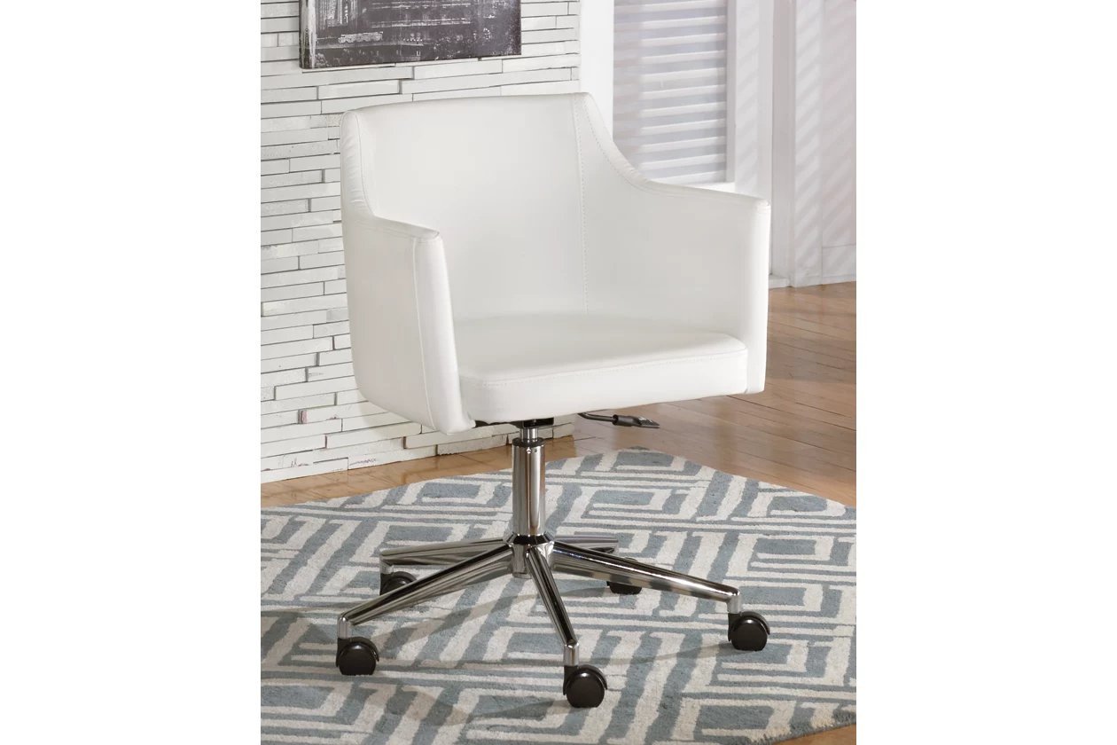

# Name product: **Baraga Swivel Home Office Desk Chair**

Elegance, Comfort, Durability

Size: 24*35*25

Material: metal

Price: 200$

Description:

Baraga swivel desk chair delivers the comfort you crave with the modern style that suits your taste. Sleek, linear design and faux leather maximize a minimalist look. Casters, adjustable seat and 360-degree swivel make this functional piece all the more flexible.

* Smooth 360-degree swivel
* Made of metal
* Casters for easy movement
* Assembly required
* Faux leather upholstery over foam cushion
* Adjustable seat height
* Shiny chrome-color finish
* Estimated Assembly Time: 15 Minutes

**Fabric Details**

* : PU (100)%