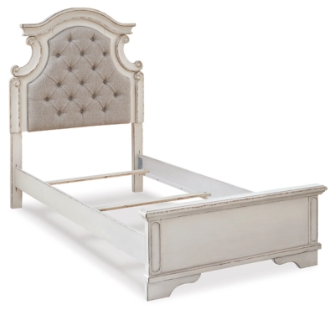

# Name product: **Realyn Twin Panel Bed**

Elegance, Comfort, Durability

Size: 45*58*82

Material: eneers, wood and engineered wood

Price: 360$

Description:

Elevating the art of traditional cottage styling, the Realyn twin upholstered bed is your dream bedroom retreat realized. A curvaceous beauty, this brilliant upholstered bed wows with dramatic scalloped details and fanciful trim work. The distressed chipped white finish charms with its heirloom appeal. Deep tufting on the cushioned upholstered headboard adds such a cozy element sure to please. Mattress and foundation/box spring available, sold separately.

* Made of veneers, wood and engineered wood, with cast resin components
* Includes upholstered headboard, footboard and rails
* Distressed, chipped white finish
* Upholstered headboard with foam cushion, button tufting
* Assembly required
* Mattress and foundation/box spring available, sold separately
* Bed is compatible with an adjustable base
* Estimated Assembly Time: 55 Minutes