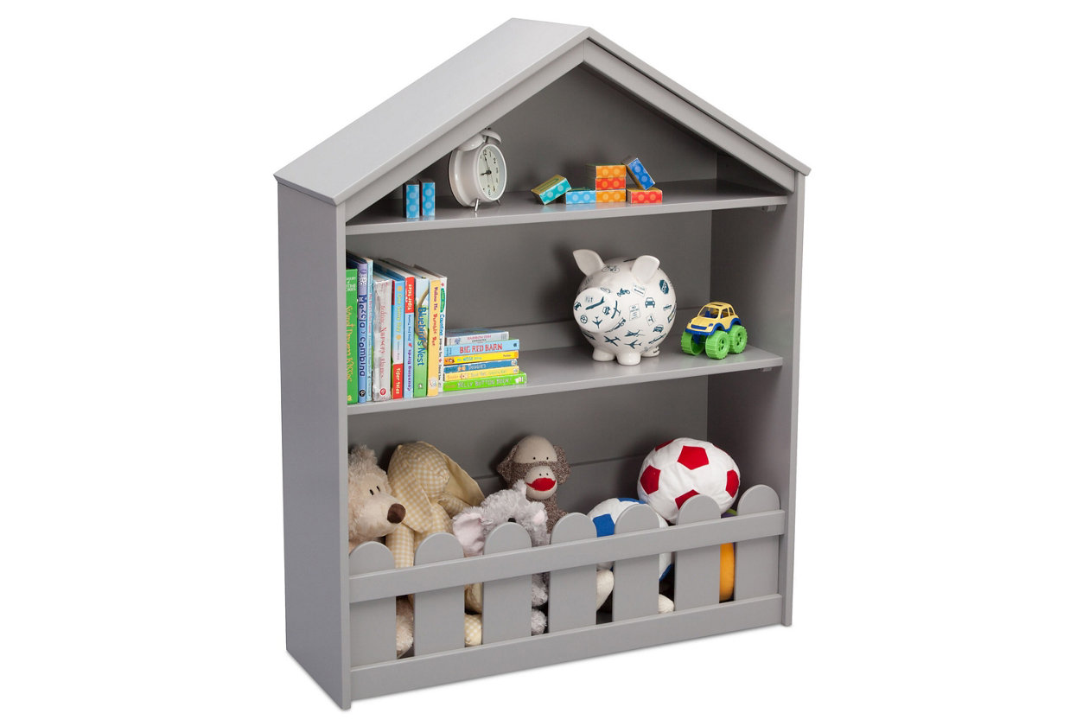

# Name product: **Delta Children Serta Happy Home Storage Bookcase**

Elegance, Comfort, Durability

Size: 12*45*37

Material: wood

Price: 223$

Description:

Perfect for the playroom or a child's bedroom, the Happy Home Storage Bookcase from Serta is the dreamiest way to store books and toys. Sure to inspire hours of imaginative play, this beautifully crafted accent piece features details like a gabled roofline, picket fence trim and strong wood construction. Designed to hold books, toys and more, the Happy Home Storage Bookcase is outfitted with two fixed shelves, plus an open cubby on the bottom for larger items.

* For any questions regarding delta children products, please contact consumersupport@deltachildren.com monday to friday, 8:30 a.m. To 6 p.m. (est)
* Made of wood
* Two fixed shelves with open cubby on the bottom for additional storage
* Includes anti-tip kit
* Assembly required
* Ships directly from third party vendor. See Warranty Information page for terms & conditions.