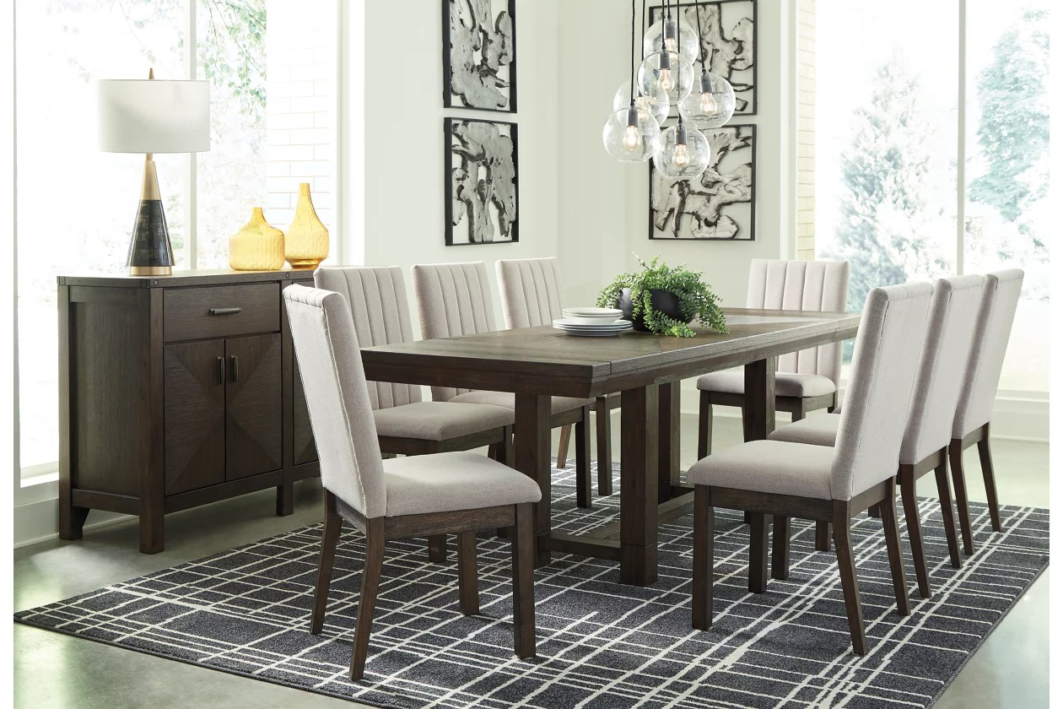

# Name product: **Dellbeck Dining Table With 8 Chairs And Server**

Elegance, Comfort, Durability

Size: 200*100*50  
Material: Leather

Price: 1500$

Description:

Feast your eyes on the stunning Dellbeck 10-piece dining room set. The table’s inlaid veneer top supported by a four-post trestle base is a look worth lingering over. When unexpected guests drop by, two extension leaves make entertaining a breeze. The chair’s crisp, clean-lined profile is softened with front-to-back upholstery that’s plush to the touch and easy on the eyes. Channel stitched detailing adds to the sense of luxury. The stately server with diamond-matched veneer inlay rounds out the set nicely.

* Includes dining table, server and 8 chairs
* Dark brown finish; assembly required
* Table seats up to 8
* Table made of wood, veneer and engineered wood
* 2 removable extension leaves
* Side chair made of wood
* Seat and back covered in cushioned polyester upholstery
* Server made of wood, veneers and engineered wood
* 2 smooth-gliding drawers
* 2 lower cabinets with soft-close door hinges; 1 adjustable shelf in each cabinet.
* Metal bar pulls in a forged steel color finish
* Estimated Assembly Time: 285 Minutes