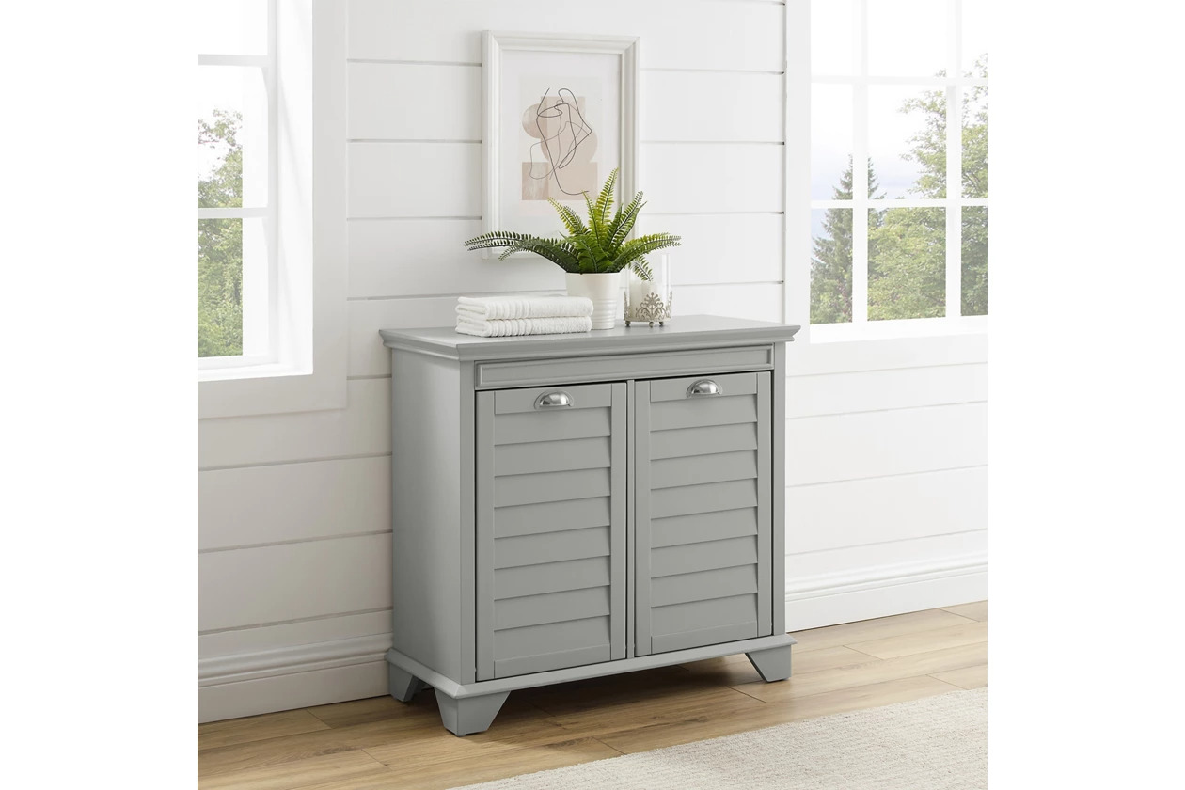

# Name product **French Cane Laundry Hamper**

# Size: 50*50*50 Material: Wood

Price: 150$

,Description:

With styling that compliments any décor, the lydia linen hamper features a compact footprint suitable for any size bathroom, laundry room, or hallway. Dual hampers provide a head start on the sorting, while the removable cloth bags transport loads to the washer in a snap. A clever pull-forward design allows the top to be used for storage and provides easy access to both compartments. The lydia linen hamper is a great laundry solution for your home.

* Genuine metal hardware in a brushed nickel finish
* Sorting compartment pulls forward for easy access
* Two compartments for easy sorting
* Machine washable removable cloth bags
* Ships directly from third party vendor. See Warranty Information page for terms & conditions.