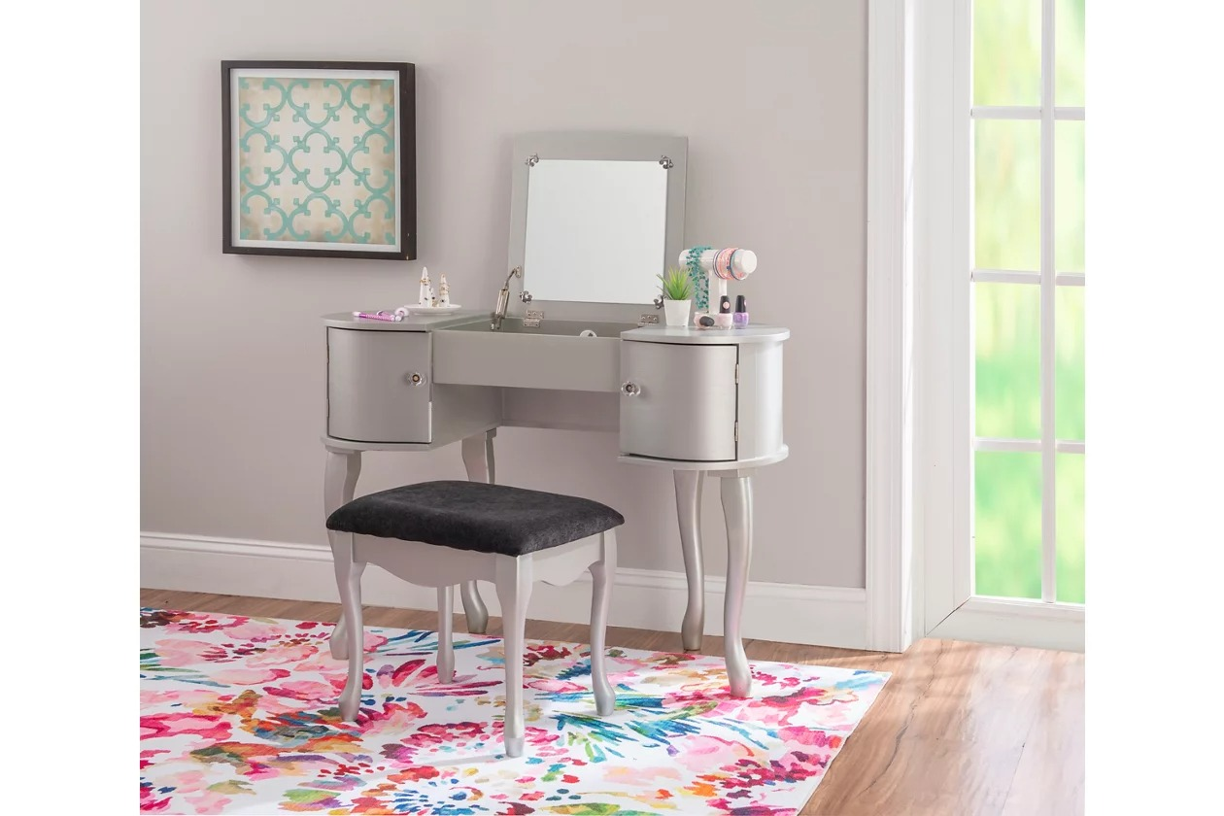

# Name product **Indi 2 Drawer Dressing Table, Mango Wood**

# Size: 50*50*50 Material: Wood

Price: 150$

,Description:

You’re a star, and this vanity set is built to remind you every morning when you look in the mirror. A frame of regal bulbs provides the perfect lighting for doing your hair and makeup before you leave the house. Five deep drawers keep things organized yet chic with beveled geometric drawer fronts and goldtone knobs that match the tips of both pieces’ legs. For the cherry on top, unbelievably fluffy upholstery is fitted over the padded stool to keep things light and fun.

* Regal bulbs frame mirror to provide perfect lighting for hair and makeup
* 5 spacious drawers offer plenty of space for beauty supplies, writing utensils, work materials and more
* Goldtone knobs on drawers and goldtone tips on beveled legs double down on a Hollywood aesthetic
* Stool features unbelievably fluffy upholstery
* 42" x 19" tabletop offers ample space for a laptop, but is compact enough for tight quarters
* Gleaming white finish looks good amongst any color palette
* Assembly required
* Imported