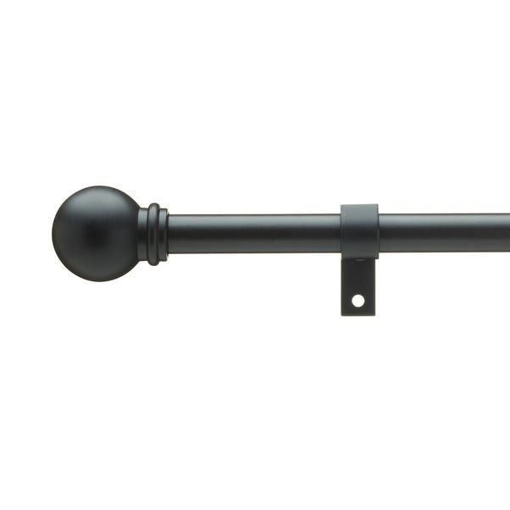

# Name product Ashton Metal Extendable Curtain Pole

# Size: 25*28 Material: Metal

Price: 100$

Description:

Supplied with all fixtures and fittings, this stylish metal extendable metal pole is available in a choice of finishes and is for suitable for hanging medium to heavyweight curtains. The extendable telescopic design allows for easy fitting to a range of window sizes without the need to cut it down.

The quantity of rings supplied is based on the industry standard of 1 ring per every 10cm.

Please note: All curtain poles in lengths of 240cm and above come in two lengths with a joiner and three brackets.

Please note: the pole length stated does not include the finials. Please allow up to an additional 6cm to the pole length to accommodate the finials.

**Disclaimer:** This pole can be cut to size and the finials can be removed.