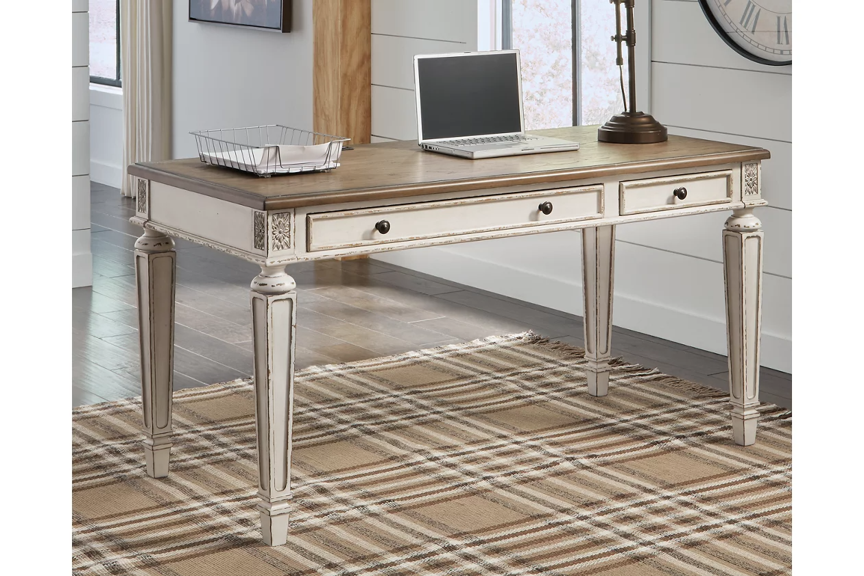

# Name product: **Realyn 60" Home Office Desk with USB Charging**

Elegance, Comfort, Durability

Size: 60*31*28

Material: wood, engineered wood and veneers,

Price: 380$

Description:

Dressed to thrill, the simply stunning Burkhaus queen upholstered bed offers a high-design look at a down-to-earth price. Ultra sleek lines are accentuated with a dark waxy brown oak-tone finish that’s so easy on the eyes. Cushioned panels emphasize the bed’s clean, modern lines, while luxurious cream and black upholstery completes the upscale aesthetic.

* Includes queen headboard, footboard and rails
* Made of wood
* Dark waxy brown oak finish
* High-low woven polyester upholstery
* Foundation/box spring required; sold separately
* Mattress available, sold separately
* Assembly required
* Bed is compatible with an adjustable base
* Estimated Assembly Time: 70 Minutes