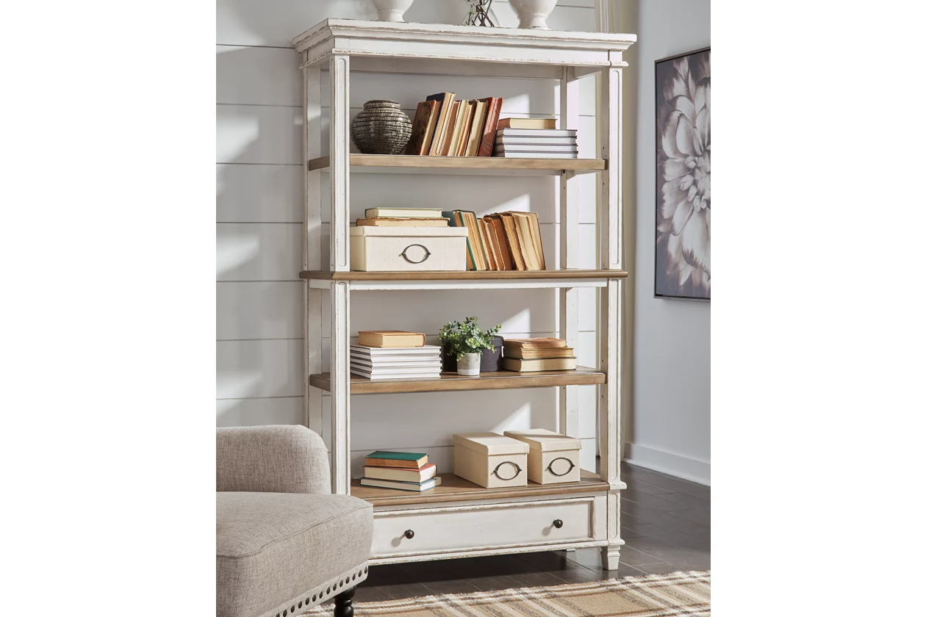

# Name product: **Realyn 75" Bookcase with 3 Shelves**

Elegance, Comfort, Durability

Size: 45*75*16

Material: wood, engineered wood and veneers

Price: 370$

Description:

Elevating the art of traditional cottage styling, the Realyn bookcase is your heavenly home office realized. Antiqued two-tone aesthetic blends a chipped white with a distressed wood tone top for added charm. Clever balance of shelf and drawer space beautifully works.

* Made of wood, engineered wood and veneers
* Antiqued two-tone finish
* Smooth-gliding drawer with dovetail construction
* 3 fixed shelves
* Dark bronze-tone finished metal hardware
* Estimated Assembly Time: 45 Minutes