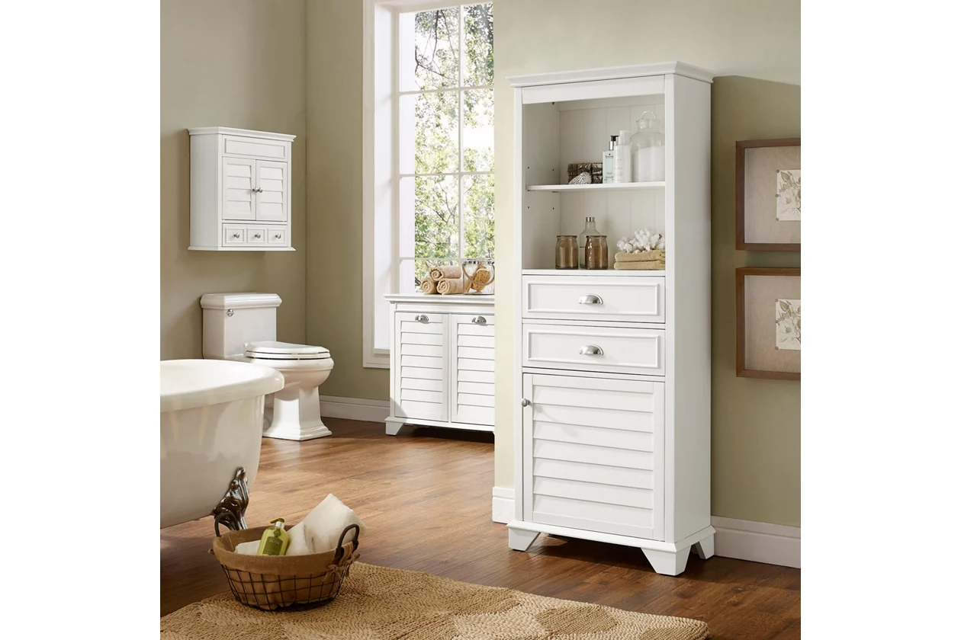

# Name product: **Crosley Tall Linen Storage Cabinet**

Elegance, Comfort, Durability

Size: 24*60*11

Material: wood, veneers and engineered wood

Price: 235$

Description:

Not quite ready for the inconvenience and expense of a complete bathroom remodel? This line of stylish storage solutions will help you create the bathroom of your dreams. The high-end design of this tall cabinet keeps your bathroom essentials neatly stored away and still close at hand. Open upper shelving is ideal for display, while roomy drawers contain smaller items and lower cabinet hides the rest. At home in the tightest or most spacious bath, its compact footprint allows you to live large in small places.

* Made of wood, veneers and engineered wood
* Steel-tone metal accents
* 2 storage drawers
* 2 upper shelves; 2 lower shelves behind a louvered door
* Assembly required
* Ships directly from third party vendor. See Warranty Information page for terms & conditions.