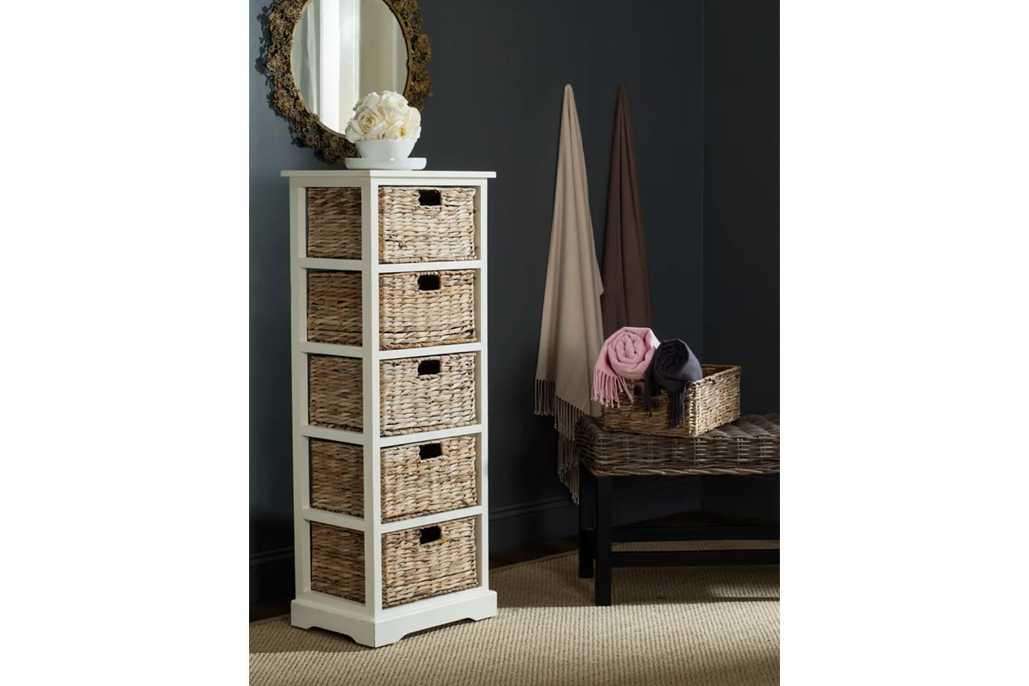

# Name product: **Vedette 5-Basket Storage Tower**

Elegance, Comfort, Durability

Size: 17*46*13

Material: pine wood and rattan

Price: 160$

Description:

Fresh as a coastal breeze, this pretty and practical five-basket storage tower works equally well in a bathroom or bedroom. Crafted of pine with a painted finish, the simple frame has rattan weave pull out drawers for easy organizing.

* Made of pine wood and rattan
* Distressed white finish
* 5 shelves with rattan storage drawers
* No assembly required
* Ships directly from third party vendor. See Warranty Information page for terms & conditions.