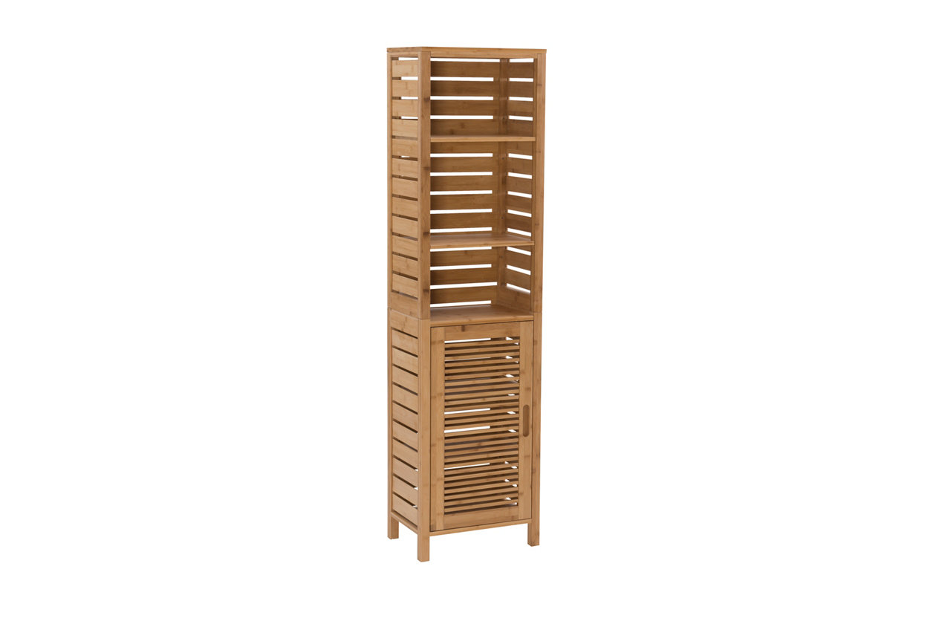

# Name product: **Linon Bracken Tall Cabinet**

Elegance, Comfort, Durability

Size: 16*61*11

Material: solid bamboo

Price: 150$

Description:

The Bracken tall cabinet takes advantage of vertical space providing ample storage and display space for linens and bathroom necessities. One door keeps the three lower shelves hidden, while three upper shelves are open for easy access. Crafted from solid bamboo, the piece is both sturdy and durable.

* Simple, versatile design
* Three open shelves and three hidden interior shelves
* Provides ample storage space for all bathroom necessities
* Sturdy and durable
* Crafted from solid bamboo
* Shelf dimensions: 13.75"w x 8.5"d x 0.5"thick
* Weight limit: 25 per shelf