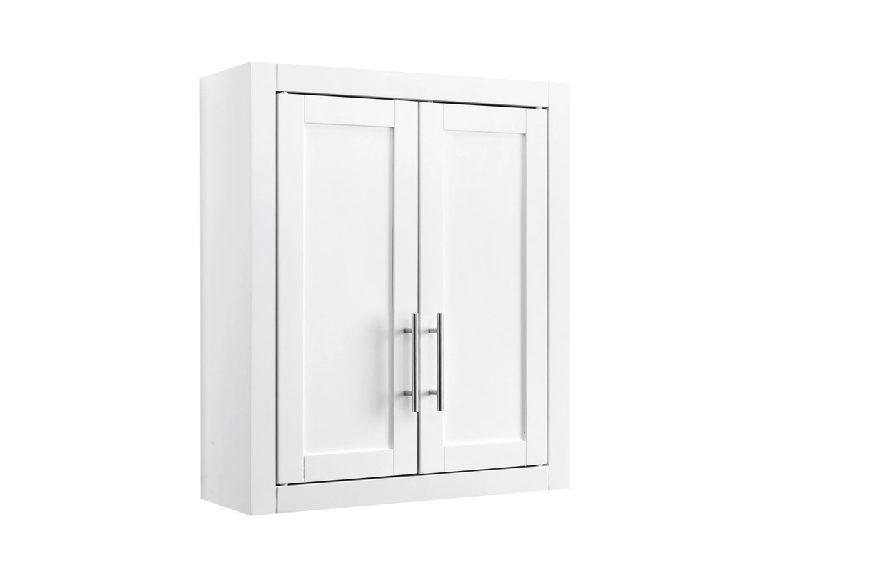

# Name product: **Crosley Savannah Wall Cabinet**

Elegance, Comfort, Durability

Size: 22*26*8

Material: Alloy

Price: 105$

Description:

Balancing chic flair with a relaxed sensibility, the Langford upholstered bed strikes just the right tone for sleek sophistication. A merger of beautifully clean lines with cushioned comfort, the headboard is layered with two plush pillows for an indulgent lay-back experience that captures the look and feel of contemporary design, while the extra-wide rails reinvent bedside seating.

* Includes upholstered panel bed (headboard, footboard and rails)
* Neutral polyester upholstery
* 2 loose bolster pillows with soft polyfill
* Bed does not require additional foundation/box spring
* Mattress available, sold separately
* Assembly required
* Bed is not compatible with an adjustable base
* Estimated Assembly Time: 50 Minutes