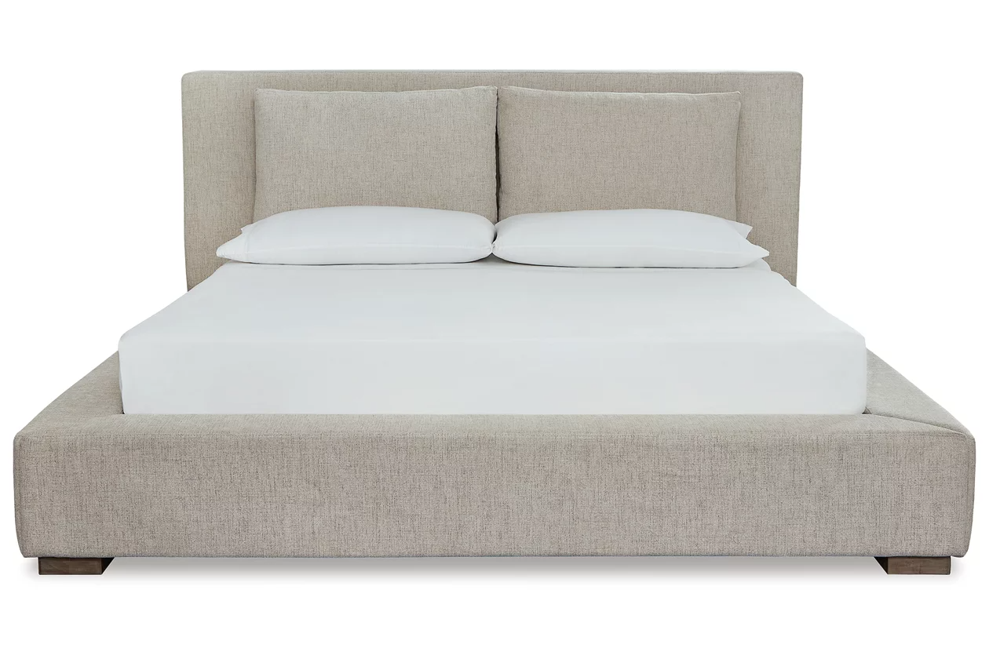

# Name product: **Langford Queen Upholstered Bed**

Elegance, Comfort, Durability

Size: 79*49*99

Material: polyester

Price: 1100$

Description:

Balancing chic flair with a relaxed sensibility, the Langford dresser and mirror set strikes just the right tone for rustic sophistication. Beautifully clean lines are subtly enhanced with a weathered gray finish and rough-sawn texture. Hardware-less approach keeps this dresser ultra minimal in design with maximum style. Quality dovetail construction reflects attention to detail from the inside out.

* Includes dresser and mirror
* Made of pine wood, pine veneer and engineered wood
* Weathered gray finish with distressed texture
* 6 smooth-gliding drawers with dovetailed construction; top drawers with felt-lined bottom
* Mirror attaches to back of dresser
* Mirror features an inset metallic accent
* Estimated Assembly Time: 35 Minutes