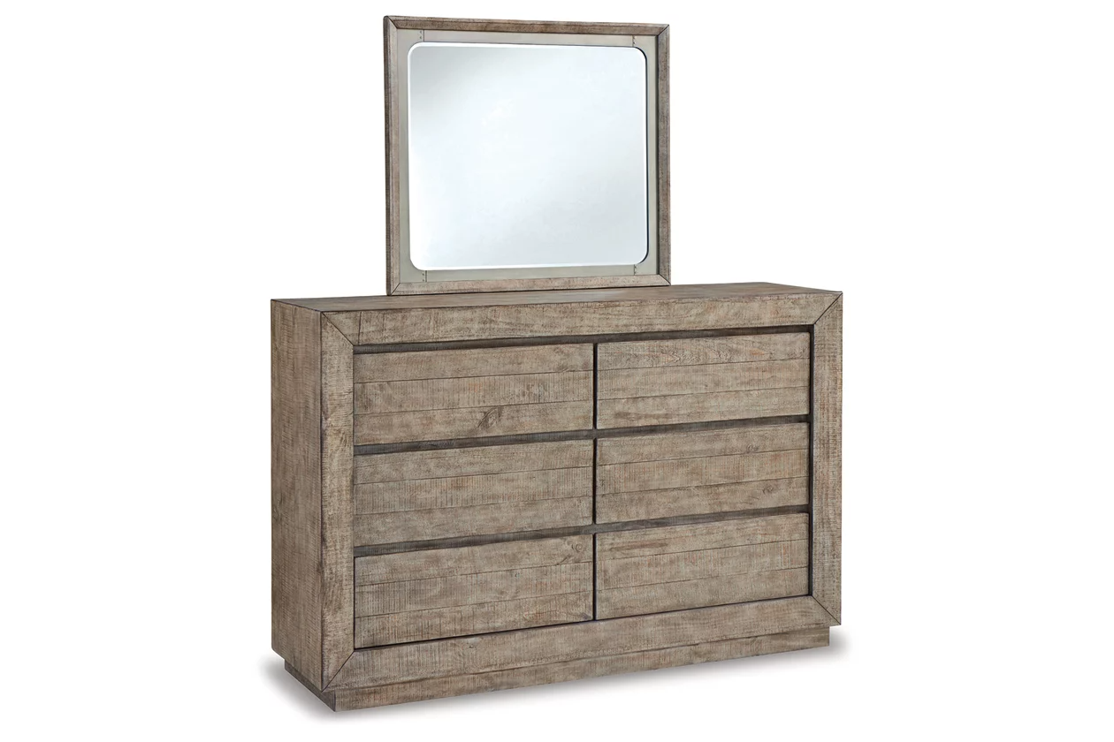

# Name product: **Langford 6 Drawer Dresser and Mirror**

Elegance, Comfort, Durability

Size: 63*76*18

Material: pine wood, pine veneer and engineered wood

Price: 1200$

Description:

If style is the question, then the Altari sofa is the answer. Sporting clean lines and sleek track arms, the decidedly contemporary profile is enhanced with plump cushioning and a chenille-feel upholstery, so pleasing to the touch. Sure to play well with so many color schemes, this sofa in slate gray includes a pair of understated floral pattern pillows for fashionably fresh appeal.

* Corner-blocked frame
* Attached back and loose seat cushions
* High-resiliency foam cushions wrapped in thick poly fiber
* 2 decorative pillows included
* Pillows with soft polyfill
* Polyester upholstery and pillows
* Exposed feet with faux wood finish
* Platform foundation system resists sagging 3x better than spring system after 20,000 testing cycles by providing more even support
* Smooth platform foundation maintains tight, wrinkle-free look without dips or sags that can occur over time with sinuous spring foundations

**Fabric Details**

* Body and One Side Toss Pillows: Polyester (100)%
* Oneside Toss Pillows: Polyester (100)%