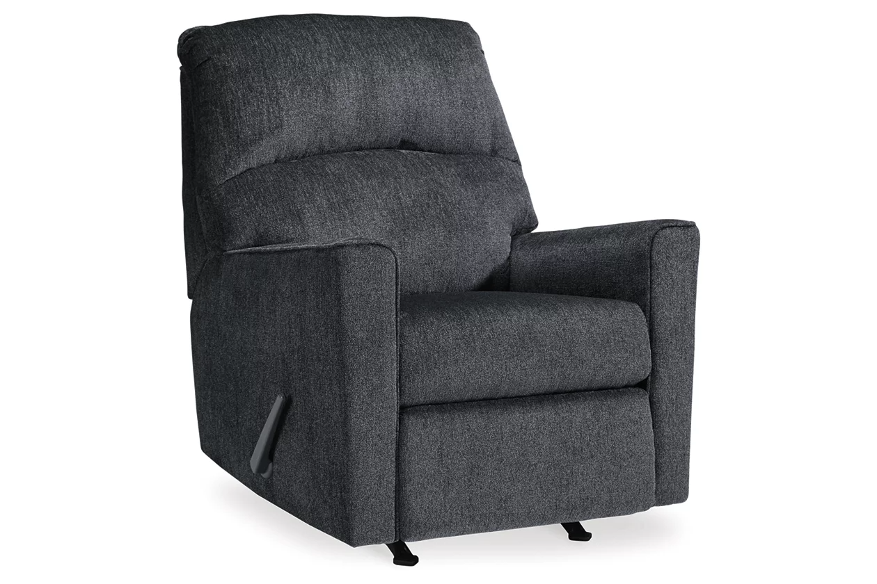

# Name product: **Altari Manual Recliner**

Elegance, Comfort, Durability

Size: 34*40*39

Material: Polyester

Price: 400$

Description:

The Skempton counter height table with storage invites you to raise the bar on small space living. An inspired choice for coastal chic or modern farmhouse settings, this clean-lined, simply striking table doubles the charm with a brown tone top with plank effect, paired with a grayish white base with rub through effect for timeworn appeal. Built-in 8-bottle wine rack and pair of open shelves make the most of every inch of space.

* Made of solid wood, engineered wood and acacia veneers
* Two-tone finish
* 2 shelves
* 8-bottle wine rack
* Seats up to 4
* Assembly required
* Estimated Assembly Time: 30 Minutes