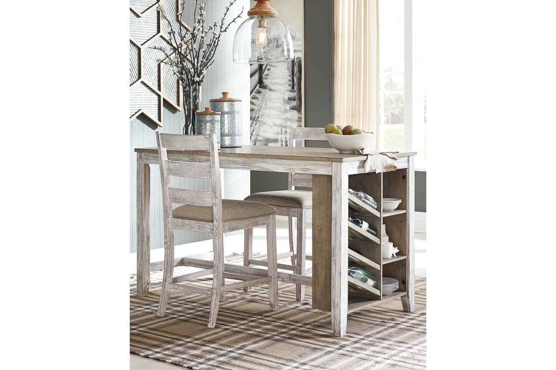

# Name product: Skempton Counter Height Dining Table with Built-In Wine Rack and Shelves

Elegance, Comfort, Durability

Size: 60*36*30

Material: solid wood, engineered wood and acacia veneers

Price: 330$

Description:

The Skempton dining chair invites you to raise the bar for small space living. An inspired choice for coastal chic or modern farmhouse settings, this comfortably cushioned chair sports a grayish white finish with rub through effect for timeworn appeal.

* Made of wood and engineered wood
* Distressed grayish white finish
* Cushioned seat with polyester upholstery
* Tall ladderback design
* Assembly required
* Estimated Assembly Time: 30 Minutes