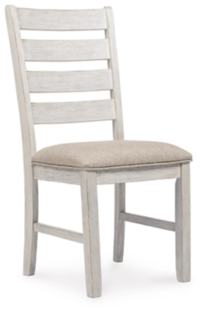

# Name product: **Skempton Ladderback Dining Chair with Upholstered Seat**

Elegance, Comfort, Durability

Size: 18*39*21

Material: wood and engineered wood

Price: 180$

Description:

The Skempton dining chair invites you to raise the bar for small space living. An inspired choice for coastal chic or modern farmhouse settings, this comfortably cushioned chair sports a grayish white finish with rub through effect for timeworn appeal.