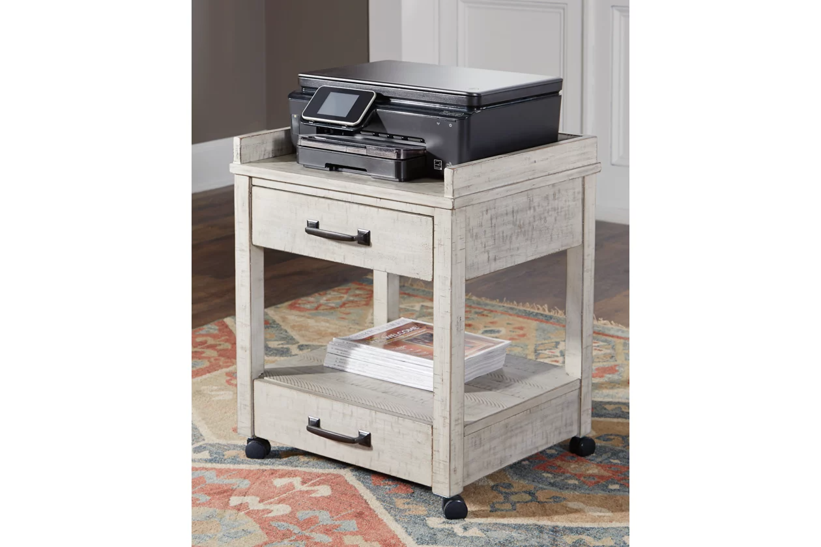

# Name product: **Carynhurst 2 Drawer Printer Stand with USB Charging**

Elegance, Comfort, Durability

Size: 21*25*18

Material: pine veneers, pine wood and engineered wood

Price: 170$

Description:

Set on casters for easy mobility, the Carynhurst printer stand rolls out a fresh look in modern farmhouse living. Two smooth-gliding drawers with dovetail construction reflect high quality that never goes out of fashion. Pair of electrical outlets and USB charging ports make it an indispensable home office essential.

* Made of pine veneers, pine wood and engineered wood
* Distressed whitewash finish
* 2 smooth-gliding drawers with dovetail construction
* 2 open shelves
* Vintage patinated bronze-color hardware
* Casters for mobility
* 2 electrical outlets and USB charging ports
* Power cord included; UL Listed
* Assembly required
* Estimated Assembly Time: 15 Minutes