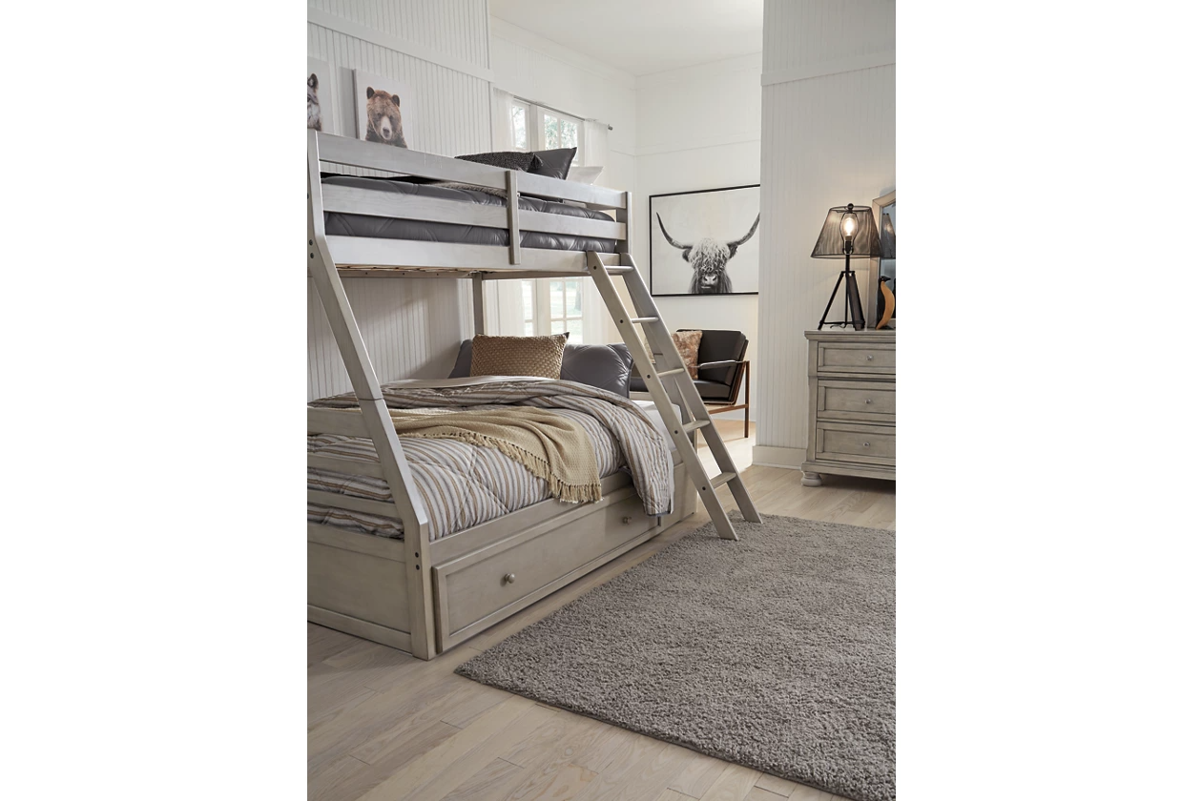

# Name product: **Lettner Twin over Full Bunk Bed with 1 Large Storage Drawer**

**Elegance, Comfort, Durability**

Size: 79*65*56

Material: veneers, wood and engineered wood

Price: 850$

Description:

Double the space means twice the fun, and that’s what they’ll enjoy with the Lettner twin-over-full bunk bed. Forever classic design details—under bed storage, a sturdy ladder and safety rails—are paired with a burnished gray finish that elevates the look with modern sensibility.

* Made of veneers, wood and engineered wood
* Includes horizontal rails
* Top bunk with side rails
* Sturdy ladder leads to top bunk
* The Consumer Product Safety Commission states top bunks not be used for children under 6 years of age
* Included slats eliminate need for foundations/box springs
* Mattresses available, sold separately
* Roomy under bed drawer for storage
* Assembly required
* Expert assembly recommended; available at check out for an additional fee
* Bed is not compatible with an adjustable base
* Estimated Assembly Time: 145 Minutes