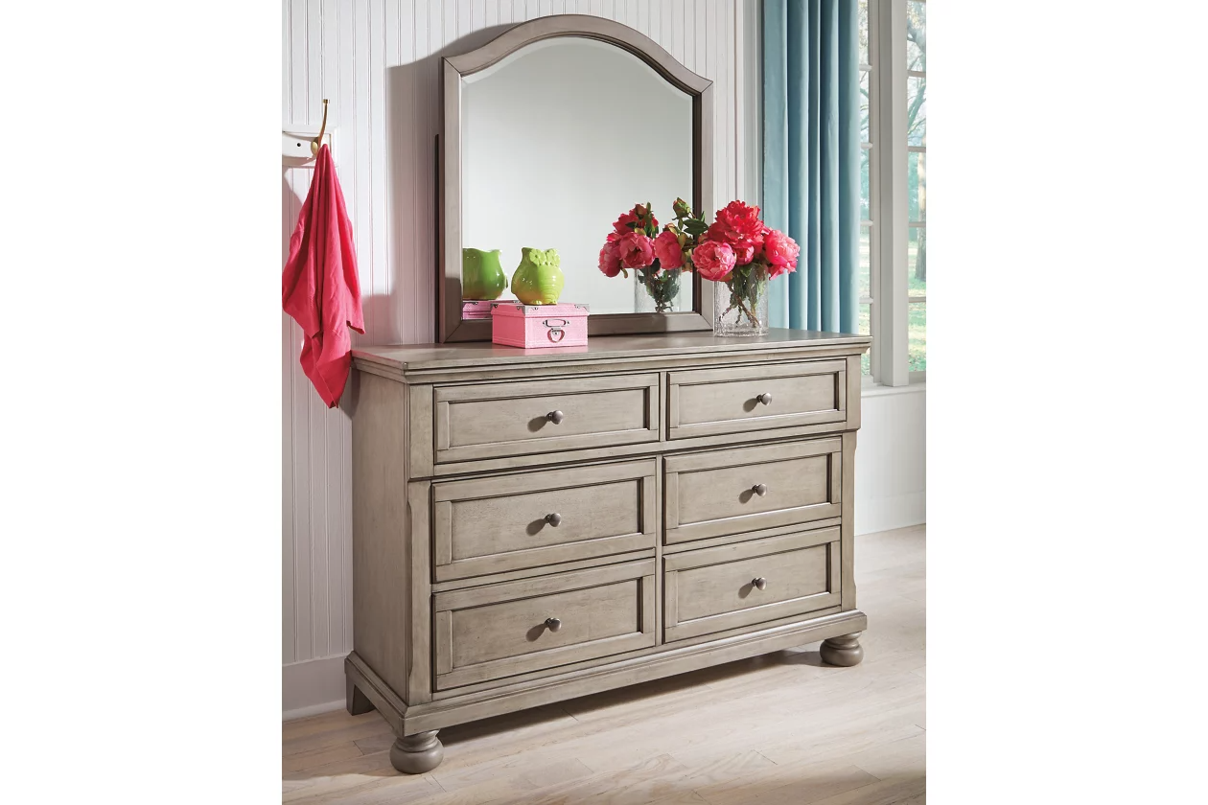

# Name product: **Lettner 6 Drawer Youth Dresser and Mirror**

Elegance, Comfort, Durability

Size: 54*71*17

Material: veneers, wood and engineered wood

Price: 730$

Description:

Satisfying your taste for tradition, the Lettner dresser and mirror set sports serene sophistication. Forever classic design details—inlaid panels, silvertone patina hardware and bun feet—are so easy to love. Six roomy drawers keep your wardrobe organized in style. Beveled mirror frame beautifully echoes the dresser’s burnished light gray finish for modern sensibility.

* Made of veneers, wood and engineered wood
* Silvertone patina hardware
* 6 smooth-gliding drawers with dovetail construction
* Top drawers felt-lined
* Mirror attaches to back of dresser
* Assembly required
* Estimated Assembly Time: 50 Minutes