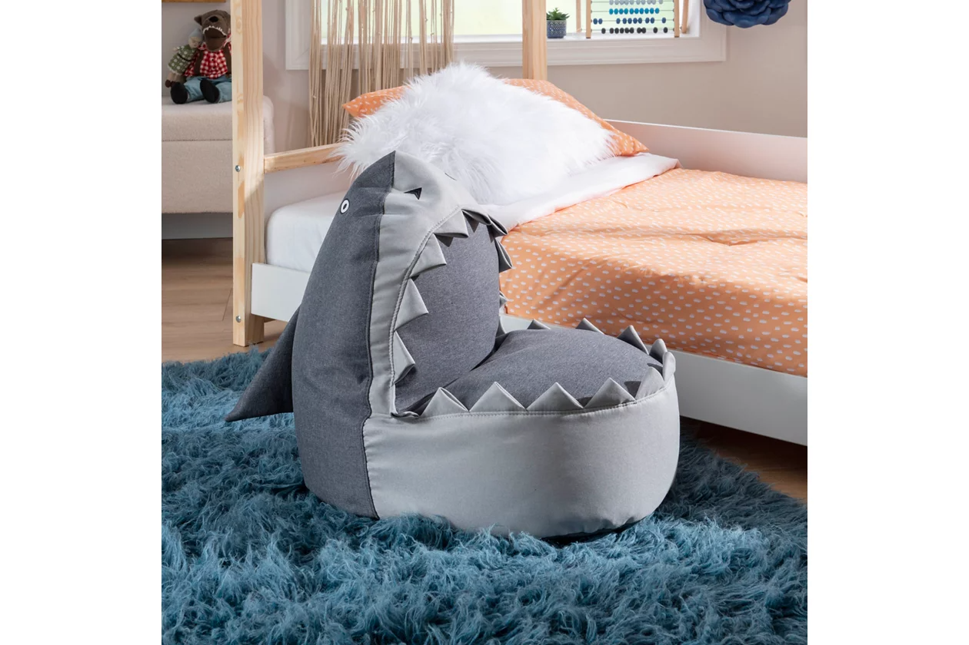

# Name product: **Linon Sammy Shark Ottoman**

Elegance, Comfort, Durability

Size: 15*25*27

Material: polyester

Price: 105$

Description:

Look out, there's something in the water! Dangerously cute and comfortable, this friendly shark doubles as a plush chair that your kids will love. The comfortable foam padded cushions are wrapped in 100% polyester fabric for easy cleaning and a soft touch, even the teeth! Measuring 15" L x 7" D x 25" H, this is a safe and accessible perch that the whole family will love. Use it as a seat, footstool, a prop in a play or as a platform for arts and crafts. Either way excitement and creativity are sure to follow.

* Cute shark design offers a friendly accent your kids will love
* 100 percent polyester fabric is soft to the touch and a breeze to clean
* Foam padded seat and backrest provide extra comfort
* Perfect as a footstool, children's seat, arts and crafts platform, a prop in a play, and much more
* 15" L x 7" D x 25" H dimensions offer a safe and accessible perch that the whole family will love
* Arrives fully assembled
* Ships directly from third party vendor. See Warranty Information page for terms & conditions.