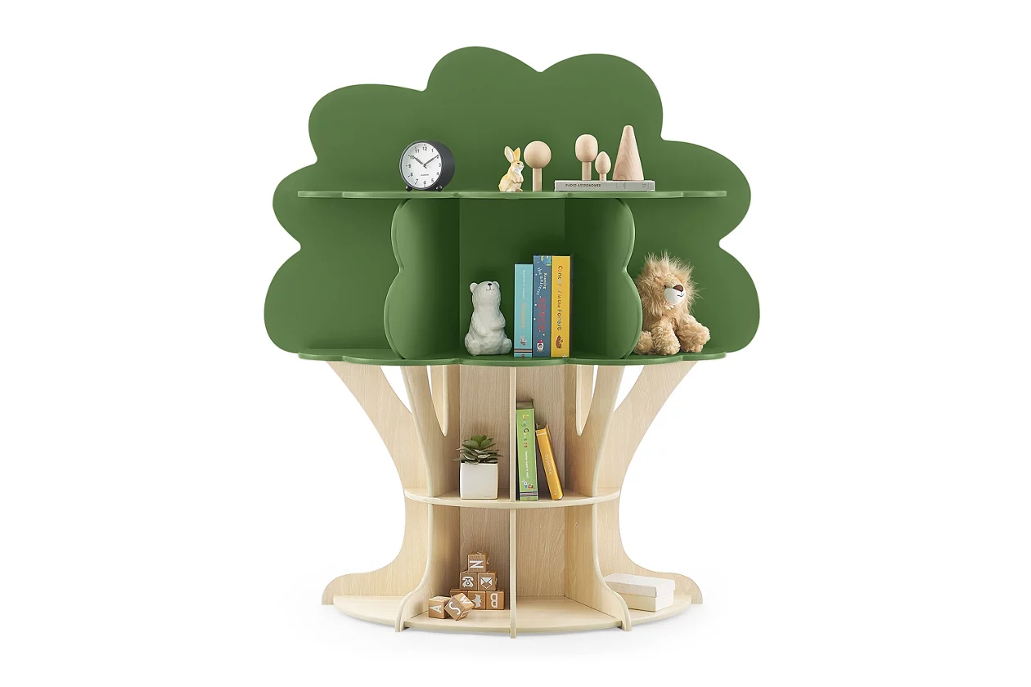

# Name product: **Delta Children Tree Bookcase**

Elegance, Comfort, Durability

Size: 44*50*13

Material: engineered wood

Price: 208$

Description:

Looking for a creative storage option for your child’s playroom our bedroom? Branch out with this Tree Bookcase by Delta Children. This bookcase features a variety of shelves in different shapes and sizes, giving plenty of space to hold toys, books or display décor. And the bottom shelves are easily accessible, so kids can help with the cleanup. Designed with your child’s safety in mind, this bookcase attaches securely to any wall with the included wall anchor. Plus, it’s GREENGUARD Gold Certified, which means it’s built to contribute to cleaner air for a healthy home. Delta Children was founded around the idea of making safe, high-quality children's furniture affordable for all families. They know there's nothing more important than safety when it comes to your child's space. That's why all Delta Children products are built with long-lasting materials to ensure they stand up to years of jumping and playing. Plus, they are rigorously tested to meet or exceed all industry safety standards.

* Functional and fun, this Tree Bookcase features multiple shelf sizes for plenty of room to display keepsakes, books or treasurers
* Goes with any décor, in any room in your home
* This bookcase meets the most stringent chemical emissions standards to create a healthier home for your child.
* Tested for more than 10,000 chemicals and VOCs, this bookcase is certified to contribute to cleaner indoor air
* Delta knows chemicals have no place in your house, so this product is made with a non-toxic multi-step painting process that is lead and phthalate safe
* Bookcases includes tipover restraint (safety anchor) for you to securely attach it to your wall
* Engineered and tested for satety
* Made of sustainable TSCA compliant engineered wood| Tested for lead and other toxic elements to meet or exceed government and ASTM safety standards
* Durable and easy to clean finish; wipe with damp cloth and dry immediately
* Assembled Dimensions: 44"W x 13.25"D x 49.75"H
* Ideal storage for both toddlers and big kids
* Ships directly from third party vendor. See Warranty Information page for terms & conditions.