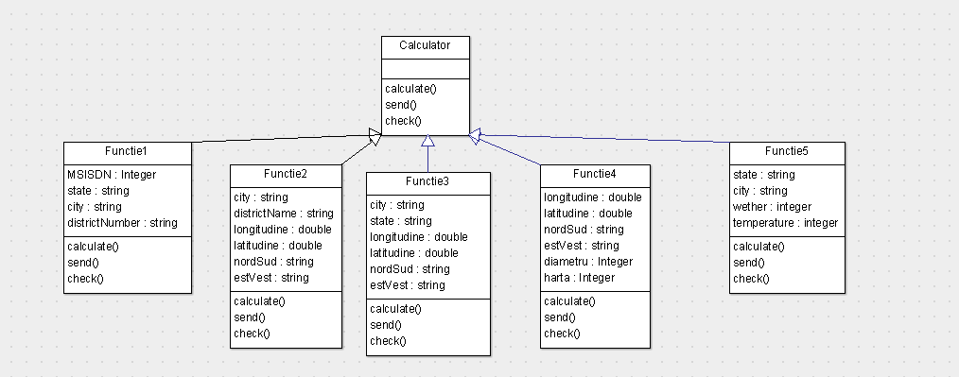

Class Diagram

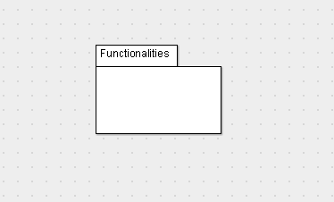

Package Diagram

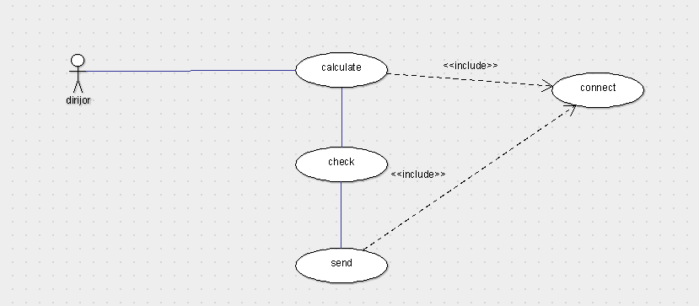

Use Case Diagram

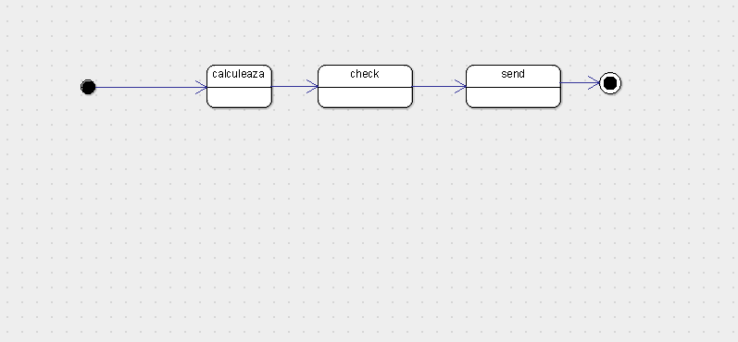

State Diagram

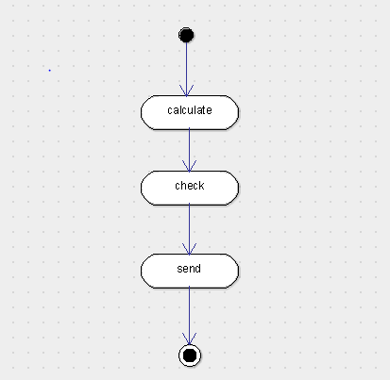

Activity Diagram

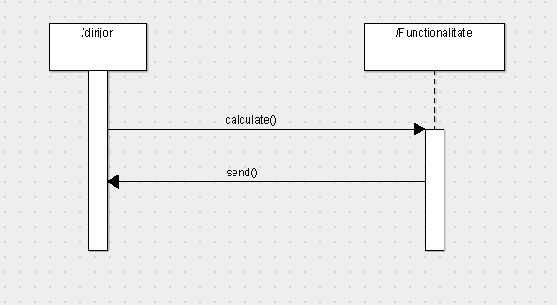

Sequence Diagram

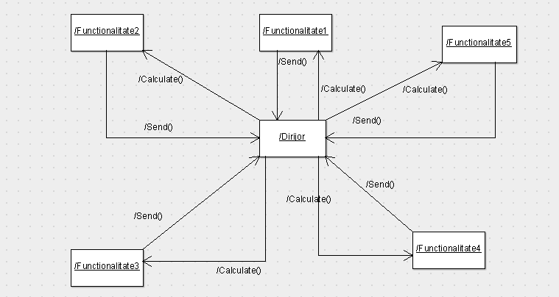

Collaboration Diagram

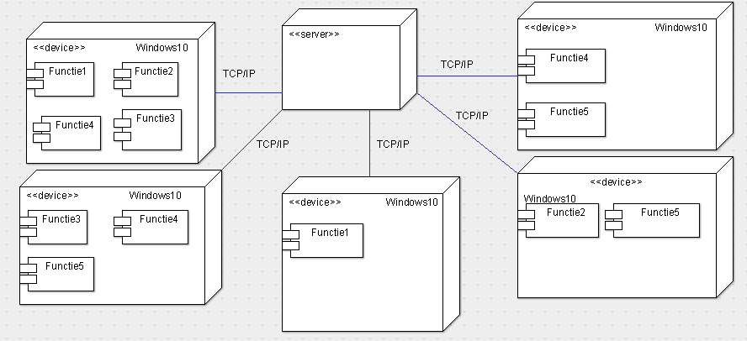

Deployment Diagram

Iacob Cosmin Georgian:collaboration diagram,package diagram

Pascaru Stefan Narcis:class diagram ,activity diagram

Stefan Cristian:deployment diagram,use case diagram,coordonator

Timofte Samuel:state diagram,sequence diagram